World Food Prize Education Programs

Simulation:
Soil and Environment in Uganda

Facilitator Guide

Activity Overview

This simulation is an interactive exercise in which students develop their understanding of the decision-making process through role-playing negotiations on solving a pressing food security challenge in another country.

In this simulation, students represent stakeholder groups who have been asked to advise decision-makers on how to address soil and environmental degradation in Uganda.

Students will:
- Represent stakeholder groups who have an interest in addressing soil and environmental degradation in Uganda;
- Read background material provided in the simulation outlining the scope of the issue in Uganda and develop solutions from the perspective of their assigned stakeholder group;
- Consider the impact of their solution from the perspective of the other stakeholder groups using the “Exploring Perspectives to Reach a Solution” table provided and then revise their solution, if needed;
- Present their stakeholder group’s solution to all other stakeholders and reach one consensus solution among all stakeholder groups;
- Learn about a real life solution for this issue in Uganda.

Teachers will:
- Assign students to stakeholder groups;
- Monitor time throughout simulation;
- Distribute the real life example solution at the end of the simulation.

Contact Information:
The World Food Prize Foundation
666 Grand Avenue, Box 1700 / Des Moines, IA, 50309
Tel: 515-245-3783 Fax: 515-245-3785
E-mail: wfpf@worldfoodprize.org
www.worldfoodprize.org
Soil and Environment in Uganda Simulation

Objectives:

Through the simulation, students will:
- Develop an understanding that science and technology can be used as tools to solve real world challenges;
- Develop an understanding of the role policy can play in implementing scientific and technological solutions to food security challenges;
- Recognize the importance of understanding scientific concepts and fundamentals to make informed decisions as individuals and for society;
- Gain an appreciation for the context in which solutions to societal challenges must be implemented – a context that includes limited resources and competing stakeholders;
- Understand the process of negotiation surrounding the implementation of solutions;
- Think critically about how solutions affect different stakeholders;
- Develop their ability to advocate among a group of peers.

Process:

What – In this simulation, students represent stakeholder groups who have been asked to advise decision-makers on how to address soil and environmental degradation in Uganda.

Why – Scientific, industry, and community leaders are often asked to provide expert advice to decision-makers. To give quality advice, experts must be aware of the context in which decisions are made. In addition to addressing the problem at hand, an effective solution must be affordable and politically acceptable to key stakeholders.

Materials for students:

- Writing utensils
- Stakeholder Simulation packet
- Description of a real life example solution “Using Conservation Agriculture to Prevent Soil Erosion and Improve Food Security in Uganda” (NOTE: DO NOT distribute real life example solution until the very end of the simulation activity, as indicated in Simulation Instructions and Timeline on page iii).

Simulation Instructions and Timeline:

Total simulation time: 105 minutes
Note: All students should have a Stakeholder Simulation packet.

Begin Simulation: Teacher reads Introduction to the simulation and Problem |  | Pg. 1 | 5 min
Part 1 | Teacher assigns students to stakeholder groups  Note: Split students evenly into the three stakeholder  groups (smallholder farmers, agribusiness, government) | Pg. 1 | 5 min
Part 2 | Students read background information as a stakeholder group, discuss and develop a solution that their stakeholder group would want to see implemented to solve the scenario.  Note: Students write down their solution(s) on page 5.  Each student group then presents their solution to the whole class. | Pgs. 2–5 | 20 min  15 min
Part 3 | Instruct students to review their stakeholder group’s proposed solution using the “Exploring Perspectives to Reach a Solution” table.  Note: Part 1 of the table includes information to help  students consider other stakeholders’ perspectives. In Part  2 of the table, students are to list the other stakeholder  groups in the “Stakeholders” column, and then answer the  questions for those stakeholder groups in each of the  following columns.  After completing the table, allow students the opportunity to revise their original proposed solution if they desire. | Pgs. 6–8 | 20 min
Part 4 | Convene students for a large group discussion in which each stakeholder group presents their final solution. During this time, students negotiate a single solution that is acceptable to all stakeholder groups.  Note: If consensus isn’t possible, allow a majority vote. |  | 20 min
Part 5 | Distribute the real life example solution “Using Conservation Agriculture to Prevent Soil Erosion and Improve Food Security in Uganda” to all students to read. | Pgs. 9–10 | 10 min
 | Facilitate discussion with your students as a large group. Questions for discussion are provided on page 9 of your Facilitator Guide. | Pg. 11 | 15 min

Soil and Environment in Uganda

Introduction: Scientific, industry, and community leaders are often asked to provide expert advice to decision-makers. To give quality advice, experts must be aware of the context in which decisions are made. In addition to addressing the problem at hand, an effective solution must be affordable and politically acceptable to key stakeholders. In this simulation, you will work in groups to represent stakeholders who have been asked to advise decision-makers on how to address a pressing food security challenge in a developing country.

Problem: Population growth and poor farming practices are degrading the soil and environment in Uganda. Families’ ability to feed themselves is becoming increasingly strained, as the long-term impacts of environmental degradation are increasingly harmful to farmers’ yields and income.

Activity

Part One: Your facilitator will divide you into three different stakeholder groups

Group One – You represent smallholder farmers. Develop a solution that reduces soil degradation while improving your food security and protecting your way of life.

Group Two – You represent agribusiness. Develop a solution that reduces soil degradation while improving food security and protecting your bottom line.

Group Three – You represent the government of Uganda. Develop a solution that reduces soil degradation while improving overall food security and balancing the needs of farmers and agribusiness.

Part Two: As a stakeholder group, read the background information about the situation in Uganda regarding soil and environmental degradation (page 2). After reading, discuss the situation and propose a solution that your stakeholder group would like to see implemented to improve the situation. Each group then presents their solution to the class.

Part Three: In preparation for proposing your stakeholder group’s solution to the other stakeholder groups, use the “Exploring Perspectives to Reach a Solution” table (page 5) to consider how other stakeholder groups may view or respond to your proposed solution.

Part Four: Each stakeholder group presents its solution to the large group. What similarities and differences are there between the groups? What did the process of stakeholder analysis teach you about how to develop and implement effective solutions?

Part Five: Learn about an actual solution to this situation that was implemented in Uganda. Your facilitator will present this information. How does this solution compare with the solutions you developed?

Soil Conservation in Uganda – Background for Simulation

Uganda, located in eastern Africa, is a poor country where most people make a living as farmers (Photos 1, 2). In recent years, the economy has grown and overall living conditions are slowly improving for many Ugandans. However, the country faces important challenges that could slow or even reverse this progress. These challenges include a rapidly growing population and stresses on Uganda’s natural resources and environment.

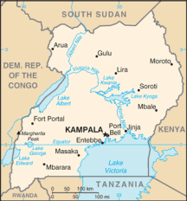 | 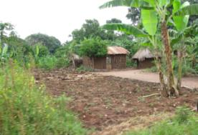
1. Map of Uganda | 2. Typical Ugandan homestead

Uganda currently faces these challenges, specifically in the Mbale, Mbarara and Pallisa Districts. The primary livelihood and source of income for inhabitants of these districts is smallholder farming. For agricultural areas, these three districts have high population densities (229 – 487 people/km²). These districts are mountainous and hilly, with high average rainfalls of 1000 – 1500 mm/year. Rainfall patterns are bimodal, meaning that there are two rainy seasons per year, one from February to May and one from August to December.

Farmers in these districts raise both crops and livestock. Those who can afford to, keep a limited number of livestock, mainly cattle, goats, pigs and chicken. Most of the cattle are the local long- horn Ankole breed, but recently a large number of farmers have started keeping upgraded crosses of cattle.

The major crops grown are perennials such as banana and coffee, and annuals such as maize (corn), beans, rice, groundnut (peanut), millet, sorghum, cowpea (black eyed peas) and sweet potato. Other crops, grown on a small scale as “reserve crops”, are cassava, irish potato, field pea and yam. Reserve crops are grown as a backup in case the main crops fail. Reserve crops are extremely important to the average Ugandan because they provide a food source during droughts, floods, or other disasters. Exotic and local vegetables are grown on a small scale, mainly as a backyard activity by women, in order to increase the nutritional quality of the diet.

Plants get most of their nutrients from the soil. Good, fertile soil is rich in all of the necessary nutrients and essential to growing healthy, productive crops. Therefore, soil quality is of critical importance to food security in Uganda. It is difficult for Ugandan farmers to maintain good soil quality in these districts. The flat lands of this area naturally have higher soil quality than soils on mountain and hill sides. However, the productivity of the flat lands has become low as farmers do not have the resources to replenish the soil nutrients, which have been depleted through continuously growing crops over the years.

With the high population density and limited productivity from flat lands, farmers must also grow crops on steep mountain and hill sides (Photo 3). Growing crops on steep slopes can be problematic because water runs quickly down the slope, removing soil from the fields in a process called erosion. Over time, erosion results in the loss of the nutrient rich upper layers of the soil, which make it difficult to grow healthy crops. The soils are difficult to farm even under normal conditions because they are low in organic matter and fertility. Soil erosion compounds the already existing difficulty of farming on poor quality soil, reducing crop production to the point where people go hungry.

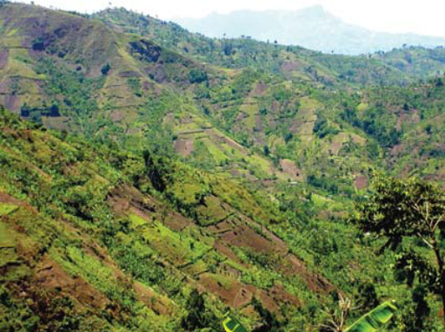
3. Agricultural fields on mountain sides

Ugandan farmers often till their land using field hoes (Photo 4). Tillage removes plants, including weeds, from the soil surface, and breaks the soil into smaller pieces. Tillage has importance to preparing the land for planting, but can also allow for soil erosion as it exposes the upper soil layers to erosion from water and wind. Erosion not only decreases crop productivity and makes farming difficult; it also increases the risk of flooding and landslides.

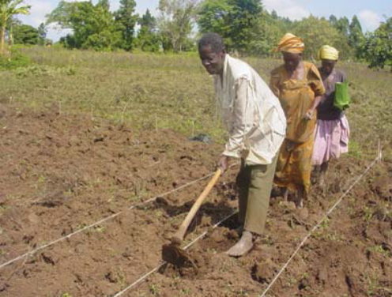
4. Farmers till their field with field hoes
In addition to growing crops on steep hillsides, deforestation and over grazing contribute to soil erosion and degradation. Deforestation is common in Uganda because families rely on trees to provide fuel for cooking. Over grazing is becoming a problem, as herds grow larger and as farmers seeking more productive soil convert more land, including pasture, to cropland. Therefore, the amount of land available for grazing is shrinking and pastures become over grazed as livestock eat any available plants faster than new ones can grow. It is important to note that livestock have great cultural significance in Uganda as symbols of status and are of great economic importance to families as livestock can be used as a fall back resource to be sold in times of emergency.

The Problem

As poor farmers in Uganda work to provide their growing families’ needs for food and shelter, they meet immediate survival needs by resorting to practices that lead to soil erosion which threatens their ability to feed their families over the long term.

Your Mission

As a stakeholder group, find a solution that can be implemented to address soil erosion for the farmers of Uganda, which will allow them to meet their short- and long-term survival needs without destroying their land and environment. Remember that the stakeholder group you represent is an important group with specific needs, goals and objectives, which other stakeholder groups may or may not share. In developing your solution, you are expected to protect the interests of your stakeholder group.

After discussing the situation with your stakeholder group, propose your stakeholder group’s solution here:

Exploring Perspectives to Reach a Solution
Expand on your solution to consider other stakeholders who may impact or be impacted by your proposed course of action.

1. Consider the following points when analyzing how other stakeholders may view or respond to your proposed solution:
Stakeholder | Their Needs | Their Level of Support | Their Power | Your Needs | Strategy
A stakeholder is any individual or organization that:  1) Is impacted by the proposed solution or;  2) Influences whether and/or how the proposed solution is carried out. | Stakeholders have a variety of needs, some more basic than others. Individual people’s needs include:  1) Basic needs, including food, water, shelter, and human interaction;  2) Human rights, including the freedoms guaranteed in the bill of rights.  Organizations’ needs include:  1) Funding – the ability to pay the bills;  2) Legitimacy – being respected well enough to attract good employees and to work in society to carry out their mission. | Possible responses include:  1) Active support – the stakeholder publicly dedicates time, money, or vocal support to advance your proposal;  2) Passive support – the stakeholder dedicates time, money, or other resources to support your proposal, behind the scene;  3) Neutrality – the stakeholder is undecided or chooses not to influence the adoption of proposal;  4) Passive resistance – the stakeholder dedicates time or money to defeat or undermine your proposal, behind the scene;  5) Active resistance – the stakeholder publically opposes your proposal with time, money, or vocal opposition. | Power comes in many forms, including:  1) The ability to decide whether or not to approve a course of action;  2) The ability to influence the public’s thoughts and feelings about a course of action;  3) The ability to determine how a course of action is implemented on the ground. | Your needs will vary based on the context and the power of the stakeholder in question. You may need active support from some groups, but only passive support from others. For some, all you need is for them to remain neutral or shift from active resistance to passive resistance. | Strategies for managing stakeholders include, but are not limited to:  1) Publically partnering to advance the proposed solution;  2) Collaborating behind the scene;  3) Attempting to persuade them to accept your point of view – through public discussions or private conversations;  4) Entering into dialogue to try to come to a compromise viewpoint;  5) Publically arguing with or shaming them, either to weaken their power or to persuade them to drop their opposition;  6) Ignoring them completely.
2. Answer the questions below. Use the information above to help you formulate your answers and consider the perspectives of other stakeholder groups.
Stakeholder | Their Needs | Their Level of Support | Their Power | Your Needs | Strategy
Write each stakeholder name here. | Summarize the key needs of the stakeholder and how are they affected by your proposed course of action. | Based on the needs you’ve identified, how is the stakeholder likely to respond to your proposed course of action? | How likely is the stakeholder to get what it wants? | What do you need from this stakeholder to meet your needs and priorities? | Based on your own values, what you know about the stakeholder, and what you need from them, write your strategy for managing them.
Stakeholder | Their Needs | Their Level of Support | Their Power | Your Needs | Strategy

After completing the “Exploring Perspectives to Reach a Solution” table, revise your stakeholder group’s proposed solution, if you desire.

Using Conservation Agriculture to Prevent Soil Erosion and Improve Food Security in Uganda

Farmers in Uganda know that they should maintain the fertility of their soils and protect fields from soil erosion. Over the years, soil degradation and soil erosion has led to increasing problems with low crop yields, flooding, and landslides, which are impossible for farmers to ignore. Farmers, with the help of agribusinesses and the government, have taken measures to prevent and reverse soil degradation and soil erosion. These include using crop rotations, cover crops, and conservation agriculture.

When crops are grown, they remove and add different nutrients to the soil. To replenish the soil with nutrients removed by a certain crop, a different type of crop which can add those nutrients can be planted. This practice, to replenish nutrients to the soil by strategically planting different types of crops in a field over time, is called crop rotation and is used by many farmers around the world (Photo 1).

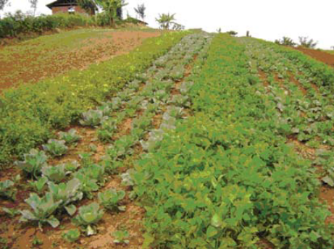
1. Cabbage and beans grown in crop rotation

Scientists working for the Government of Uganda have begun teaching farmers which sequences of crops work best for maintaining soil quality. Farmers, agribusinesses that buy and process crops, and government scientists are working together to figure out crop rotations that maintain soil quality while also producing food that farmers want to eat and companies want to buy.

Cover crops are crops that are planted for the purpose of protecting and improving the soil (Photo 2). They act as a protective layer, or buffer, between the soil and the damaging effects of wind and rain. Cover crops can be grown in between rows of the main food crop, covering soil that would have otherwise been exposed to wind and rain, or grown as part of a crop rotation. When managed well, cover crops protect the soil from erosion and add nutrients to the soil because they are left on the fields after they have reached maturity to decompose as mulch (Photo 3). In some cases, cover crops can even be harvested as food for people or forage for livestock. Unfortunately, many types of cover crops can be difficult for poor farmers to manage well. This can lead to big problems, such as when a poorly managed cover crop outcompetes a food crop by taking too much water out of the soil as it grows.

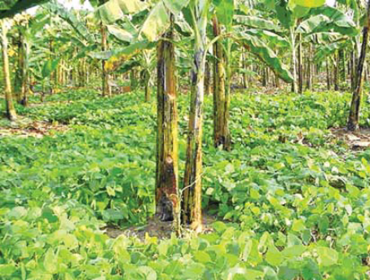 | 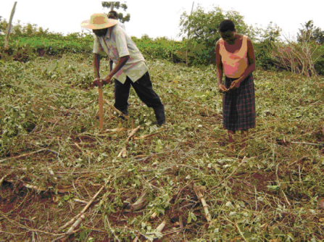
2. Banana plants growing surrounded by mucuna bean cover crop | 3. Farmers planting into a mulch cover crop
Farmers and government scientists are working together to discover which types of cover crops are easiest to manage in Uganda, while also providing the most benefits in terms of food or forage production. As these cover crops are identified, agribusinesses are beginning to grow them and sell cover crop seeds to farmers, who can afford to buy the seeds because of the additional food or forage that these cover crops produce.

The practices of crop rotation and cover cropping go a long way towards reducing soil erosion and degradation in Uganda, but in many places they aren’t enough on their own. Realizing this, the Government of Uganda partnered with the Food and Agriculture Organization of the United Nations to introduce a “package” of farming practices known as “conservation agriculture”. Farmers who practice conservation agriculture use appropriate crop rotations and well-managed cover crops, while also tilling the soil as little as possible. Instead of the traditional Ugandan practice of tilling their entire fields with hoes before planting, farmers use tools such as jab-planters. Jab planters are hollow tubes that are thrust into the soil in the locations where a farmer wants to plant her crop. The farmer then drops a seed through the hollow tube to plant it (Photo 4).

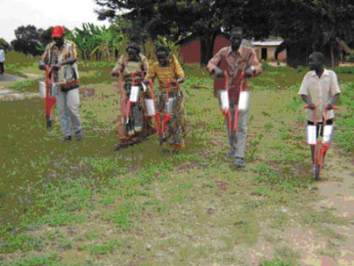
4. Farmers learn to use jab planters

Conservation agriculture has worked well in many of the communities where it was introduced, but there are still some problems that need to be solved. Jab planters are more expensive than hoes, and provisions need to be made that will allow farmers to purchase them after the Food and Agriculture Organization stops funding the project. Companies have also had some challenges in producing enough cover crop seeds at prices that farmers can afford. Finally, in some areas conservation agriculture has not worked well for farmers, and there is a need to do more research to figure out why. Once the government knows why conservation agriculture doesn’t work for everyone, they can either modify conservation agriculture or look for other solutions for areas where it doesn’t work.
Suggested Discussion Questions for Reflection

1. What are your general thoughts or reflections after completing the simulation?

2. Which parts of the simulation were easiest and most difficult? Why?

3. What did the process of negotiating a solution with other stakeholder groups teach you about how to develop and implement effective solutions?

4. Was there competition or disagreement between or among stakeholder groups? If so, why did that occur and how was it resolved? Can you think of any similar conflicts or disagreements in real life?

5. In thinking about the solutions your stakeholder groups discussed and agreed upon, as well as the real life example presented, what are some limitations that make solutions difficult to implement?

6. How does the “Conservation Agriculture” solution that was actually implemented in Uganda compare with the solutions you developed?

7. What were the roles of science, technology and policy in the solutions proposed by the stakeholder groups and the “Conservation Agriculture” example and how are they linked together?

8. In having completed this simulation and playing the role of a stakeholder impacted by the situation and the proposed solution, how does an understanding of science help you make informed decisions and advocate for your position?
References and Further Reading:

Central Intelligence Agency. 2013. “Uganda”. The World Factbook. Accessed March 27, 2013.
https://www.cia.gov/library/publications/the-world-factbook/geos/ug.html

Nyende, Paul; Nyakuni, Anthony; Opio, John Peter; Odogola, Wilfred. 2007. Conservation agriculture:
a Uganda case study. Nairobi. African Conservation Tillage Network, Centre de Coopération
Internationale de Recherche Agronomique pour le Développement, Food and Agriculture
Organization of the United Nations. www.fao.org/ag/ca/doc/Uganda_casestudy.pdf

