Table of Contents

Acknowledgments 2
Abstract 4
Introduction 5
The Mission of CNHRRDC 5
The Importance of Rice 6
Lipoxegenase-3 (LOX3) 6
Targeted Genome Editing Technology 7
CRISPR/Cas-9 8
Materials & Method 10
Choosing the Target Location 10
Designing the Primers 10
Reagents and Equipment 11
Constructing the Cloning Vector 12
Agarose Gel Electrophoresis 14
Constructing the Destination Vector 15
Results and Discussion 17
Personal Experience 19
References 20

Acknowledgements
My experience at the China National Hybrid Rice Research and Development Center (CNHRRDC) was an incredible opportunity full of thrilling triumphs and difficult challenges. Spending eight weeks in a foreign country, learning from and conducting research with people whose language I did not know, was quite an obstacle. However, the experience taught me that even if there is a language barrier, communication is possible. Even with all of the times a dictionary was consulted or a concept took three times as long to fully grasp, the knowledge I received from the people at CNHRRDC and the lab experience I have gained, is a testament to how, with excellence, perseverance, and joy, anything is possible.
My incredible journey in China would not have been possible without the selfless support and care of so many people and to all of them I would like to show my deepest appreciation. I would like to thank the World Food Prize Foundation (WFP) and President Ambassador Kenneth Quinn for the excellence with which he leads the WFP.
I am so grateful to Dr. Norman Borlaug, “Father of the Green Revolution,” Nobel Peace Prize Laureate, and founder of the WFP, as well the John Ruan Foundation for the opportunity to live out my dream of being an active hunger fighter. Their lives have inspired me and my peers to pursue a life serving others, striving to relieve food insecurity and malnutrition around the world.
I would like to thank Crystal Harris, Director of International Internships and Career Development at the WFP, for all her work with myself and the 23 other interns. Her role as a director and as an advisor was invaluable throughout my time as a Borlaug-Ruan International Intern.
Thank you to Dr. Randall Wisser, Associate Professor of Plant Genetics at the University of Delaware, for serving as my mentor throughout the Global Youth Institute and a source of guidance throughout this internship.
Thank you to Mo Yi, my supervisor and best friend in China, for being there for me every step of the way. From taking me with her to visit her hometown to ensuring my cultural experience in China would be unforgettable to teaching me so many skills in the lab, I am so grateful for all the memories.
Thank you also to Peng Yan and Pan Yinlin for guiding me throughout my time working in the lab. Their patient help and support allowed me to learn so much during my time at CNHRRDC.
I would like to thank Dr. Mao Bigang and Dr. Xin Yeyun for your support during my stay in Changsha. Although, I did not get to personally interact with them often, I will not forget their generosity and kindness in ensuring I had a wonderful experience.
Finally, I would like to thank Dr. Yuan Longping, the “Father of Hybrid Rice,” for founding the CNHRRDC and for the dedication he has to his mission of providing food for the world. His attitude towards life and his determination to serve the world with his research is truly admirable: “I sincerely hope that the hybrid rice development will make more contributions to the cause of safeguarding the stability of the world food market and promoting the peace of humanity!” (Longping, 2015, p. 296).

Abstract
The objective of this experiment was to knockout the Lipoxegenase-3 (LOX3) gene from rice, Oryza sativa, using the targeted genome editing technology of CRISPR/Cas-9. The Clustered Regularly Interspaced Short Palindromic Repeats (CRISPR)/CRISPR-associated protein (Cas-9) system is able to edit genomes accurately, efficiently, and at low cost. LOX3 is a gene responsible for catalyzing the peroxidation of polyunsaturated fats in rice seeds; lipid metabolism affects lipid membrane degradation and seed deterioration, thus affecting seed longevity. The current storage time and viability of rice grains is ~2 years, so the goal of this research experiment was to remove LOX3 using CRISPR/Cas-9 to maintain the integrity of polyunsaturated fatty acids for an extended period of time. The knockout of LOX3 and the development of a mutation was successfully accomplished; the mutant gene will be transmitted into desired lines of hybrid rice for planting, observation, and continued testing.

Introduction
The Mission of CNHRRDC
CNHRRDC, the China National Hybrid Rice Research & Development Center, was founded in 1984 by Academician Yuan Longping. Located in the Furong District of Changsha, the capital of the Hunan Province, China, CNHRRDC was the very first research center dedicated to the research and development of hybrid rice in the world. The center specializes in breeding high yield, multi disease/insect resistant, high quality rice, as well as, researching the heterosis mechanism and utilization, molecular technology, and transgenic application (“National…”).
The research conducted at CNHRRDC over the past few decades has made great strides in improving rice. To name just a few of the achievements, the ~140 individuals currently working and 93 retirees who worked at the center, successfully developed 112 hybrid rice combinations, published over 1000 papers, and acquired over 60 patents and 60 new plant species rights (“National…”).
The research team led by Yuan Longping developed super hybrid rice in accordance with the super hybrid rice breeding project launched by the Ministry of Agriculture in 1996. The fifth phase of the project, a target of 16 tons per hectare, was accomplished in 2015 (“National…”). The next goal is to reach 17 tons per hectare within the next couple years. However, even after this goal is met, CNHRRDC will continue researching and developing even better strains of hybrid rice in accordance with the mission statement found at the entrance of the research facility: “Developing hybrid rice for the welfare of the people all over the world.”

The Importance of Rice
Rice, Oryza sativa, was the third most produced and consumed grain worldwide in 2017/18 at 488,600,000 metric tons, after corn and wheat which are the first and second most consumed grains respectively (USDA, “Total…”). It must be noted that although corn and wheat production is of higher quantity, much of those grains are incorporated in other food products or animal feed rather than being consumed as is. China, the most populated country on the earth, consumed the most rice in 2017/18 at 142,700,000 metric tons, almost a quarter of all rice produced globally (USDA, “Rice…”). Rice is an essential crop, necessary for providing essential calories to millions around the world.

Lipoxegenase-3 (LOX3)
Lipoxegenase-3 (LOX3), is a gene involved in a number of different aspects of plant physiology including growth and development, pet resistance, and senescence or responses to wounding. LOX3 is responsible for catalyzing the peroxidation of polyunsaturated fatty acids in rice seeds; lipid metabolism affects lipid membrane degradation and seed deterioration, thus affecting seed longevity (“LOX3… “). As discovered in a 2013 study on the effects of LOX3 on rice seeds, “in all, our data indicated that sLOX3 has a negative effect on seed longevity” ((Long et al., 2013)). The current storage time and viability of rice grains is only 2 years. Another consequence of LOX3 is the development of stale flavor during storage (Shirasawa, Takeuchi, Ebitani, & Suzuki, 2008). A 2015 study sought to remove LOX3 from rice with TALENs (which will be discussed more in the next section). Although 1 heterozygous mutant out of 25 lines was created and transmitted to the next generation, the search for more a successful line of LOX3 free rice is still ongoing (Ma et al., 2015). The most effective method to remove LOX3 from Orzya sativa is by using targeted genome editing technology.

Targeted Genome Editing Technology
Targeted genome editing technologies are recent advances in science that allow us to make precise changes in the genomes of eukaryotic organisms. An endonuclease is used to generate a double stranded DNA break (DSB); the DSB could result in targeted gene deletions, integrations, or modifications. The four primary targeted genome editing technology are meganucleases, zinc finger nucleases (ZFNs), transcription activator-like effector nucleases (TALENs), and CRISPR/Cas-9 (Quinlan, 2016).
Meganucleases, or homing endonucleases, were the first targeted endonucleases to be discovered. Although they seemed to be very promising, the difficulty in altering their DNA-recognition specificity has prevented its widespread use (Quinlan, 2016). Some advancement was made in overcoming this obstacle in 2016 with the release of ARCUS, a next-generation meganuclease platform, but other genome editing technologies have already established their accessibility and ease of use.
Zinc-finger nucleases (ZFNs) combine DNA-binding domains (comprised of a chain of two finger modules) with the DNA-cleaving endonuclease of Fok1. When these two domains come together, a highly specific pair of scissors is created; to generate a DSB, a pair of ZFNs have to be designed to detect either side of the desired cut site. Although ZFNs are easier to use than meganucleases, it is still difficult to predict how the base pair recognition of one ZF is affected by neighboring ZFs (Quinlan, 2016).
Transcription activator-like effector nucleases (TALENs) are similar to ZFNs in that they are also comprised of a DNA-binding domain and the non-specific nuclease Fok1. TALENs is much easier to use than ZFNs in that the DNA-binding domain can be easily engineered so TALENs can target any sequence. One major limitation TALENs has is that it is significantly larger than both of the previously mentioned genome editing technologies; each TALENs pair is recognized by a single 33-35 amino acid repeat, which limits the viral vectors available for use, and the repetitive sequences have a tendency to lead to unwanted recombinations (Quinlan, 2016). In addition to meganucleases, ZFNs, and TALENs is the system of CRISPR/Cas-9, which was the system utilized in this experiment. CRISPR/Cas-9 has definite advantages as a system of targeted genome editing technology in comparison to the three alternatives given here.

CRISPR/ Cas-9
Clustered Regularly Interspaced Short Palindromic Repeats (CRISPR)/CRISPR associated protein (Cas-9) systems, known simply as CRISPR/Cas-9 is the simplest targeted genome editing technology to date; the system is remarkably fast, inexpensive, more accurate, and more efficient in comparison to any other system. The CRISPR/Cas-9 system is comprised of a guide RNA (gRNA) and the associated endonuclease, which in this case is Cas-9. The system is adapted from a naturally occurring genome editing system in bacteria; bacteria store pieces of DNA from invading viruses and create new DNA segments called CRISPR arrays. The arrays allow the bacteria to recognize the virus or related virus(es) in the case of another attack. In the case that a virus saved as a CRISPR array invades again, the bacteria produces RNA segments from the arrays and uses them to target and attack the virus; an enzyme, such as Cas-9, is used to cut the DNA of the virus, resulting in the disabling of the intruder (Quinlan, 2016).
When CRISPR/Cas-9 is being used in the lab, the RNA segment, as well as a short guide sequence (to attach to the target sequence), have to be designed and created from the DNA sequence of the target genome. Then, as is done naturally by bacteria, the RNA segment is used to recognize the DNA sequence, and Cas-9 cuts the DNA at the target location. This system is ideal in terms of ease of design and is highly amenable to multiplexing (Lowder et al., 2015). The CRISPR/Cas-9 system was used to remove LOX3, the target gene, by knocking its sequence out of the DNA sequence of Orzya sativa. A stable mutated progeny can be developed by the improvement of site-specific traits of plants.

Materials & Method
(NOTE: Due to the language barrier and the lack of an English protocol, the technical terminology of materials and lab procedures may differ from standard English terminology. Additionally, detailed information regarding the sources or specific information of materials may be lacking.)

Choosing the Target Location:
- Find the target CDS (coding region) sequence using the BLAST software developed and provided by the NCBI (National Center for Biotechnology).
- Once you find the sequence, find a “GG” nucleotide (nt) sequence and count 19nts upwards. This 20nt sequence is your target location.
Designing the Primers:
- In order to determine which DNA fragments should be amplified by the PCR (polymerase chain reaction) amplification, we must have 2 primers, a forward and reverse primer for the target sequence. Add the PAM (protospacer adjacent motif).
- Forward primer: 5’- GGC [19nt] – 3’ GCC: forward primer PAM
Reverse primer: 3’- [19nt] CAAA – 5’ CAAA: reverse primer PAM
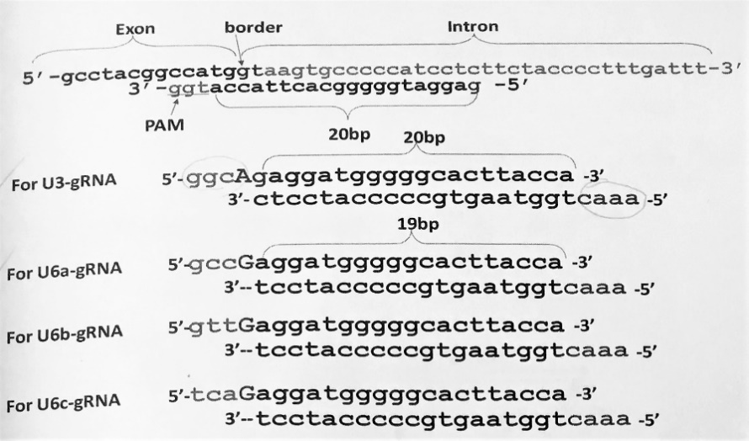
Fig. 1: Visualization of identification of target sequence and structure of primers.

Reagents: Equipment:
2x Mix | 20 µl, 200 µl, and 1,000 µl Pipette Tips
Agarose Powder | 250mL, 1000mL Glass Bottles
B₁ and BL Plasmids | Biosafety Cabinet
BsaI Enzyme | Electrophoresis Tank
Competent Escherichia coli (E. coli) cells | Gel Casting Tray and Well Comb
CutSmart Buffer | Gel Doc Imaging System Software
DNA Marker | Hot Water Bath
DNase/RNase-Free Distilled Water (DdH₂O) | Ice Box
dNTP | Incubator
Ethidium Bromide (EtBr) | Microcentrifuge Tubes
gRNA-R | Microwave
Kna | Mini Centrifuge
KODTAQ Enzyme and KODTAQ Buffer | Parafilm Tape
LB-kanamycin agar plate | Power Supply and Cables
Lysogeny Broth (LB) | Spatula
MT 1 | Sterile Cell Spreader
Primers GF₁ and GR₁ | Thermal (PCR) Cycler
T4 DNA Ligase Enzyme and T4 DNA Ligase Buffer | Transilluminator
TAE (50x) | Vortex
U6a RNA Promoter
U-F
Constructing the Cloning Vector:
- Dilute 2uL Primer GF₁ and 2uL Primer GR₁ with 36uL DdH₂0 and label as Tube 1. Use a pipette to mix the liquids, then use a vortex to spin the liquid to the bottom of tube.
- Place Tube 1 into the PCR cycler to separate the DNA’s double helix:
30 seconds | 90℃
- Dilute 1.5uL BsaI enzyme with 4.5uL DdH₂O and 1.0uL T4 DLig enzyme with 9uL DdH₂O (keep enzymes stored in ice box to maintain temp ~4℃). Mix the diluted enzymes with a pipette and store in an ice box to prevent degradation.
- Mix 5uL DdH₂0, 1uL diluted primer, 1uL U6a promoter, 1uL T4DNA ligase buffer, 1uL diluted BsaI, and 1uL diluted T4D and label as Tube 2.
- Place Tube 2 into the PCR cycler:
5 cycles
5 minutes | 37℃
5 minutes | 20℃
Preserve the product at 12℃.
- Mix 0.5uL DdH₂O, 2uL U6a-gRNA (Tube 2), 1uL U-F, 1uL gRNA-R, 1uL dNTP, 7.5uL KODTAQ buffer, and 1uL KODTAQ enzyme and label as Tube 3. Spin the mixture in the mini centrifuge.
- Place Tube 3 into the PCR cycler:
Preserve the product at 12℃.
10 cycles
20 cycles
1 minute | 95℃
10 seconds | 95℃
15 seconds | 60℃
20 seconds | 68℃
10 seconds | 95℃
15 seconds | 60℃
30 seconds | 68℃
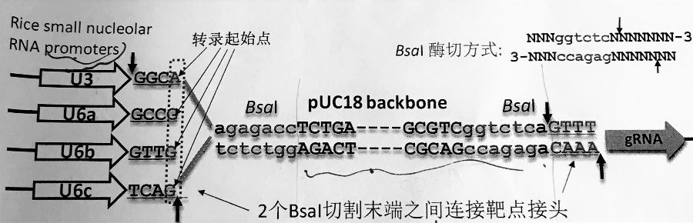
Fig. 2: Construction of mutant gene

- Dilute the 2uL PCR product (Tube 3), the contents of Tube 3, with 78uL of DdH₂O. Use a pipette to mix the liquids, then use a vortex to spin the liquid to the bottom of tube.
- Mix 9uL DdH₂O, 1uL diluted contents of Tube 3, 3uL dNTP, 0.5uL B₁, 0.5uL BL, 15uL KODTAQ buffer, and 1uL KODTAQ enzyme and label as Tube 4. Use a pipette to mix the liquids, then use a vortex to spin the liquid to the bottom of tube.
- Place Tube 4 into the PCR cycler:
25 cycles
10 seconds | 95℃
15 seconds | 60℃
20 seconds | 68℃
Preserve the product at 12℃.
- Once Tube 4 has gone through the PCR process, store the product in a 4℃ fridge and dispose of all tubes used throughout experiment except Tube 3.
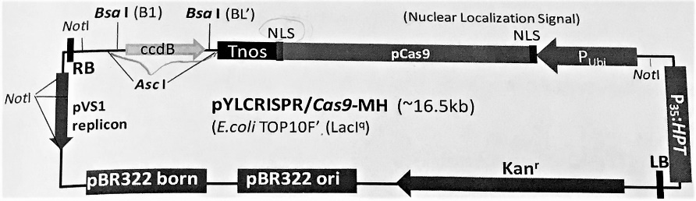
Fig. 3: Initial (Cloning) Vector

Agarose Gel Electrophoresis:
- Dilute 20mL TAE (50x) with 1L of Dd₂O in a 1000mL glass bottle.
- Mix 20mL diluted TAE and 0.3g agarose powder in a 250mL glass bottle.
- Microwave the mixture on medium high heat, swirling the contents every 30 seconds, until the agarose powder is fully melted into the dissolved TAE.
- Carefully remove agarose solution from microwave and let cool to ~50℃.
- Pour the agarose solution into the gel casting tray, insert well comb, and let sit for at least 20 minutes at room temperature to set.
- Place the solid gel into the electrophoresis tank and fill the tank with enough diluted TAE to submerge the gel.
- Add 2uL DNA marker into the first well.
- Mix 2uL PCR product (Tube 4) and 1uL loading buffer with a pipette and add into subsequent wells. Be sure to note which sample is added into which well.
- Run the electrophoresis for 30 minutes at 120V (400 mA).
- Remove the gel from the gel tray once the electrophoresis has finished and place the gel in the EtBr solution to stain it. Be sure not to let any skin or clothing articles come into contact with the EtBr.
- Use the spatula to remove the gel from the ethidium bromide and rinse the gel 3 times under running water.
- Use the Gel Doc Imaging System to visualize the DNA fragments and take a picture.

Constructing the Destination Vector:
- Dilute 1uL BsaI enzyme with 3uL DdH₂O then mix 1uL diluted BsaI, 1.5uL CutSmart Buffer, 1uL MT 1, and 11.5uL DdH₂O and label as Tube 1. Use a pipette to mix the liquids, then use a vortex to spin the liquid to the bottom of tube.
- Place Tube 1 in the PCR cycler:
10 minutes | 37℃
Preserve the product at 12℃
- Dilute 1uL T4DNA Ligase enzyme with 9uL DdH₂O and mix with a pipette.
- Mix all 15uL BsaI solution (Tube 1), 2uL T4DNA Buffer, 1uL diluted T4D, 1uL PCR product (site G), and 1uL DdH₂O and label as Tube 2. Spin the mixture in the mini centrifuge.
- Place Tube 2 in the PCR cycler:
12 cycles
5 minutes | 37℃
5 minutes | 10℃
5 minutes | 20℃
Preserve the product at 16℃
- Add all 20uL Tube 2 into 100uL E. coli. Shake well and place in ice box for 30 minutes.
- Quickly transfer the tube from the ice box into a 42℃ water bath. Heat the solution for 60 seconds then quickly transfer back into the ice box and leave for 2 minutes.
- Transfer the tube to a tray at room temperature in the biosafety cabinet and add 1mL of LB; wrap the tubes in saran wrap to ensure no contamination occurs.
- Place the securely wrapped tubes of bacterial fluid in the refrigerated incubator shaker for 1 hour at 37℃ at 200rpm/min.
- Add 200uL of bacterial fluid product to a LB-kanamycin agar plate and spread it evenly with a sterile cell spreader. Put a lid on the plate and stretch parafilm tape around the circumference. Make 4 total disks following the same instructions.
- Place the agar plates in the incubator at 37℃ overnight.
- Choose 36 single colonies from the agar plates.
- Inoculate each single colony in 15mL LB medium supplemented with 15uL Kna.
- Place the tubes into the 37℃ incubator for at least 6 hours.
- Once the bacterial fluid has completed incubation, mix 1uL bacterial fluid, 5uL 2x mix, 0.2uL F’, 0.2 uL R’, and 3.6uL DdH₂O.
- Place this mixture into the PCR cycler:
5 minutes | 94℃
30 seconds | 94℃
30 seconds | 53℃
45 seconds | 72℃
5 minutes | 72℃
Preserve the product at 12℃
35 cycles
- Using the Agarose Gel Electrophoresis procedure, run the all 36 samples for 30 minutes at 120V and analyze the results.
- Determine the genomic sequence for any positive DNA fragments to confirm the results and to ensure no off-target sites were affected.
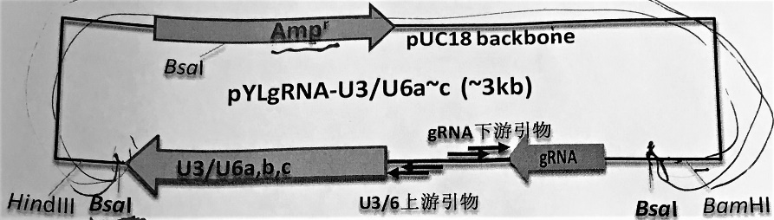
Fig. 4: Destination Vector

Results and Discussion
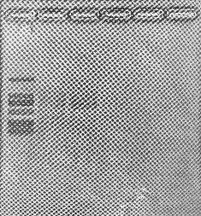
After finding the target location from the first exon of LOX3, Site G, the cloning vector was successfully constructed:
Fig. 5: Agarose gel results of cloning vector. 1st column, DNA Ladder; 2nd column, Failed Site A; 3rd column, successful Site G.

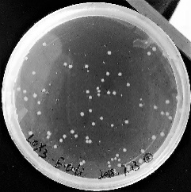
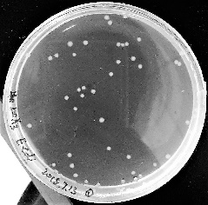
Once it was confirmed that the cloning vector was successful, the destination vector was constructed, and E. coli colonies inoculated with the new vector were cultivated:
Fig. 6: Two LB-kanamycin agar plates with the inoculated E. coli colonies.

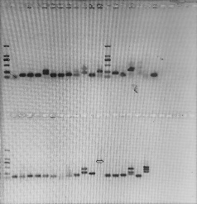
36 single colonies were chosen from the two plates of colonies in Fig. 6 and tested with agarose gel electrophoresis to determine is any successful mutants had been constructed:
Fig. 7: Gel reading of 36 single colonies.

Of the 36 single colonies tested, the 12th sample (column 13) on the bottom row of Fig. 6 showed that the DNA fragment was within reasonable length to be successful. The sample was sent to another lab to be sequenced using the Sanger method, and it was determined from the nucleotide sequence that the LOX3 gene had successfully been knocked out from Oryza sativa using the targeted genome editing technology of CRISPR/Cas-9.

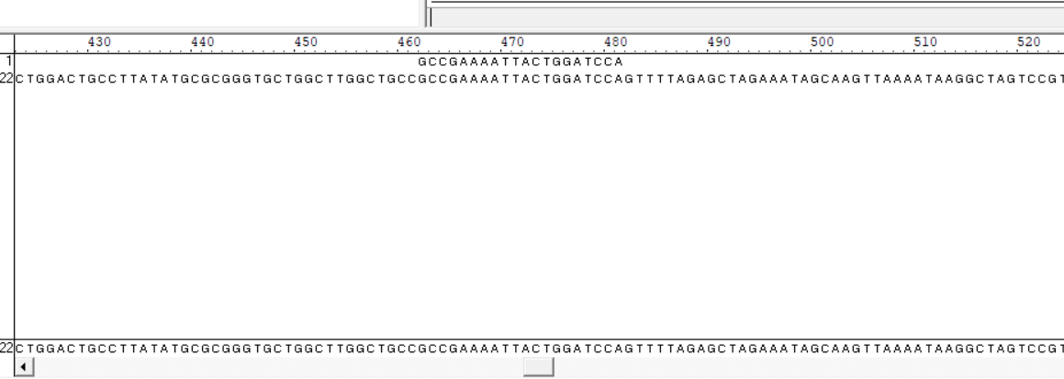
Fig. 8: 1st row, gRNA designed for the experiment; 2nd row, full sequence of DNA, showing successful insertion of gRNA and successful construction of destination vector.

The experiment was successful and a mutant with no altered off-target sites was constructed. The next challenge is to create a new vector with this gene sequence and transmit it into the desired line of rice. The goal is that after planting, the tests conducted on the mutant rice seeds will relay significant improvements in the period of storage and viability, at which point, after development with hybrid rice lines, the LOX3-free rice seeds will be available on the market. Although the work necessary to release LOX3-free seeds on the market has not been accomplished yet, the CRISPR/Cas-9 knockout of the gene is a major step forward.
We are currently faced with the challenge of sustaining a population of over 9 billion people while being responsible stewards of the natural resources available to us. Continued advances in agricultural technology are necessary in ensuring the food security of the millions who are suffer from hunger and malnutrition as well as that of the millions of people to come. As I mentioned, the successful construction of a mutant plasmid without LOX3 marks just a hopeful beginning to a long road of work ahead, but it has tremendous implications on our food storage. Ensuring we have a steady supply of nutritious food is key to fighting hunger and malnutrition, and the period of time we can store the food post-production/harvest is just as important as how much is produced/harvested in the first place. The potential outcome of storing grains of rice, an excellent source of carbohydrates, for an extended time, could be the difference in sustaining even a million more people.
Personal Experience
In the summer of 2018, I embarked on a journey to Changsha, China with a mission: I wanted to return home having changed the world. Instead, I returned home with the world having changed me. I quickly came to the realization that I would not be changing the world in my short 8-week visit, but I didn’t realize how quickly I could be changed. Although, I did not return home with “magic rice” on my list of accomplishments, I did return with the affirmation and the further fueling of my passion to serve this world as a hunger fighter. The opportunity to travel to an international research institute to conduct my own research regarding a topic affecting food insecurity and world hunger as a 17 year-old is unfathomable. As a Borlaug-Ruan Intern, I gained not only professional experience, but also a cultural understanding of a country, a people, and a history that was entirely foreign to me.
I had the opportunity to contribute to a number of different experiments and projects in addition to my own, and my knowledge about hybrid rice, plant breeding and genetics, and laboratory work grew everyday. But perhaps even more significant were the things I learned about people. Even though I had no method of verbal communication with the vast majority of the people I interacted with, I found how powerful a simple smile and laughter are. The emotions we share, an act of kindness, a welcoming attitude… all of these can be understood without a single spoken word. I was blessed to be in a work environment with a team of knowledgeable, talented, enthusiastic researchers, and I was happiest when I was at work in the lab alongside this team of hunger fighters.
My trip did not go without struggle and every hour I was in China was a step further out of my comfort zone, but every hour was so meaningful and special. My 8-weeks as a Borlaug-Ruan Intern will carry a special place in my heart and in who I am for the rest of my life
References
Longping, Y., & Xin, Y. (2015). Oral Autobiography of Yuan Longping (K. Zhao, Ed.; B. Zhao
& K. Zhao, Trans.). United Kingdom: Aurora Publishing.
Long, Q., Zhang, W., Wang, P., Shen, W., Zhou, T., Liu, N., … Wan, J. (2013). Molecular genetic characterization of rice seed lipoxygenase 3 and assessment of its effects on seed longevity. Journal of Plant Biology, 56(4), 232–242. https://doi.org/10.1007/s12374-013-0085-7
Lowder, L. G., Zhang, D., Baltes, N. J., Paul, J. W., Tang, X., Zheng, X., … Qi, Y. (2015). A CRISPR/Cas9 Toolbox for Multiplexed Plant Genome Editing and Transcriptional Regulation. Plant Physiology (Vol. 169). https://doi.org/10.1104/pp.15.00636
LOX3_ARATH. (2018, May 23). Retrieved from https://www.uniprot.org/uniprot/Q9LNR3
Ma, L., Zhu, F., Li, Z., Zhang, J., Li, X., Dong, J., & Wang, T. (2015). TALEN-Based
mutagenesis of lipoxygenase LOX3 enhances the storage tolerance of rice (Oryza sativa) Seeds. PLoS ONE, 10(12), 1–16. https://doi.org/10.1371/journal.pone.0143877
National Hybrid Rice Research and Development Center and Hunan Hybrid Rice Research
Center. (2015, April 27). Retrieved from http://www.hhrrc.ac.cn/PageView.asp?MenuID =1
Quinlan, A. (2016, October 13). From megaTALs to CRISPR: The Many Ways to Edit a Gene.
Retrieved from http://www.bioradiations.com/from-megatals-to-crispr-the-many-ways-to-edit-a-gene/
Shirasawa, K., Takeuchi, Y., Ebitani, T., & Suzuki, Y. (2008). Identification of gene for rice (Oryza sativa) seed lipoxygenase-3 involved in the generation of stale flavor and development of SNP markers for lipoxygenase-3 deficiency. Breeding Science, 58, 169–176. https://doi.org/10.1039/c0cc03288c
US Department of Agriculture. (n.d.). Rice consumption worldwide in 2017/2018, by country (in
1,000 metric tons)*. In Statista - The Statistics Portal. Retrieved October 17, 2018, from https://www.statista.com/statistics/255971/top-countries-based-on-rice-consumption-
2012-2013/
US Department of Agriculture. (n.d.). Total rice consumption worldwide from 2008/2009 to
2017/2018 (in 1,000 metric tons)*. In Statista - The Statistics Portal. Retrieved from https://www.statista.com/statistics/255977/total-global-rice-consumption/.

