Adoption Behavior of Green Production Technologies by Vegetable Growers and Its Influencing Factors
——A Case Study of Changli County and Yongqing County

Cao Yaqing
Shijiazhuang Foreign Language Education Group
E-mail: drongepafture@163.com
August 30, 2025
Supervisor: Cao Lizhe
Adoption Behavior of Green Production Technologies by Vegetable Growers
and Its Influencing Factors
——A Case Study of Changli County and Yongqing County
Hebei Shijiazhuang Foreign Language Education Group, Cao Yaqin

ABSTRACT
With the advancement of the green agriculture development strategy, the adoption behavior of green production technologies by vegetable growers plays a crucial role in achieving sustainable agricultural development. Based on field survey data from 152 vegetable-growing households in Changli County and Yongqing County of Hebei Province, this study systematically analyzes the key factors influencing farmers’ adoption of green production technologies. The research reveals that the adoption rate of organic fertilizer technology stands at only 38.8%. Farmers’ cognition of green technologies, participation in technical training, and the intensity of policy support exert significant positive impacts, whereas the pressure from substitution costs of green technologies, uncertainty of returns, and the difficulty in accessing production information and materials show significant negative effects. The study also finds that the standardization and regulation of agricultural input supply markets, as well as the personalization of technology extension services, play a facilitating role in technology adoption. Based on the empirical findings, it is recommended to enhance farmers’ willingness and capacity to adopt green technologies through a combination of policies, including improving the technology extension system, strengthening fiscal subsidy mechanisms, and establishing market channels for green agricultural products. These measures aim to provide decision-making references for advancing the green transformation of agriculture.
Keywords: agricultural carbon reduction; vegetable growers; green production technology; adoption behavior
I. Introduction

As one of China’s core bases under the national “vegetable basket” program, Hebei Province ranks fourth nationwide in terms of vegetable sowing area and output (Statistical Bulletin on National Economic and Social Development of Hebei Province, 2022). However, according to the 2022 Report on Agricultural Non-Point Source Pollution Control in China released by the Ministry of Agriculture and Rural Affairs, the province’s fertilizer application intensity reached 305.2 kg/hectare, exceeding the national average of 284.6 kg/hectare. Furthermore, data from the 2022 Work Report of Hebei Provincial Department of Agriculture and Rural Affairs indicate pesticide usage in Hebei was 70,200 tons, also surpassing the national average of 65,000 tons per year. Against this backdrop, the present study conducted questionnaire surveys, data collection, and analysis in Changli County and Yongqing County of Hebei Province, carefully selected on the basis of their particularity, representativeness, feasibility, and data quality. The aim is to explore strategies that can achieve the dual goals of environmental protection and stable supply, thereby providing policy suggestions for promoting green agricultural development in Hebei.
(i) Current Research Status at Home and Abroad
In the context of domestic research, scholars have investigated the driving factors behind the adoption of green production technologies from multiple perspectives. Huang Jikun and Wang Xiaobing pointed out that agricultural subsidy policies have significantly increased farmers’ adoption rates of green technologies, although the efficiency of policy implementation is largely affected by local fiscal capacity and the strength of regulatory oversight ^{[1]}. Zhang Lin and Luo Biliang emphasized that government-led technology extension systems need to be integrated with market mechanisms; for example, providing technical training through cooperatives can help reduce farmers’ learning costs ^{[2]}. The study by Xu Yongquan and Liu Guoyong demonstrated that beyond individual characteristics such as age, income, and education level, whether farmers join cooperatives and engage in the learning and practice of new technologies also plays a crucial role in the adoption of these innovations ^{[3]}. In analyses of the impact of social networks and information transmission, Zhao Liange and Cai Shukai found that when farmers obtain technical information through cooperatives or neighbor demonstrations, their probability of adoption is 40% higher than under traditional extension methods, highlighting a significant “trust transmission” effect within social networks ^{[4]}. Regarding the hindering factors of green technology adoption, Qiu Huanguang et al. revealed that farmers’ insufficient awareness of biopesticides has resulted in an actual adoption rate below 35%, with the main reason being the lack of targeted technical training ^{[5]}. Liu Shouying pointed out that small-scale farmers (operating less than 5 mu) are more inclined toward traditional high-input production models due to capital and labor constraints, and the implementation of land transfer policies can partially alleviate this issue ^{[6]}.An imperfect market mechanism is also a critical factor; Huang Zuhui and Qian Fengyan emphasized that the absence of a robust certification system for green agricultural products and the lack of a premium pricing mechanism for high-quality produce have led to farmers’ insufficient long-term incentives to adopt such practices ^{[7]}.
Relevant international studies have primarily explored farmers’ technology adoption from the perspectives of behavioral theories and psychological mechanisms, innovations in extension models, and climate change drivers. The Theory of Planned Behavior (TPB) framework proposed by Ajzen has been widely used to explain farmers’ technology adoption behaviors ^{[8]}. Rezaei et al. found that farmers’ pro-environmental values exert a stronger influence on their decisions to adopt green technologies than pure economic rationality ^{[9]}. Matuschke’s research indicated that farmers in developing countries, due to their weaker risk-bearing capacity, tend to avoid the uncertainties associated with technological changes ^{[10]}. In Europe, the co-construction of technology extension platforms by governments, enterprises, and farmers has significantly boosted technology adoption rates. For instance, under the Netherlands’ “Green Deal Program,” the ecological technology coverage among vegetable growers increased to 78% ^{[11]}. Blockchain technology can enhance transparency along the supply chain, thereby strengthening consumer trust in green agricultural products and indirectly incentivizing farmers to adopt new technologies ^{[12]}. Regarding the impact of climate change, Mbow et al. elaborated that in order to cope with extreme weather events, farmers in Africa have proactively adopted drought-resistant varieties and water-saving technologies ^{[13]}.
(ii) Design of the Questionnaire
To achieve the objectives of this study, a “Questionnaire on Awareness and Adoption of Green Production Technologies” was developed. The basic information section concerning vegetable growers (specifically the primary household cultivators) includes data on age, gender, educational attainment, farming experience, scale of cultivation, land transfer status, and household income. The section on government involvement covers aspects such as subsidies received, satisfaction with support, and expectations for services. The section on organizational participation encompasses cooperative involvement, access to loans, agricultural input supply, and technical training. The section on green production includes items related to the purchase and use of chemical fertilizers and pesticides, various sources of information, environmental awareness, knowledge of green production technologies, as well as willingness and actual behavior regarding the adoption of green production technologies—amounting to a total of 35 items.

II. Current Status of Green Production Among Vegetable Growers in Changli County and Yongqing County

A total of 160 questionnaires were distributed across the two counties, with 155 recovered and 152 deemed valid (52 from Changli and 100 from Yongqing).
(i) Current Situation of Vegetable Cultivation and Green Production Support
As shown in Table 1, 1.individual characteristics such as age and educational level indicate that growers aged 51–60 years and those over 60 together account for 62.5% of the total sample. Regarding education, those with junior high school education and below constitute 82.24% of the total sample. The age distribution of vegetable growers is generally skewed toward older cohorts, and their level of education is relatively low. 2.Regarding the current cultivation situation, an analysis was conducted from three perspectives: years of vegetable cultivation, scale of cultivation, and farming income. The results show that more than half of the growers have 16–30 years of planting experience, indicating that farmers possess a certain degree of cultivation expertise. In terms of scale, those farming less than 4 mu account for 78.2% of the total sample, reflecting a relatively low level of scale operation. Regarding income, 42.1% of the growers have planting income below 50,000 yuan, while 47.4% earn between 60,000 and 100,000 yuan, generally placing them at a medium to lower income level. 3.As for the current status of green technologies and production support, the survey mainly referenced three indicators: technical training, government subsidies, and the establishment of agricultural input supply stations. Regarding technical training, 62.5% of respondents reported having never participated in any training. Concerning government subsidies, 78.3% indicated they had not received any subsidies. In terms of agricultural input supply stations, the proportion responding “yes” was 67.31% in Changli County and 49% in Yongqing County, suggesting a generally modest level of establishment.
In summary, the current situation of green technology and production support can be characterized by insufficient technical training, limited government subsidy intensity, and substantial room for improvement in the establishment of agricultural input supply stations.

Table 1 Individual Characteristics and Current Status of Vegetable Cultivation and Green Production Support
 |  | Changli County |  | Yongqing County
 |  | Number | Share | Number | Share
Age Distribution | Below 40 years old | 5 | 9.62% | 10 | 10%
Age Distribution | 40–50 years old | 16 | 30.77% | 26 | 26%
Age Distribution | 51–60 years old | 27 | 51.92% | 52 | 52%
Age Distribution | Above 60 years old | 4 | 7.69% | 12 | 12%
Educational Attainment | Below primary school | 7 | 13% | 34 | 34%
Educational Attainment | Junior high school | 32 | 62% | 52 | 52%
Educational Attainment | Above high school | 13 | 25% | 14 | 14%
Years of Cultivation | Less than 5 years | 5 | 9.62% | 7 | 7%
Years of Cultivation | 6–15 years | 16 | 30.77 | 37 | 37%
Years of Cultivation | 16–30 years | 27 | 51.92% | 52 | 52%
Years of Cultivation | More than 30 years | 4 | 7.69% | 4 | 4%
Scale of Cultivation | Less than 4 mu | 43 | 82.69% | 76 | 76%
Scale of Cultivation | 5–6 mu | 9 | 17.31% | 16 | 16%
Scale of Cultivation | More than 6 mu | 0 | 0.00% | 8 | 8%
Planting Income | Below 50,000 yuan | 22 | 42.31% | 42 | 42%
Planting Income | 60,000–100,000 yuan | 27 | 51.92% | 45 | 45%
Planting Income | Above 100,000 yuan | 3 | 5.77% | 13 | 13%
Technical Training | Participated | 20 | 38.46% | 37 | 37%
Technical Training | Not participated | 32 | 61.54% | 63 | 63%
Government Subsidies | Received | 7 | 13.46% | 26 | 26%
Government Subsidies | Not received | 45 | 86.54% | 74 | 74%
Input Supply Stations | Yes | 35 | 67.31% | 49 | 49%
Input Supply Stations | No | 17 | 32.69% | 51 | 51%
(ii) Current Status of Green Awareness
1.Awareness of Pollution
As shown in Figure 1, respondents in both counties demonstrated a relatively high level of awareness regarding environmental pollution. In both counties, 50% or more of the farmers believed that the current production methods have a relatively serious impact on the ecological environment.
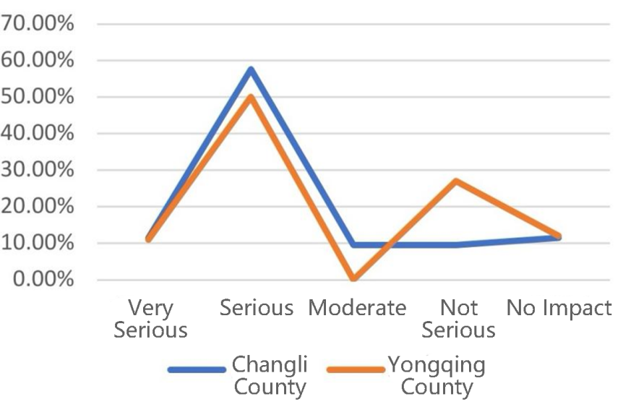
Figure 1 Awareness of Pollution
2. Sources of Information on Green Technologies
As shown in Figure 2, vegetable growers in the two counties primarily obtained information on green technologies through four channels: government extension services, media, relevant enterprises, and other farmers. Since multiple responses were allowed, a comparative analysis was conducted between the frequency of each source and the total sample size. The results indicate that government-led publicity and extension efforts constitute the most prominent source, accounting for nearly 70% of the total sample. This is followed by promotional activities by relevant enterprises, such as those dealing with agricultural inputs and tools, which reached more than half of the respondents. Information shared by other growers or producer groups accounted for approximately 40%. Surprisingly, the proportion of respondents obtaining green technology information through media—including the internet, television, radio, and printed materials—was the lowest, at less than 20%. This finding suggests that farmers still largely acquire green technology information passively, lacking a proactive mindset and initiative in seeking such knowledge.
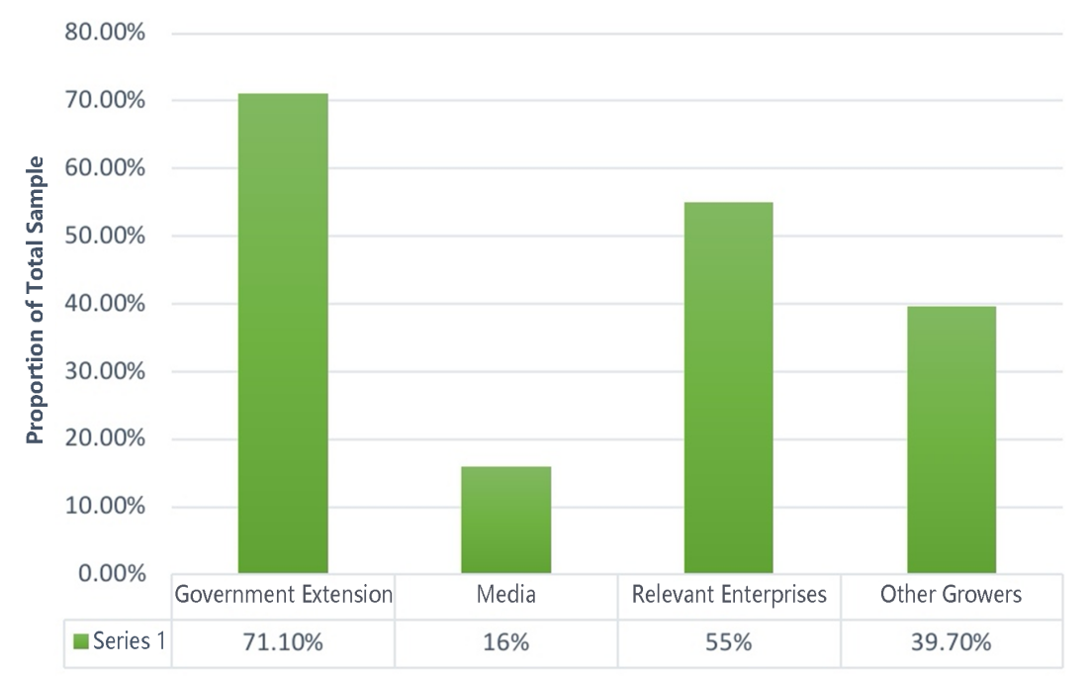
Figure 2. Sources of Information on Green Technologies

III. Vegetable Growers’ Willingness and Behavior in Adopting Green Technologies

This section analyzes vegetable growers’ willingness to adopt and actual behavior regarding two types of green technologies: green organic fertilizers and green pest and disease control technologies.
(i) Willingness and Behavior in Adopting Green Organic Fertilizers
Based on the survey of whether farmers in the two counties are willing to adopt green organic fertilizers and whether they have already implemented such substitution, it was found that the adoption willingness in both counties is relatively high, exceeding 70%. In particular, Changli County exhibited a higher willingness rate than Yongqing County, reaching 80%.
Table 2. Vegetable Growers’ Willingness and Behavior in Adopting Green Organic Fertilizers
 | Changli County |  | Yongqing County
 | Number of Households | Proportion | Number of Households | Proportion
Willing | 42 | 80.77% | 70 | 70.00%
Unwilling | 10 | 19.23% | 30 | 30.00%
Adopted | 18 | 34.62% | 41 | 41.00%
Not Adopted | 34 | 65.38% | 59 | 59.00%

As shown in Table 2, 34.6% of farmers in Changli County had adopted organic fertilizer substitution, compared with 41% in Yongqing County. This indicates that although the willingness to adopt among Changli farmers is significantly higher than in Yongqing County, the actual adoption rate is lower. The discrepancy between willingness and behavior in Changli County may be attributed to limited or one-dimensional understanding of organic fertilizers. As a result, widespread behavioral adoption has yet to emerge. A similar pattern is also observed in Yongqing County. Overall, 38.8% of surveyed farmers had adopted organic fertilizer substitution, while 61.2% had not. This outcome suggests that promoting farmers’ adoption of green production technologies is a complex and systematic undertaking, rather than a matter of mere publicity and education. While continuously enhancing farmers’ awareness of green practices, it is also essential to help them clearly assess the "economic account" of adopting green technologies, the "technical account" of field-level operations, and the "confused account" during the substitution process. Full-process support is necessary to facilitate comprehensive adoption and replacement.
(ii) Willingness and Behavior in Adopting Green Pest and Disease Control Technologies
Pest and disease control is a critical component of vegetable cultivation, and its implementation directly concerns whether the pesticides used are environmentally friendly and whether the techniques are green. As shown in Table 3, the survey results indicate a relatively high willingness to adopt such technologies in both sample counties—94.2% in Changli County and 72% in Yongqing County. The high willingness is closely linked to stringent government enforcement against the production and use of prohibited pesticides, as well as intensified campaigns highlighting the dangers of highly toxic and banned chemicals.
Table 3. Vegetable Growers’ Willingness and Behavior in Adopting Green Pest and Disease Control Technologies
 | Changli County |  | Yongqing County
 | Number of Households | Proportion | Number of Households | Proportion
Willing | 49 | 84.23% | 72 | 72.00%
Unwilling | 3 | 5.77% | 28 | 28.00%
Adopted | 43 | 82.69% | 62 | 62.00%
Not Adopted | 9 | 17.31% | 38 | 38.00%

In Changli County, the adoption rate of green pest control technologies has reached 82.69%, while in Yongqing County, the rate stands at 62%. The willingness to adopt and the actual adoption behavior of green control technologies are generally aligned in both counties. However, analysis of areas where willingness and actual adoption levels are low reveals that one of the primary reasons is the high cost of new green biopesticides. Under standard application protocols, the cost is not only unaffordable for smallholder farmers, but even large-scale vegetable growers operating as new agricultural entities find it financially burdensome.

IV. Analysis of Factors Influencing the Adoption Behavior of Green Production Technologies

Subjective factors influencing the adoption of green production technologies primarily include: skepticism about its effectiveness, fearing potential yield reduction; a stronger reliance on personal farming experience. Objective factors mainly include: high cost of technology adoption; lack of awareness of green production technologies; lack of promotion of green production technologies.
As shown in Table 4, in the cases of adopting organic fertilizers and low-toxicity biopesticides, 44.09% of farmers cited "concerns about poor effectiveness" as a subjective reason for not adopting organic fertilizers, and 36.17% cited the same concern for biopesticides. Among the objective reasons, "high cost of technology adoption" was cited by 49.46% for organic fertilizers and 42.55% for biopesticides.

Table 4. Factors Influencing the Adoption Behavior of Green Production Technologies
 |  | Organic Fertilizer | Percentage | Biopesticides | Percentage
Subjective Factors | Concern about poor effectiveness | 41 | 44.09% | 17 | 36.17%
 | Trust in personal experience | 10 | 10.75% | 15 | 31.91%
 | High adoption cost | 46 | 49.46% | 20 | 42.55%
Objective Factors | Unaware of the technology | 29 | 31.18% | 13 | 27.66%
 | Lack of active promotion | 26 | 27.96% | 7 | 14.89%

It can be seen that the primary obstacle to farmers’ adoption of green production technologies lies in the significant disadvantage of their high cost. Price is one of the most critical reference points for farmers when deciding whether to adopt green production technologies and often plays a decisive role. “How much does it cost?” is consistently the first question raised by farmers during technology promotion. The higher the upfront investment, the greater the risk borne by small-scale vegetable growers, resulting in a lower likelihood of adoption behavior ^{[14]}. For small-scale growers, even with government subsidies, if the expected return on production is not realized—and if adoption requires substantial time and financial input—there is a high probability that even those who initially adopted green production technologies will eventually abandon their use.
Secondly, the perceived effectiveness of the new technology plays a crucial role. The adoption outcomes experienced by vegetable growers who have already implemented green technologies significantly influence those who have not yet adopted them. The latter often base their decisions on observation; if they perceive the adoption outcomes to be unsatisfactory, they are likely to reject the technology. For vegetable growers who have previously adopted green production technologies, their personal experience with the technology strongly affects the degree of continued adoption. When growers perceive that the effectiveness of the green technology is poor, subsequent adoption behavior is unlikely to occur ^{[15]}.
Thirdly, a lack of active technology promotion is another key factor. In both the cases of organic fertilizers and biopesticides, approximately 30% of farmers reported that they had never heard of them. The absence of proactive promotion leads to farmers being unaware of the available green technologies or how to properly apply them, indicating shortcomings in technology extension efforts. Relevant government departments, organic fertilizer suppliers, cooperatives, and other actors serve as the main bodies for promoting and disseminating technologies. However, due to various constraints, their efforts often fall short of achieving their intended promotional goals. The quality of extension services has a significant impact on encouraging vegetable growers to adopt green production technologies ^{[16]}. The quality assurance of extension services is generally achieved through three main approaches: First, understanding personalized needs to enhance the applicability of technologies. Both organic fertilizers and green pest control measures require case-specific approaches; that is, fertilization or pesticide application plans must be tailored to local conditions. This customization meets farmers’ individualized demands for green production technologies and promotes their adoption; Second, creating favorable material conditions. The degree of standardization and regulation in agricultural input markets largely determines the time and information costs vegetable growers incur when selecting and purchasing organic fertilizers or biopesticides. If low-quality organic fertilizers or biopesticides are purchased or applied, the effectiveness of green production technologies will inevitably be compromised, which in turn affects growers’ adoption decisions ^{[17]}. Third, improving the accessibility of technical services and establishing platforms for sharing technical information. The effectiveness of technical services plays a critical role in both the adoption and subsequent performance of green production technologies. When relevant services are readily accessible, they can significantly enhance the correct application of green technologies and ensure that their ecological and economic benefits are fully realized.

V. Conclusions and Policy Recommendations

(i) Conclusions
There exists a significant deviation between the willingness and actual behavior of adopting green production technologies among vegetable growers in Changli County and Yongqing County. Specifically, actual adoption behavior lags considerably behind adoption intention. The primary reasons include the high cost associated with adopting green production technologies; unclear or uncertain economic returns; insufficient promotion efforts; lack of detailed, sustained, and personalized extension services; low levels of standardization and regulation in the agricultural input supply market, where counterfeit and substandard products are mixed with genuine ones and illegally sold; limited and weak channels for accessing technical information, making it difficult for farmers to obtain necessary knowledge; inadequate government-led training programs; and insufficient financial subsidies.
(ii) Policy Recommendations
1.Technological advancement. The government should strongly support the upgrading and research and development of green products, aiming to reduce costs and increase efficiency. Enhancing the market competitiveness of green production technologies and products is fundamental.
2.Government support. Increase the intensity of fiscal subsidies in the adoption phase of green technologies; Provide comprehensive and convenient services, including technical training, guidance, assistance linkages, streamlined administrative procedures, and green product certification; Strengthen training for various types of market service providers to improve their capacity for delivering market-based services^{[18]}; Enhancing the precision and scope of technology extension, and increasing the frequency of promotion. Efforts should be made to ensure comprehensive awareness and detailed understanding of green production technologies by every individual and household, leaving no blind spots. It is essential to strengthen the identification of the characteristics of vegetable growers, ensuring accurate recognition of the diverse traits among different groups. This enables the implementation of tailored extension strategies, thereby improving the targeting and effectiveness of extension policies ^{[19][20]}; Exemplars should be established by cultivating local technical leaders. In newly developed areas, pilot plots and demonstration households should be set up to exert a catalytic and exemplary effect.
3.Social support dimension. Efforts should be directed toward reducing the individual cost for farmers to adopt new technologies. A unified green input procurement system led by cooperatives and agricultural supply stations should be developed to ensure better quality inputs at more competitive prices; An "enterprise + farmer" contract-based production model should be established to effectively secure marketing channels for farmers.
4.Market dimension. Emphasis should be placed on the development of market standardization. By leveraging the industry–academia integration mechanism, collaboration between farmers and researchers from academic institutions should be promoted to jointly improve and popularize high-quality varieties across the county; Local agricultural product brands should be developed to enhance market competitiveness. A brand strategy that reflects local characteristics should be implemented, along with the cultivation of dedicated teams specialized in brand operation and management. This will help to enhance brand recognition, solidify brand value, and ensure long-term sustainability.
5.Financial support. The government should first increase investment in both technology and financial resources. Additionally, it should actively create favorable conditions and formulate policies to broaden and encourage diversified funding sources. Strengthening the management of financial resources is also crucial to ensure proper allocation and utilization. By leveraging external resources to stimulate internal development ("using borrowed resources to incubate local assets"), the local green vegetable production industry can be effectively promoted and rapidly expanded.

References

- Huang Jikun, Wang Xiaobing. Influencing Factors of Agricultural Technology Adoption: Policies, Resource Endowments and Farmer Behavior [J]. Chinese Rural Economy, 2019(5): 2–18.
- Zhang Lin, Luo Biliang. Government and Market in Agricultural Technology Extension: Mechanism Design and Policy Choice [J]. China Rural Survey, 2013(5): 40–52.
- Xu Yongquan, Liu Guoyong. A Study on Farmers’ Adoption Behavior of New Varieties and Technologies and Its Influencing Factors—Taking Grain Farmers in Shicun Village, Wutai County as an Example [J]. Modern Agricultural Science and Technology, 2015(01): 304–305, 307.
- Zhao Liange, Cai Shukai. Social Networks, Information Access, and the Efficiency of Farmers’ Technology Adoption [J]. Chinese Rural Economy, 2014(11): 56–70.
- Qiu Huanguang, et al. A Study on Farmers’ Awareness and Willingness to Pay for Biopesticides [J]. Chinese Rural Economy, 2012(7): 58–71.
- Liu Shouying, Xiong Xuefeng. The Transformation of Agricultural Management Patterns and Policy Choices in China [J]. Management World, 2018, 34(7): 98–108.
- Huang Zuhui, Qian Fengyan. An Analysis of Influencing Factors on Farmers’ Green Production Behavior—Based on Survey Data from Zhejiang Province [J]. Chinese Rural Economy, 2014(2): 59–71.
- Ajzen, I. The Theory of Planned Behavior [J]. Organizational Behavior and Human Decision Processes, 1991, 50(2): 179–211.
- Rezaei, R., et al. Drivers of Farmers’ Intention to Adopt Integrated Pest Management [J]. Journal of Cleaner Production, 2019, 228: 1232–1240.
- Matuschke, I., Qaim, M. Adoption and Impact of Natural Resource Management Technology: The Case of Rainwater Harvesting in India [J]. Ecological Economics, 2008, 64(2): 198–207.
- Wesseler, J., Smart, R. D. The Role of Public-Private Partnerships in Promoting Sustainable Agriculture: Lessons from the Netherlands [J]. Food Policy, 2021, 105: 102168.
- FAO. Digital Agriculture Report: Harnessing Digital Technologies [R]. Rome: FAO, 2022.
- Mbow, C., et al. Climate-Resilient Agriculture in Africa [J]. Nature Climate Change, 2019, 9(9): 622–628.
- Xu Xiaohua. A Study on the Behavior of Tea Farmers Adopting Green Production Technologies under the Background of Green Development [D]. Fujian Agriculture and Forestry University, 2020.
- Yu Weizhen. A Study on Initial and Continuous Adoption Behavior of Green Production Technologies among Rice Farmers [D]. Huazhong Agricultural University, 2020.
- Tong Rui, Wang Yongqiang. Has the Certification of Agricultural Product Bases Promoted Safe Pesticide Use Among Farmers?—Empirical Evidence from Apple Growers in Shaanxi Province [J]. Ecological Economy, 2019, 35(11): 112–116.
- Du Weiyan. Vegetable Growers’ Willingness to Pay for Replacing Chemical Fertilizers with Organic Fertilizers and Its Influencing Factors [D]. Chinese Academy of Agricultural Sciences, 2020.
- Wu Xuelian, Zhang Junbiao, Feng Junhui. Influencing Factors of Farmers’ Cognition of Green Agricultural Technologies and the Decomposition of Their Hierarchical Structure—Based on the Probit-ISM Model [J]. Journal of Huazhong Agricultural University (Social Sciences Edition), 2017(05): 36–45+145.
- Yang Zhihai. Aging, Social Networks, and Farmers’ Adoption Behavior of Green Production Technologies—Evidence from Household Data in Six Provinces Along the Yangtze River Basin [J]. China Rural Survey, 2018(04): 44–58.
- He Lijuan, Tong Rui, Wang Yongqiang. The Impact of Social Network Heterogeneity on Fruit Farmers’ Adoption of Organic Fertilizer Substitution Models [J]. Resources and Environment in the Yangtze Basin, 2021, 30(01): 225–233.

