An Analysis of the Entrepreneurial Behavior Process of Farmers in Hebei Province
——A Case Study of Gaocheng District, Shijiazhuang

Cao Yafei
Shijiazhuang Foreign Language School
- mail: DelikePoatisti@163.com
August 30, 2025
Supervisor: Cao Lizhe

An Analysis of the Entrepreneurial Behavior Process of Farmers in Hebei Province
——A Case Study of Gaocheng District, Shijiazhuang
Shijiazhuang Foreign Language School, Hebei Province，Cao Yafei

ABSTRACT
Against the backdrop of the rural revitalization strategy, the entrepreneurial behavior of farmers in Hebei Province has emerged as a critical driving force in the transformation of rural economies. This study, based on field research and data analysis of farmer entrepreneurship cases in Hebei, systematically explores the process characteristics, influencing factors, and practical dilemmas of rural entrepreneurship. The findings indicate that: (1) The majority of entrepreneurial actors are middle-aged males, primarily engaged in crop cultivation and integrated farming-related industries; (2) The entrepreneurial process follows a phased trajectory of “spontaneous exploration—learning and opportunity recognition—resource integration—gradual development,” driven by a combination of personal experience, family support, policy environment, and market opportunities; (3) Farmer entrepreneurship faces several challenges, including limited sources of funding, asymmetric access to technology and information, low profitability, and weak risk resistance. The constraints imposed by the conflict between traditional agricultural mindsets and modern business concepts are particularly pronounced. This study proposes a set of recommendations to optimize entrepreneurship support policies, including improving rural financial services, strengthening entrepreneurial skills training, enhancing infrastructure and support systems, and deepening household registration reform. These suggestions aim to stimulate entrepreneurial vitality among farmers and provide theoretical references for promoting high-quality rural economic development in Hebei Province.
Keywords: farmer entrepreneurship; behavioral process; rural revitalization; rural economy

I. Introduction

The Ministry of Agriculture and Rural Affairs' 14th Five-Year Plan for National Agricultural and Rural Science and Technology Development explicitly states the goal of cultivating one million high-quality farmers with demonstrative and leading capacities by 2025. According to the Annual Report on China Rural Revitalization (2021), the growth rate of farmer entrepreneurship in Hebei Province is approximately in line with the national average (10%–15%). However, in terms of entrepreneurial success rates, the 2022 National Report on Rural Entrepreneurship and Innovation published by the Ministry of Agriculture and Rural Affairs indicates that the three-year survival rate of farmer-run enterprises nationwide is only about 45%. In central and southern Hebei, this figure is even lower due to resource constraints. Gaocheng District, located in the south-central region of Hebei Province, has in recent years capitalized on the Beijing-Tianjin-Hebei coordinated development strategy to foster the emergence of new industries such as agricultural industrialization, specialized handicrafts (e.g., palace noodles and palace lanterns), and rural tourism. Nevertheless, entrepreneurial behavior among local farmers exhibits a dual characteristic: strong policy dependence and weak market adaptability. This calls for a systematic investigation into the internal mechanisms and optimization pathways of farmer entrepreneurship. Using Gaocheng as a case study, this research analyzes the entrepreneurial process and behavioral patterns of farmers, aiming to address the challenge of effectively integrating smallholder farming with modern agriculture. This has practical significance for informing decision-making on optimizing the rural revitalization talent supply system.
Both domestic and international scholars have explored this issue from various perspectives. In China, research has largely focused on the interactive mechanisms between rural revitalization and farmer entrepreneurship. Huang Jikun and others have pointed out that policies such as land transfer systems and financial support significantly enhance farmers' entrepreneurial willingness ^{[1]}. Regarding demographic shifts, Liu Shouying emphasized that rural aging has pressured a transformation in agricultural production methods, with entrepreneurship among the remaining rural population becoming a vital channel for “intergenerational continuity” ^{[2]}. Regarding the locational advantages of leisure agriculture in the areas surrounding Beijing and Tianjin, Liu Yu, Li Guoxiang, and others have proposed that policies should guide farmers in utilizing suburban resources to develop distinctive integrated agri-tourism projects ^{[3]}. In addition, the effectiveness of policies aimed at cultivating new professional farmers has gradually become a focal point of research. Wang Shuguang found that although the “Yanzhao Agricultural Talent Program” in Hebei Province has improved farmers' skill levels, the success rate of entrepreneurial ventures remains constrained by asymmetric market information and inadequate industrial chain support ^{[4]}. Family support serves as a core driving force in farmers’ entrepreneurial activities, while social relationships can effectively compensate when familial support is insufficient ^{[5]}.
International research on farmers’ entrepreneurship began relatively early and has developed a more mature theoretical framework. Developed countries tend to focus on analyzing the driving factors behind agricultural entrepreneurship. Based on Ajzen’s (1991) Theory of Planned Behavior (TPB), Fitz-Koch S et al. (2018), in the Journal of Rural Studies, constructed a model of farmers’ entrepreneurial intentions. Their study revealed that subjective norms (e.g., community support) and perceived behavioral control (e.g., policy resources) are key factors influencing entrepreneurial decision-making ^{[6]}. In countries with a high degree of agricultural modernization, such as the Netherlands and the United States, studies have shown that digital technologies significantly reduce entrepreneurial risk for farmers. Farmers can more precisely manage resources such as irrigation and fertilization, thereby reducing production costs and mitigating risks associated with climate uncertainty. Digital tools also facilitate access to high-end markets and enhance farmers’ bargaining power. Furthermore, cloud platforms and mobile applications enable smallholder farmers to obtain professional agricultural services (e.g., pest and disease diagnostics) at relatively low costs, thereby alleviating resource constraints. These factors are particularly critical for new market entrants ^{[7]}. In contrast, research on developing countries tends to focus more on institutional environments and resource constraints. In World Development, scholar Agyapong and others found that rural returnee entrepreneurship among African youth, through the "upgrading of agricultural value chains," has helped mitigate the issue of rural hollowing. However, underdeveloped infrastructure and difficulties in accessing credit remain major obstacles ^{[8]}.

II. Survey on the Current Status of Farmers’ Entrepreneurship in Hebei Province
Based on a comprehensive consideration of both theoretical foundations and the practical circumstances of farmers' entrepreneurship, a questionnaire was designed to investigate issues related to rural entrepreneurship. A stratified sample survey and interview were conducted across all 11 prefecture-level cities in Hebei Province. A total of 549 questionnaires were distributed and collected, achieving a response rate of 100%. Among them, 529 were valid, resulting in an effective response rate of 96.4%.
(i) Number and Characteristics of Farmer Entrepreneurs
The results show that out of the 529 surveyed farmers, 335 are currently engaged in entrepreneurial activities, accounting for 63.3%. These individuals have either expanded their original scale of production and operations, engaged in the research, promotion, and application of new agricultural technologies, provided socialized services such as plowing, planting, and harvesting, initiated specialized farming, breeding, or processing ventures, or developed rural leisure tourism projects. The remaining 194 individuals, representing 36.7%, have not undertaken entrepreneurial activities and continue to engage in agricultural practices using traditional scales and methods.
As shown in Table 1, an analysis of gender, age, political affiliation, and education level reveals that males constitute the majority, accounting for 70.1%, while females make up 29.9%. In terms of age distribution, the largest group falls within the 41–50 age range, while those under 30 represent the smallest proportion. Regarding political affiliation, most entrepreneurial farmers are non-party-affiliated individuals, accounting for 75.1%. In terms of educational attainment, 38.7% have completed junior high school, and 45.4% have completed high school (including vocational, technical, and secondary specialized schools), indicating that the educational background of entrepreneurial farmers is mainly concentrated at the junior and senior high school levels.

Table 1. Number and Characteristics of Farmer Entrepreneurs
Characteristic | Group | Number | Percentage
Entrepreneurial Status | Entrepreneurs | 335 | 63.30%
Entrepreneurial Status | Non-entrepreneurs | 194 | 36.70%
Gender | Male Entrepreneurs | 235 | 70.10%
Gender | Female Entrepreneurs | 100 | 29.90%
Age | Under 30 years | 33 | 9.80%
Age | 30–40 years | 97 | 28.90%
Age | 41–50 years | 105 | 31.40%
Age | Over 50 years | 100 | 29.90%
Educational Attainment | Below Primary School | 19 | 5.70%
Educational Attainment | Junior High School | 130 | 38.70%
Educational Attainment | Senior High School, Vocational Secondary School, Technical School | 152 | 45.40%
Educational Attainment | Junior College | 25 | 7.40%
Educational Attainment | Bachelor’s Degree or Higher | 9 | 2.80%
Political Affiliation | Communist Party Member | 61 | 18.10%
Political Affiliation | Communist Youth League Member | 28 | 6.80%
Political Affiliation | Member of Democratic Parties | 0 | 0.00%
Political Affiliation | General Public (Masses) | 251 | 75.10%
(ii) Content of Farmers’ Entrepreneurial Activities
According to Figure 1, the survey results regarding the content of entrepreneurship show that the majority of respondents engage in crop cultivation, accounting for 65.1%. Very few individuals are solely engaged in animal husbandry. A significant proportion are involved in integrated crop-livestock systems. Additionally, a portion of respondents are engaged in service industries and commercial enterprises, such as fruit picking, leisure tourism, and related sectors.
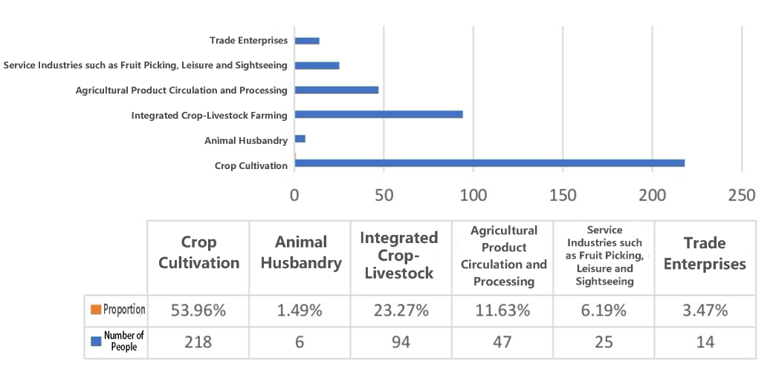
Figure 1. Content of Entrepreneurial Activities
(iii) Scale of Farmers’ Entrepreneurship
As shown in Figure 2, farmers cultivating between 50 to 200 mu constitute the largest proportion, with those cultivating less than 50 mu accounting for a combined 65.83%. Meanwhile, a noteworthy portion of farmers operate on a scale of over 500 mu, indicating that those engaged in crop cultivation possess a certain production capacity. Nonetheless, there remains room for expansion and improvement, and the conditions for doing so are present.
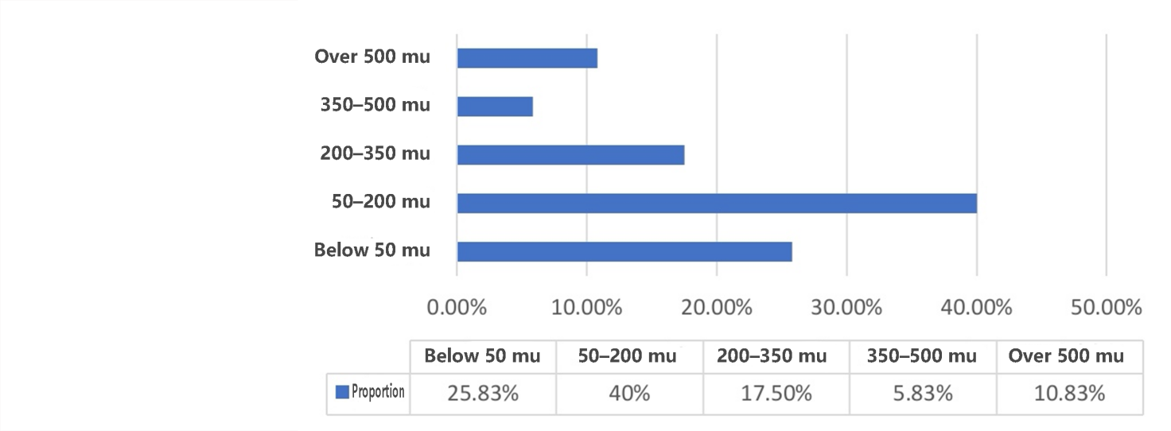
Figure 2. Cultivation Scale
As shown in Figure 3, in terms of livestock scale, most farmers raise fewer than 60 animals, indicating relatively small-scale operations. This is likely due to the fact that very few farmers are exclusively engaged in animal husbandry; most practice integrated crop-livestock operations.
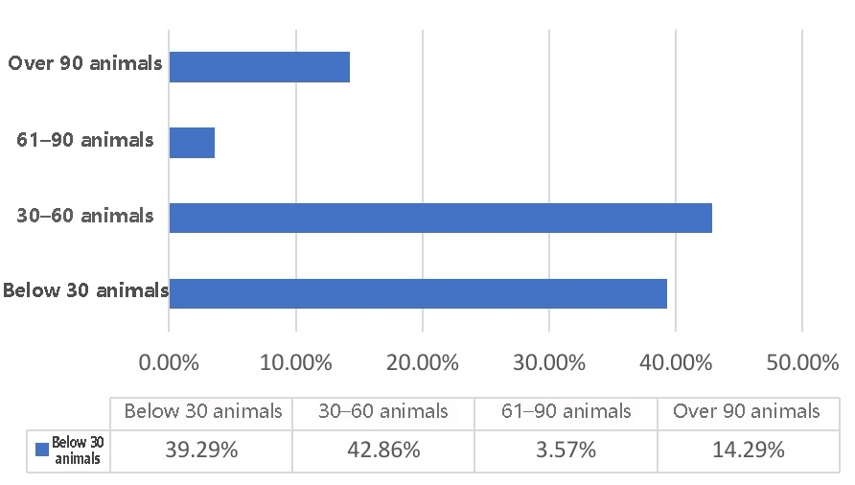
Figure 3. Livestock Farming Scale
(iv) Forms of Farmer Entrepreneurship
As shown in Figure 4, the dominant form of entrepreneurship among farmers remains self-employment, accounting for 78.5%.
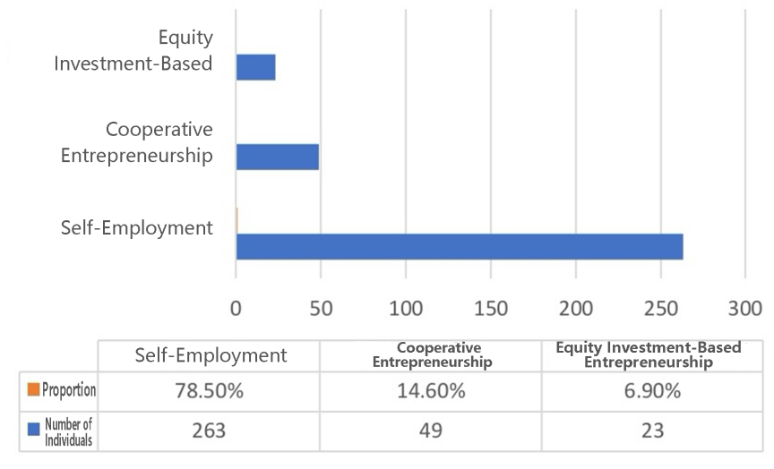
Figure 4. Forms of Entrepreneurship
(v) Sources of Entrepreneurial Capital
According to Figure 5, 60.66% of startup capital comes from household savings, while 18.22% is sourced from loans from relatives and friends. Although the sources of entrepreneurial capital have become more diversified, nearly 80% still originate from household savings and informal borrowing, comprising a total of 78.88%.
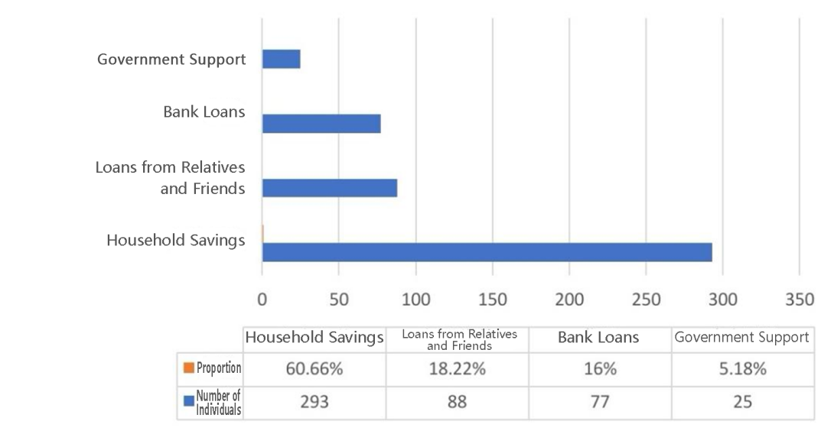
Figure 5. Sources of Capital
(vi) Entrepreneurial Income
As depicted in Figure 6, 48.6% of farmers report a business income of less than RMB 150,000, while 31.9% fall within the RMB 150,000–300,000 range. The vast majority of farmers have entrepreneurial incomes below RMB 300,000, with only a small proportion earning above this threshold.
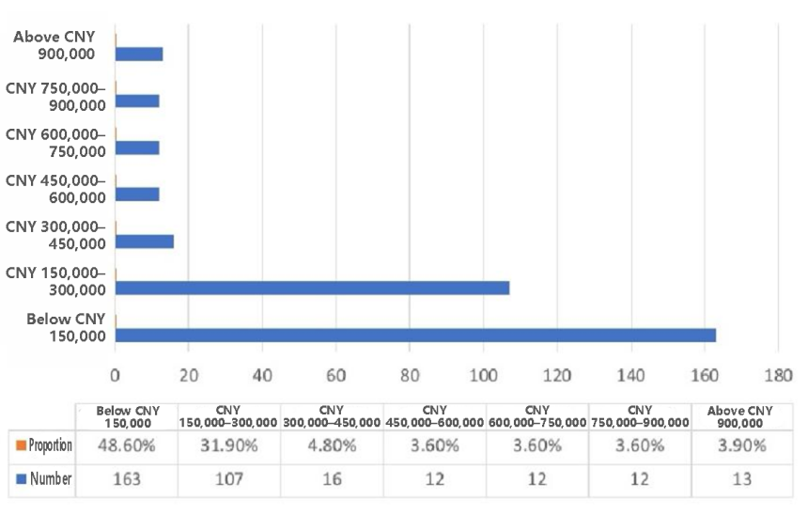
Figure 6. Entrepreneurial Income

An analysis of the current status of farmer entrepreneurship in Hebei Province reveals that nearly 80% of entrepreneurial activities are concentrated in crop cultivation and integrated crop-livestock farming. Entrepreneurial ventures related to agriculture (e.g., planting and breeding) tend to rely heavily on local resources, whereas non-agricultural entrepreneurship (e.g., e-commerce and service industries) is more dependent on external markets and technologies ^{[9]}. Diversifying into non-agricultural entrepreneurship may offer greater potential by leveraging external regional resources and strengthening technical training. Based on the analysis of entrepreneurial forms and sources of funding, it is evident that the vast majority of farmers rely on household savings and self-employment to initiate their entrepreneurial activities. Research has shown that farmers with stronger social networks are more inclined to opt for partnerships or cooperative forms of entrepreneurship, whereas individuals with weaker social capital tend to pursue family-based entrepreneurship ^{[10]}. Moreover, factors influencing the scale of entrepreneurial ventures indicate that social capital significantly promotes the expansion of business scale ^{[11]}. The analysis reveals that farmers’ financial awareness and financial capabilities remain insufficient. Financial literacy plays a critical role in enhancing farmers’ entrepreneurial decision-making. For every one-unit increase in financial literacy, the probability of a farmer engaging in entrepreneurship rises by approximately 5% to 8% ^{[12]}. Farmers’ entrepreneurial income is influenced by both human capital (education and skills training) and social capital (network relationships), with skills training having a more pronounced effect on income from non-agricultural entrepreneurial activities ^{[13]}.

III. Analysis of the Entrepreneurial Behavior Process of Farmers

(i) Research Design

1.Research Method
"Grounded Theory" is a qualitative research methodology proposed by Glaser and Strauss in 1967. Its primary aim is to construct theory inductively from empirical data, building concepts and theoretical frameworks from the ground up based on observed phenomena ^{[14]}. Grounded theory assists researchers in analyzing and mining data, abstracting new concepts from empirical facts, and developing novel theoretical models ^{[15][16]}.
Based on a comprehensive review of relevant literature, the research process for grounded theory is illustrated in Figure 7.
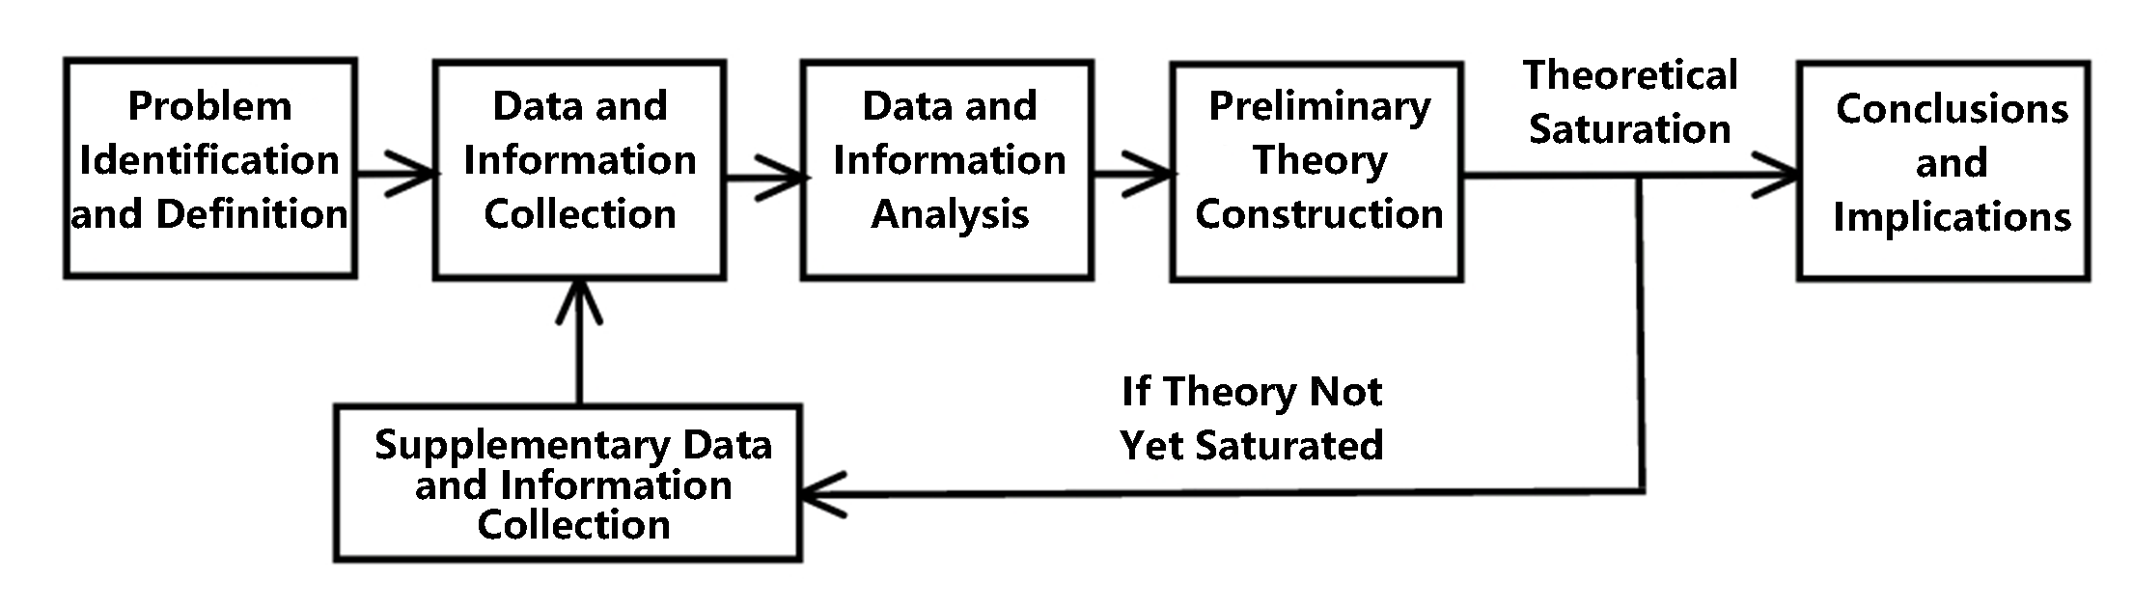
Figure 7. Flowchart of the Grounded Theory Research Methodology
2.Case Selection
In recent years, Hebei Province has attached great importance to farmer education and training. Notably, at the Second National Forum on the Development of Farmer Education and Training, Gaocheng District of Shijiazhuang City received three prestigious awards. Therefore, conducting an in-depth analysis of entrepreneurial cases from Gaocheng District represents an optimal approach to studying the entrepreneurial behavior process of farmers. The criteria for sample selection are as follows: ① The selected cases must involve exemplary farmer entrepreneurs, possessing both typicality and a high degree of representativeness; ② Sufficient data on the selected cases should be available to allow for the excavation of rich entrepreneurial behaviors and to comprehensively reflect the entrepreneurial development trajectory of the individuals involved.
3.Data Collection
Six farmer entrepreneurs from Gaocheng District, Shijiazhuang City, were invited to participate in a discussion forum, with each interview lasting approximately one hour. Following these discussions and exchanges, three entrepreneurs were ultimately selected for in-depth interviews. The interview data, combined with other supplementary materials, constitute the primary research data for the grounded theory analysis. Throughout the research process, multiple sources were employed to gather relevant information about the cases, thereby ensuring the reliability and validity of the study.
(ii) Data Analysis
1.Open Coding
Open coding is an operational process in which collected data are deconstructed, assigned conceptual labels, and then recombined in a new form. This process follows the sequence of “defining phenomena – developing concepts – identifying categories.” As shown in Table 2, the specific steps for open coding of data related to farmer entrepreneurship in this study are as follows: ① Tagging: statements in the data repository potentially related to entrepreneurial behavior are marked with “ax” as identifiers; ② Defining phenomena: simplifying and initially extracting meaning from the “ax” statements; ③ Conceptualization: reclassifying the “ax” statements into concepts, denoted as “Ax”; ④ Categorization: abstracting and grouping related concepts into broader categories. Through open coding, a total of 44 labels, 25 concepts, and 13 categories describing the entrepreneurial behavior of farmers were identified.
Table 2. Open Coding of the Entrepreneurial Behavior Process of Farmers
Tagging (Labeling) | Defining Phenomenon | Conceptualization | Categorization
After graduating from high school in 1997, worked as a driver, ran a retail store, and operated a coal yard. From 2010 to 2013, worked on an underfloor heating project at a construction site under Regiment 106 of the Sixth Agricultural Division of the Xinjiang Production and Construction Corps (a1). After years of hard work, accumulated a certain amount of capital (a2). | a1 Accumulation of entrepreneurial experience outside the hometown a2 Accumulation of startup capital | A1 Accumulation of Entrepreneurial Experience (a1) A2 Acquisition of Financial Resources (a2) | AA1 Integration of Multiple Resources (A1, A2, A6, A11, A18, A19, A20, A23)
In September 2012, I returned to my hometown with the dream of starting a business and years of savings (a3). At that time, the government was promoting land transfer, which I perceived as a business opportunity (a4). I started a rural business by establishing the Fengkede Agricultural Machinery Planting Cooperative in Gaocheng District (a5), leasing over 500 mu of farmland in the village to grow wheat. When I announced my decision to return home and farm, my family strongly opposed it... However, I have always been tenacious and firmly believe that “food is the most essential to the people, and land is the foundation of food.” No matter how big a business is, it should never abandon its roots. After repeated communication, I finally gained my family's understanding and support (a6). At that time, I knew little about agriculture, so I treated it as an investment and hired a professional manager to oversee operations. | a3 Return to hometown with entrepreneurial intent a4 Identification of policy-driven opportunity a5 Establishment of cooperative and start of agricultural operations a6 Persistence and family support acquisition | A3 Return with Entrepreneurial Aspirations (a3) A4 Recognition of Institutional Opportunities (a4, a24, a32） A5 Establishment of Agricultural Business Entity (a5, a13, a25） A6 Perseverance and Support Mobilization (a6) | AA2 Entrepreneurial Passion（A3, A12） AA3 Opportunity Recognition（A4） AA4 Establishment of Enterprise or Organization（A5）
During the wheat harvest season in 2013, due to a lack of planting experience and insufficient preparation, I delayed the harvesting schedule. (a7) As a result, before even one-third of the total area could be harvested, heavy rainfall struck, and over 200 mu of wheat were drenched. The grain quality deteriorated, leading to financial losses for the entire year. (a8) … This incident was a painful lesson. I conducted a thorough analysis of the reasons behind my failure and came to realize that modern agriculture must rely on scientific and technological methods. Only through large-scale operations, mechanization, improved varieties, and advanced technologies can income be increased. (a9) | a7 Lack of experience and inadequate preparation  a8 Encountered setbacks and failures  a9 Reflected on and analyzed the causes of failure | A7 The threat of failure (a7, a8, a16) A8 Proficiency in reflection (a9, a36) | AA5 Effectual Reasoning（A7, A9） AA6 Learning and Reflection（A8, A10, A15）
In September 2013, I acquired an additional 500 mu of farmland through land transfer, expanding the total cultivated area to 1,000 mu. I shifted my strategy to focus on the cultivation of cash crops, including green onions, onions, carrots, and spinach. (a10) I began investing capital, gradually purchasing agricultural machinery, and constructed drying yards and grain storage facilities. (a11) | a10 Shifted mindset and embraced new attempts  a11 Prepared mechanical equipment | A9 Willingness to experiment and accept trial-and-error (a10) | AA7 Development and Application of New Technologies（A13）
In the winter of 2013, I enrolled in the first session of the New-Type Farmer Training Program organized by the District Agricultural Broadcasting School. Through systematic and professional training, (a12) I acquired and mastered a series of specialized skills and management techniques that I previously lacked. Upon completing the training, I registered and established the “Lv Zhi Bao” Family Farm in Gaocheng District, Shijiazhuang. (a13) … In 2015, I participated in several additional training sessions. (a14) Through these learning experiences, I also connected with many peers engaged in crop farming, laying a solid foundation for future development. (a15) | a12 Participated in training programs  a13 Established a family farm  a14 Participated in training programs  a15 Networked with peers and expanded professional connections | A10 Engagement in learning and training (a12, a14)  A11 Embeddedness in social networks (a15, a26)
In 2014, I invested 200,000 yuan to cultivate 100 mu of green onions. Although the crop grew exceptionally well, I was unable to control the market price—by the time of harvest, green onions were selling for only 0.2 yuan per jin. The income from selling the onions wasn’t even enough to cover the wages of the hired laborers. The following day, I had no choice but to crush the entire crop back into the soil. This experience revealed a hard truth: when cultivating cash crops on a large scale, the high costs and labor-intensive nature of the operations render it unfeasible. (a16) | a16 Experienced another failure and recognized previous mistakes
By 2015, I once again adjusted my strategy, shifting to the specialized cultivation of wheat and corn, with an emphasis on enhancing the level of mechanization. I continued to invest in agricultural machinery. (a17) | a17 Developed an awareness of sustainable development | A12 Entrepreneurial passion (a17)
I installed advanced "micro-spray irrigation and fertilization integration" systems across all 1,000 mu of farmland. These scientifically designed irrigation facilities enabled precise water and nutrient delivery tailored to the crops’ different growth stages. The result was significant: water and fertilizer savings, reduced labor input, and increased yield and income. (a18) | a18 Applied new technologies | A13 Development and application of new technologies (a11, a18, a21, a23, a42)
In advance of the planting season, I established direct contact with seed companies. Previously, these companies purchased seeds from scattered smallholders, which made coordination and quality control difficult. I proposed that the enterprise purchase seeds directly from my 1,000 mu of farmland, and we quickly reached a cooperation agreement. Selling foundation seeds yields a premium of 0.1 yuan per jin compared to commodity grain, resulting in over 100 yuan of additional income per mu. (a19) | a19 Broadened horizons | A14 Continuous opportunity exploration (a19) | AA8 Continuous Opportunity Development（A14）
I visited a cooperative in Zhao County for observation and learning, where I saw their fertilizer blending machine. After engaging in discussions to understand its usage, I decided to purchase one for myself. By blending fertilizer independently, I was able to save 300 to 400 yuan per ton. Nearby farmers also came to use the machine, and even after adding a modest margin, my blended fertilizer was still cheaper than what they could purchase elsewhere. (a20) | a20 Demonstrated critical thinking and a willingness to learn | A15 Aptitude for learning (a20, a31)
In 2014, I collaborated with the District Agricultural Technology Center to carry out experiments on different wheat sowing methods and fertilizer applications. This project provided valuable data support for wheat cultivation models and led to the development of two technical solutions. (a21) | a21 Emphasized technological research and development
Whether cultivating wheat or corn, I always secure buyers and sign purchase contracts before planting. As a result, when the corn market experienced a downturn in 2015 and 2016, I was largely unaffected. (a22) | a22 Signed purchase contracts in advance to mitigate risks | A16 Innovation in sales models (a22) | AA9 Innovation（A16, A22）
At present, the farm owns more than 30 units of agricultural machinery, including tractors, combine harvesters, and unmanned plant protection drones. (a23) | a23 Achieved a high degree of mechanization
Since I provide agricultural machinery services that involve government procurement and bidding, and cooperatives are not eligible to participate in such tenders, I registered a company in 2017 to meet the qualification requirements. (a24)(a25) | a24 Identified entrepreneurial opportunities  a25 Registered a company
In 2016, in collaboration with ten local major grain producers and cooperatives, the Qingnonghui Premium Wheat Planting Service Cooperative Union of Gaocheng District, Shijiazhuang City was established (a26). At present, the union manages 21,000 mu of transferred land and operates 11 planting bases... It has signed purchase and sales contracts with multiple companies, thereby encouraging greater farmer participation in contract farming (a27). By leveraging the collective strength of cooperatives, this model allows members to jointly resist market risks (a28), reduce production costs... and achieve significant cost-saving and efficiency gains (a29). | a26 Formed alliances for mutual support  a27 Mobilized local farmers to participate in contract farming  a28 Reduced market risks  a29 Gained bargaining power | A17 Entrepreneurial vision (a27, a30, a38) A18 Joint risk resistance (a28) A19 Collective development to reduce costs (a29) | AA10 Entrepreneurial Vision（A17）
Lvzhibao Family Farm, as a practical training base for the cultivation of new-type professional farmers in Hebei Province, has... trained over 3,000 new-type farmer trainees in recent years (a30). | a30 Trained apprentices as a form of social contribution
A field school was established. Through interactions with trainees, I also continue to learn—mutual learning takes place. Every year brings in a different group of students, and I firmly believe that among them, there must be individuals who are more capable than I am (a31). | a31 Committed to continuous learning and maintained humility
In terms of subsidies, a 30% subsidy is provided for the purchase of agricultural machinery. The rest comes from undertaking projects assigned by the Agriculture Bureau, with funding ranging from 30,000 to 100,000 yuan, aimed at promoting new models and new varieties, thus playing a demonstrative and leading role (a32). | a32 Benefited from agricultural policies and government-funded projects
For each task, I personally spend a day doing it to assess how much a worker can accomplish in a day, determine the highest efficiency, and then reasonably allocate workloads for the workers (a33). | a33 Took a hands-on approach | A20 Acquisition of human resources (a33, a34, a35)
The agricultural machinery operators are all from nearby villages and possess a certain level of work experience. Wages are calculated on a daily basis—300 yuan per day—which is slightly better than in other places. I do not assume the posture of a boss, nor am I overly harsh with them (a34). I maintain a harmonious relationship with the workers; if an employee is short on cash or facing difficulties, they are allowed to receive wage advances. We also regularly organize communal meals in the canteen for everyone (a35). | a34 Provided favorable treatment and generous benefits to employees  a35 Effectively motivated employees
A group of close friends of ours gathers annually—not to discuss where or how much money was made, but to share experiences of failure. The lessons from failure are more important than the stories of success. I share my own failures openly so that when others encounter similar situations, they will not make the same mistakes (a36). | a36 Captured information and avoided others' mistakes
In the beginning, I incurred losses, but I did not give up. I decided to return and farm the land myself, with the sole objective of persisting—persisting until I could at least break even (a37). | a37 Remained resilient in the face of adversity | A21 Strong willpower (a37) | AA11Strong Willpower（A21）
In 2012, I signed a land transfer contract for a period of ten years, with rent fixed at 800 jin of wheat per year, a figure that has remained unchanged. Even when the venture is not profitable, since the land is leased from local villagers, as long as I am able to continue, I will not breach the contract with them (a38). | a38 Demonstrated a strong sense of responsibility
For example, when it comes to irrigation, experts may specify the exact date—such as a particular day in a given month—while local farmers typically rely on traditional cues, saying, “Once you see people burning paper for Qingming Festival, it’s time to irrigate” (relying solely on agricultural calendar customs). However, I need to consider the actual conditions: if irrigation is needed but it rains, then there is no need to irrigate (a39). | a39 Integrated traditional agricultural practices with real-world conditions | A22 Spirit of innovation (a39, a40)
In cultivating crops, I cannot follow the traditional methods of local farmers; I must operate differently. This includes adopting mechanization, intelligent technologies, and managing operations at scale—none of which can be effectively handled through smallholder farming methods (a40). | a40 Showed a spirit of innovation
In March 2017 and again in March 2018, the “First Time” program on CCTV’s Finance Channel reported on our crop protection service operations for two consecutive years. During the 2018 spring “multi-effect spraying” stage for wheat, our advanced technology and well-implemented measures attracted attention from media at various levels… (a41) | a41 Gained public attention and maintained a positive reputation | A23 Gaining social recognition (a41)
In 2018, the farm introduced intelligent agricultural machinery—specifically, the “Beidou Agricultural Navigation Autopilot System”—which enabled intelligent and precision-based management of the production process (a42). | a42 Enhanced the level of mechanization and intelligent technology
Looking ahead, there is a clear strategic plan to further extend the wheat planting industry chain and to develop deep processing of wheat. A trademark—“Lvzhiyang”—has been registered, aiming for the comprehensive development and value enhancement of strong-gluten wheat across the entire industry chain (a43). At the same time, future efforts will focus primarily on developing land trusteeship services, fully utilizing various agricultural machines, reducing idle rates, and providing farmers with comprehensive production services (a44). | a43 Prioritized brand development  a44 Maintained a clear development plan | A24 Emphasis on brand building (a43) A25 Effective allocation of resources (a44) | AA12 Emphasis on Brand Building（A24） AA13 Efficient Resource Allocation（A25）

2. Axial Coding
As illustrated in Figure 8, the task of axial coding is to identify and establish various relationships among the categories. This is typically achieved through the paradigm model of “causal conditions → phenomenon → context → intervening conditions → action/interaction strategies → consequences,” which serves to integrate the categories derived from open coding. Based on this paradigm model, axial coding was conducted on the 13 categories related to farmers’ entrepreneurial behavior.
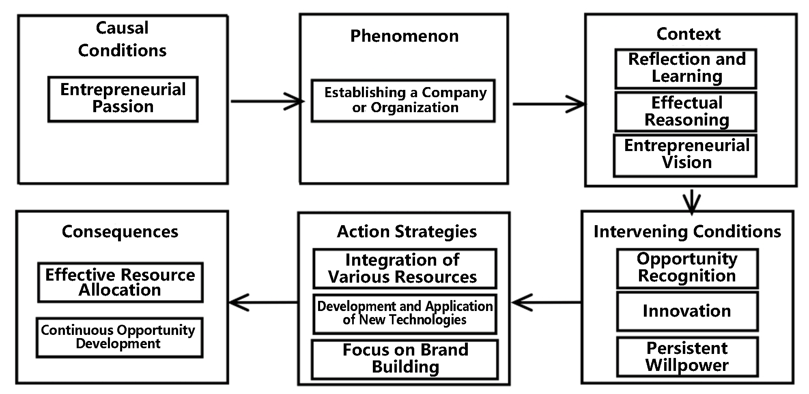

Figure 8. Paradigm Model of the Farmers’ Entrepreneurial Process

3. Selective Coding
Selective coding involves systematically analyzing all the identified conceptual categories and then choosing a “core category.” This core category must repeatedly demonstrate its overarching significance in comparison with other categories, thereby encompassing the majority of research findings within a relatively broad theoretical scope. As shown in Figure 9, through an in-depth analysis of the various categories in conjunction with the original data, it was found that the “farmers’ entrepreneurial process” could be established as the core category governing the other categories. Around this core category, a clear narrative emerges: with the continuous advancement of modern agriculture, various pro-farmer policies have attracted aspiring farmers to return to their hometowns to start businesses. They actively participate in farmer education and training programs, establishing family farms, farmers’ specialized cooperatives, and other organizations or enterprises. During the early stages of entrepreneurship, they encounter setbacks, prompting ongoing reflection and learning. Gradually, they clarify their development direction, accurately identify market opportunities, emphasize the development and application of new technologies and brand building, acquire and effectively integrate the machinery, technology, human resources, and other factors required for efficient organizational operation, thereby achieving stable and healthy organizational growth. To more clearly illustrate the research context, a diagram depicting the relationships among the core categories was drawn, namely the model of the “entrepreneurial behavior process” of farmers.

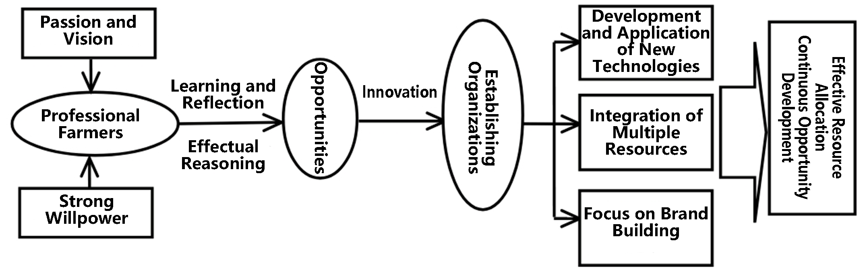
Figure 9. Model of the Entrepreneurial Behavior Process of Farmers

4. Theoretical Saturation Test
After forming the above preliminary conclusions, a test of the saturation of the derived conclusions was conducted. This involved following the logic of “open coding — axial coding — selective coding” to carry out subsequent comparative analyses on the remaining five cases. Through this process, three new categories were identified: “maintaining subsistence,” “emphasis on agricultural product quality,” and “industrial chain extension.” However, upon analyzing the third case, no further new categories emerged. Therefore, it is considered that the category coding and theoretical model obtained in this study have reached the point of theoretical saturation. After revising and integrating the concepts and categories derived from all analyzed case materials, the categorical and conceptual results are presented in Table 3.
Table 3. Revised categories across all cases
No. | Category | Source Explanation | Oriented Set
1 | Entrepreneurial Passion | Integration of the two categories: passion and willpower | Cherishing the dream of returning to the countryside, having a consciousness of sustainable development, and not giving up in the face of adversity
2 | Entrepreneurial Vision |  | Driving more farmers to participate in contract farming, bearing a sense of responsibility, cultivating trainees, and giving back to society;
3 | Learning and Reflection |  | Summarizing and reflecting on the reasons for failures, avoiding others’ mistakes through communication and feedback, participating in farmer education and training multiple times, and going on study visits
4 | Maintaining Subsistence |  | Transitioning to agriculture to seek prosperity after previous industries became unsustainable
5 | Effectual Reasoning |  | Daring to experiment, engaging in continuous trial and error to identify the correct direction
6 | Opportunity Recognition |  | Multiple agricultural policies and projects provided favorable development opportunities; seeking suitable business partners to improve efficiency; establishing companies to gain bidding qualifications
7 | Innovative Activities | Integration of three categories: innovation, new technology development and application, and founding enterprises or organizations | Combining traditional agrarian practices with local realities, innovating marketing channels, developing new service models, advancing new technologies, and establishing farmers’ cooperatives, family farms, and agricultural enterprises
8 | Integration of Diverse Resources |  | Integrating human resources, financial resources, and material resources (infrastructure), etc
9 | Emphasis on Brand Building | Integration of the two categories: emphasis on agricultural product quality and brand building | Developing organic specialty agricultural products, creating agricultural product brands
10 | Industrial Chain Extension | Integration of resource optimization and industrial chain extension | Fully utilizing various types of machinery to provide socialized services, developing agricultural product processing, leisure agriculture, and agritourism
11 | Continuous Opportunity Development |  | Continuously broadening horizons and discovering new opportunities

(iii) Revised Entrepreneurial Behavior Process Model

Through multiple case comparative analyses, the entrepreneurial behavior process model of farmers was ultimately distilled, as shown in Figure 10.

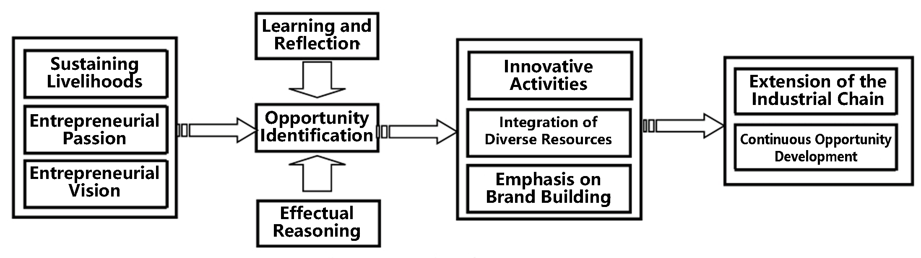

Figure 10. Revised Entrepreneurial Behavior Process Model of Farmers
The entrepreneurial behavior process of farmers can be interpreted as follows: the entrepreneurial motivation of farmers may stem from the fact that the industries they previously engaged in have become unsustainable, prompting them to turn to agriculture as an alternative means of sustaining their livelihoods; or from their desire to transform traditional modes of agricultural production and management to achieve prosperity; or perhaps driven by aspirations to return to their hometowns and pursue entrepreneurial ventures. Under the impetus of entrepreneurial motivations, farmers consciously participate in various forms of farmer education and training to acquire new knowledge. Even when confronted with setbacks due to factors such as lack of experience or market instability, they engage in reflection amidst adversity, thereby identifying opportunities based on effectual reasoning, establishing family farms or enterprises, and continuously discovering opportunities and developing markets. The following section further elucidates the categories involved in the entrepreneurial behavior process model of farmers, as well as the relationships among these categories.
1. Sustaining Livelihoods, Entrepreneurial Passion, and Entrepreneurial Vision. Sustaining livelihoods refers to the scenario in which entrepreneurs find that the industries they previously engaged in have become unsustainable, prompting them to seek alternative avenues for survival by choosing to engage in agricultural entrepreneurship. Entrepreneurial passion encompasses passion, dreams, and willpower. Entrepreneurial vision represents the answer to the question, “What kind of organization do we aspire to become?”
2. Learning and Reflection, Effectual Reasoning. Learning and reflection refer to the entrepreneurs’ examination of failures encountered during the entrepreneurial process, analyzing their causes and summarizing experiences, thereby generating learning effects and altering their own behaviors. Effectual reasoning is a general decision-making theory proposed by Sarasvathy under conditions of high uncertainty and unpredictability inherent in the entrepreneurial environment. It emphasizes proactiveness, contingency, and iterative trial and error, constituting the core mechanism of opportunity creation.
3. Opportunity Identification. Opportunity identification refers to the process in which entrepreneurs gradually develop and identify entrepreneurial opportunities arising from policies and market changes, typically through continuous learning, reflection, and trial and error.
4. Innovative Activities, Integration of Diverse Resources, and Emphasis on Brand Building. Innovation encompasses multiple dimensions, including business concepts, organizational models, marketing approaches, and technological equipment. Integration of diverse resources refers to the process by which entrepreneurs bring together various types of resources they have acquired—such as human resources, financial resources, social resources, and material resources (infrastructure)—leveraging both internal and external forces for comprehensive integration. Emphasis on brand building indicates that entrepreneurs, grounded in regional characteristics and advantageous industries, vigorously develop green and organic agricultural products, shifting from a focus on increasing output to improving quality and efficiency, with the goal of cultivating brands for high-quality green agricultural products.
5. Extension of the Industrial Chain and Continuous Opportunity Development. This refers to entrepreneurs’ ability to fully utilize existing human and material resources (such as agricultural equipment and facilities) to carry out socialized services, develop agricultural product processing, leisure agriculture, and agritourism, thereby continuously extending the industrial chain, identifying new opportunities, and opening up new markets.

IV. Strategies to Promote Farmers’ Entrepreneurship in Hebei Province

(i) Promoting Shifts in Mindset
Efforts should be made to strengthen professional awareness among women, enabling them to achieve greater success in their entrepreneurial pursuits. In addition, the government ought to emphasize the publicity of exemplary entrepreneurial farmers to enhance the influence of farmer entrepreneurship, thereby fostering a social environment that attaches greater importance to farmers' entrepreneurial endeavors and cultivating a robust atmosphere conducive to farmers’ innovation and entrepreneurship.
(ii) Improving the Entrepreneurial Environment
1.Establish and improve systems for vocational education and training for farmers. Training, certification, and management should be carried out at multiple levels according to the individual characteristics of trainees; targeted entrepreneurial coaching should be provided to new-type farmers; agricultural enterprises, agricultural parks, and other social forces should be actively engaged in training initiatives; vigorous promotion of approaches such as “training delivered to villages,” “cloud-interactive training platforms,” and “farmers’ night schools” should be undertaken to facilitate the sharing of quality training resources. Furthermore, the government should coordinate special funds dedicated to farmers’ education and training. These measures aim to create a favorable environment in which farmers are willing and find it easy to participate in education and training.
2.Improve infrastructure and supporting conditions, and guide the rational allocation of factor resources. This involves deepening comprehensive rural environmental management, enhancing rural infrastructure such as roads, drainage, and power supply, strengthening the construction of farmland water conservancy projects, and promoting water-saving irrigation technologies; Increase the level of agricultural mechanization; strengthen the development of various entrepreneurial platforms such as rural innovation and entrepreneurship incubation and training bases and farmer entrepreneurship parks; coordinate the spatial layout of functions including production, R&D, processing, logistics, and services to provide convenient and low-cost entrepreneurial services, thereby enabling more farmers to engage in specialized, standardized, and intensive production.
3.Intensify financial and fiscal support. Broaden the scope and channels of financing available to farmers to mitigate entrepreneurial risks arising from capital constraints; expand the adoption of service models such as rewards in place of subsidies, post-construction subsidies, and government procurement. For farmers undertaking entrepreneurship for the first time and operating in a standardized manner for over one year, a one-time start-up subsidy may be granted. Additionally, guide certain financial institutions to increase efforts in developing loan products tailored to farmers’ entrepreneurial needs.
4.Improve government support policies and build a comprehensive service system. Efforts should align with local resource endowments and industrial advantages to establish corresponding service platforms; promote brand development through initiatives such as “one specialty product per county, one dominant industry per township”; fully provide services including information consulting, administrative approvals, and legal protection; vigorously advance the integration of “Internet + farmers’ entrepreneurship,” facilitate the practical application of agricultural remote sensing and Internet of Things (IoT) technologies in agricultural production; and implement the “e-commerce into rural areas” initiative to enhance entrepreneurial returns.
(iii) Optimizing the Entrepreneurial System
Advance reforms of the land transfer system. Unblock channels for land transfer and encourage farmers to make full use of their land through diverse forms such as transfers, custodial management, exchanges, equity participation, substitute farming, and leasing. Establish land transfer service platforms to effectively supervise land transfer methods and procedures. Encourage farmers to leverage their own or idle farmhouses and courtyards to run agritainment businesses; promote the development of emerging industries and new business models such as rural fruit-picking and agritourism. Deepen household registration (hukou) system reforms to break down barriers between urban and rural areas, enabling free mobility of rural labor and equal access to development opportunities.
(iv) Enhancing Family Resource Empowerment
Family support for farmers’ entrepreneurial endeavors, both economically and emotionally, exerts a substantial driving force. Fully showcasing the entrepreneurial achievements of representative farmers who operate on a “household” basis can significantly motivate and inspire more farmers to embark on entrepreneurial ventures.
(v) Leveraging Other Forms of Social Capital
While capitalizing on existing family capital and geographical capital, it is also essential to actively engage in social organizations, industry gatherings, and other networking activities to expand new forms of social capital. This enables the acquisition of funding, information, emotional support, and entrepreneurial partners. Furthermore, by aligning the type of social capital selected with the identified attributes of entrepreneurial opportunities, farmers can precisely seize entrepreneurial timing and effectively realize the value of these opportunities.
The promotion of farmers’ entrepreneurship in Hebei Province constitutes a vital component of rural revitalization and agricultural modernization in the region. Grounded in the local context, this study analyzed the influence mechanisms of key factors such as policy support, resource integration, skills training, and the financial environment on entrepreneurial behavior. The results indicate that to further stimulate and advance entrepreneurship, it is imperative to strengthen policy precision, deepen industry-education integration to attract younger talent, broaden financing channels, and leverage digital network technologies to empower agricultural innovation. Construct a synergistic development model characterized by “government guidance — market-driven forces — farmer-centered” . By continuously stimulating the endogenous motivation of farmers, this approach will facilitate the enhancement of quality and efficiency in Hebei’s agriculture, thereby injecting momentum into the sustainable development of rural areas.

References
- Huang Jikun, Liu Ying, Wang Xiaobing. Policy effects of farmers’ entrepreneurship under the background of rural revitalization [J]. Chinese Rural Economy, 2019(5): 2-18.
- Liu Shouying, Xiong Xuefeng. The evolution of China’s agricultural business models and policy choices [J]. Management World, 2020, 36(7): 98-108.
- Liu Yu, Li Guoxiang, Chen Yangfen. Location advantages and path selection of leisure agriculture development in the areas surrounding Beijing and Tianjin [J]. Journal of China Agricultural Resources and Regional Planning, 2020, 41(4): 12-20.
- Wang Shuguang, Li Bingbing. Policy performance evaluation of new-type professional farmer cultivation: An empirical analysis based on Hebei Province [J]. Journal of Agrotechnical Economics, 2023(2): 45-59.
- Dong Jing, Zhao Ce. The impact of family support on farmers’ entrepreneurial motivation: Also on the substitutive role of personal connections [J]. Chinese Journal of Population Science, 2019(01): 61-75, 127.
- Fitz-Koch S., et al. Entrepreneurship in the agricultural sector: A literature review[J]. Journal of Rural Studies, 2018, 61: 237-247.
- Wolfert S. et al. (2017)：Big Data in Smart Farming – A Review, Agricultural Systems 153: 69-80.
- Agyapong D., et al. Youth agripreneurship in Africa: Challenges and opportunities[J]. World Development, 2020, 126: 104693.
- Zhang Yingliang, Wang Chunchao. Farmers’ entrepreneurial choices: Agriculture or non-agriculture? [J]. China Economic Quarterly, 2017, 16(03): 1021-1044.
- Kong Rong, Wang Yajun. Social networks and farmers’ choice of entrepreneurial forms [J]. Journal of Northwest A&F University (Social Science Edition), 2018, 18(05): 110-118.
- Guo Hongdong, Zhou Huijun. Prior experience, social capital, and the growth of farmers’ entrepreneurial enterprises [J]. Issues in Agricultural Economy, 2013(05): 65-70.
- Su Lanlan, Kong Rong. Financial literacy, entrepreneurship training, and farmers’ entrepreneurial decision-making [J]. Journal of South China Agricultural University (Social Science Edition), 2019, 18(03): 53-66.
- Ma Jiujie, Li Xin. A study on the influencing factors of farmers’ entrepreneurial income: From the perspective of human capital and social capital [J]. China Rural Survey, 2020(03): 56-70.
- Chen Xiangming. The ideas and methods of grounded theory [J]. Educational Research and Experiment, 1999(04): 58-63+73.
- Liu Meiyu. A study on the entrepreneurial mechanism of the new generation of migrant workers based on grounded theory [J]. Issues in Agricultural Economy, 2013, 34(03): 63-68+111.
- Su Yufeng, Wu Nengquan, et al. An institutional perspective entrepreneurial process model: A multi-case study based on grounded theory [J]. Nankai Business Review, 2017, 20(01): 181-192.

