Aanya Tripathi
John F. Kennedy High School
Cedar Rapids, IA, USA
Vietnam, Sustainable Agriculture
March 31, 2025
The Mekong River Delta: Balancing Growth and Sustainability for the Future of Agriculture

Stretching across six nations with a length of approximately five thousand kilometers, the Mekong River is one of the most important waterways in Southeast Asia. Traditionally known as the “Sông Cửu Long” in Vietnamese, the “Nine Dragons River” symbolizes the network of smaller rivers, canals, and streams that run through settlements in southern Vietnam, creating the Mekong River Delta, also known as the “Rice Bowl of Vietnam”. A common saying in the Mekong Delta is “cơm muối”, meaning rice and salt, which is used when blessing someone or wishing them good health. Rice is so deeply rooted to Vietnamese culture that its significance goes beyond that of a staple crop feeding the country's entire population.

Background Information on the Mekong Delta
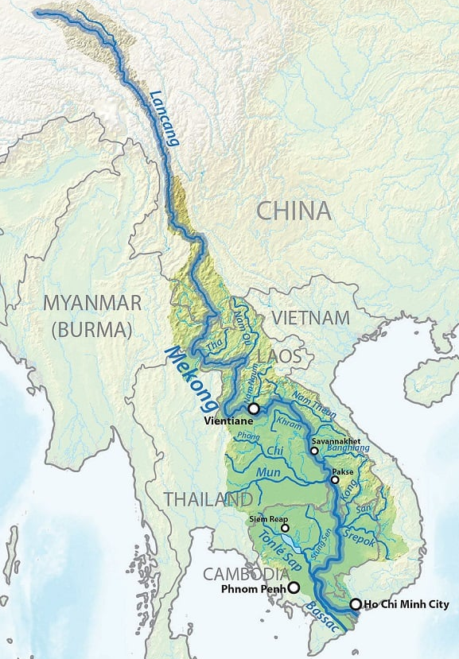
With almost 106 million people (Census.gov), Vietnam is located in Southeast Asia, with Laos and Cambodia to the west and the South China Sea to the east. The Communist Party of Vietnam rules the socialist republic. Around 34.4% of the population lives in urban areas. This leaves the majority (65.6%) residing in rural areas. Roughly 43% of Vietnamese are involved in agriculture, making it one of the most significant job sectors in the country. However, only a third of the land is cultivated for agriculture. As a result, limited land availability leaves Vietnamese farmers with some of the smallest agricultural land holdings in the world—only 0.3 hectares per farmer, about half the size of a soccer field.

Specifically, the Mekong Delta is home to over 17 million farmers. The climate is largely tropical, with temperatures ranging from 23° C to 34° C (70°F to 90°F). The basin experiences heavy rainfall during the Monsoon season (June through November). Monsoon rains are essential for agriculture but can often create severe flooding and landslides. This 40,000 square kilometer region is the backbone of Vietnam’s agriculture, producing 50% of the country's rice, 65% of its seafood, and 70% of its fruits. Furthermore, the Mekong Delta contributes almost 31% to Vietnam’s GDP, producing 95% of rice exports and 60% of fish exports. (Vietnam Economic Times)

Figure 1. Lower Mekong River Basin Map, US Geological Survey, 2019
Typical Family Life
In the Mekong Region, families typically have three to four members and often rely on agriculture for their livelihood. On most farms, family members work together to cultivate and harvest their crops. Farmers earn an average monthly wage of 5.95 million Vietnamese Dong, about $250. (Statista.com) Most families in this region have a high intake of rice, meat, fish, vegetables, soup, and sauces. Rice appears in multiple forms at each meal of the day, such as rice noodles, and rice paper rolls. (Unilever Food Solutions)

In rural areas, such as this region, diets depended heavily on locally produced food. The Mekong Delta produces enough rice to feed more than 100 million people in Vietnam and still has a large portion left for exports. (CGIAR) Rice is the primary source of available protein, calcium, carbohydrates, iron, and zinc in the Mekong Delta. However, having rice as one of the only sources of nutrition has caused the diets of the Mekong region to be less diverse for both adults and children.

Due to the large biodiversity in the Mekong Delta, common diseases such as the Avian flu, the Zika virus, chikungunya, and dengue fever have affected most of the population in the region. However, Vietnam is strengthening its healthcare system, particularly in rural areas. The Mekong Regional Health Support Project has made health insurance more affordable and provided quality healthcare to 70% of people living close to the poverty line in the region. (WorldBank)

The availability of infrastructure in the Mekong River Delta is relatively mixed. Access to clean water is among the key challenges. Rainwater, rivers, or groundwater is used by most communities. With variations in weather, pollution, and saltwater intrusion, access to clean water is a significant challenge. Most households have electricity, which is generated mostly from hydropower. There are occasional power cuts and changes in the flow of the Mekong River, however, which cause irregular electricity in the area. This area's transport is a mixture of water and road. The majority of villagers and farmers make use of boats. Flooding, however, can disrupt transport.

Agricultural Challenges in the Mekong Delta
Most rice that is grown in the Mekong Delta Region is wet rice. Wet rice is often grown in flooded rice fields. The crop is submerged under a few inches of water for most of the growing period. As the rice ripens and absorbs water, the fields are drained. Later, the rice is threshed by hand by the farmers. It is estimated that, with 1 hectare of rice in the Mekong region, a farmer can harvest 15 to 16 bags of rice per year.

Recent government policies supporting increased rice production have helped Vietnam’s Mekong River Delta become the third-largest global rice exporter. On average, Vietnam exports around 7.5 million metric tons of rice worldwide (Statista). In the 1980s, the Vietnamese government enacted a policy shifting rice production from one to two seasons per year. In the 2000s, another policy shifted crop production to three seasons per year, also known as triple-cropping. Although these policies have helped increase global rice exports and build national revenue, intensified rice production has created severe issues. Due to rice being harvested three seasons per year, rice fields don't have time to rest in between each harvest. This has resulted in poor soil health, plants susceptible to pests and diseases, and poor rice yield. A farmer in the Mekong Delta shared that because of overproduction and the continuous cultivation of his rice fields, he was only able to harvest five to six bags of rice this season.

Before the first policy change in the 1980s, farmers produced one rice crop per year, which allowed the rice field to flood during the monsoon season and rest. Nowadays, intensive farming requires farmers to use fertilizers three to four times per season and pesticides five to six times per season. The heavy use of chemical fertilizers and pesticides has polluted nearby water bodies. These chemicals can wash into rivers and lakes, causing harmful algal blooms that reduce oxygen levels in the water and create areas where fish and other aquatic life can't survive. This pollution damages ecosystems and threatens the livelihoods of people who rely on fishing and clean water.

Key Challenges to Sustainable Agriculture
Another impact of the overproduction of rice has been land subsidence, which refers to the sinking of the earth’s surface when there isn’t enough sediment. Land subsidence causes the area to be more vulnerable to rising sea levels. As the sediment decreases, due to damming of rivers and overextraction of groundwater, the land can sink and increase the risk of flooding, making it more difficult for farmers to grow crops. Currently, in the Mekong Delta, farmers and water companies are pumping groundwater, which decreases the pressure in the subsoil and leads to soil compaction. As a result, the delta is sinking by up to three centimeters per year. If this trend continues, a third of the delta will be below sea level by 2050.
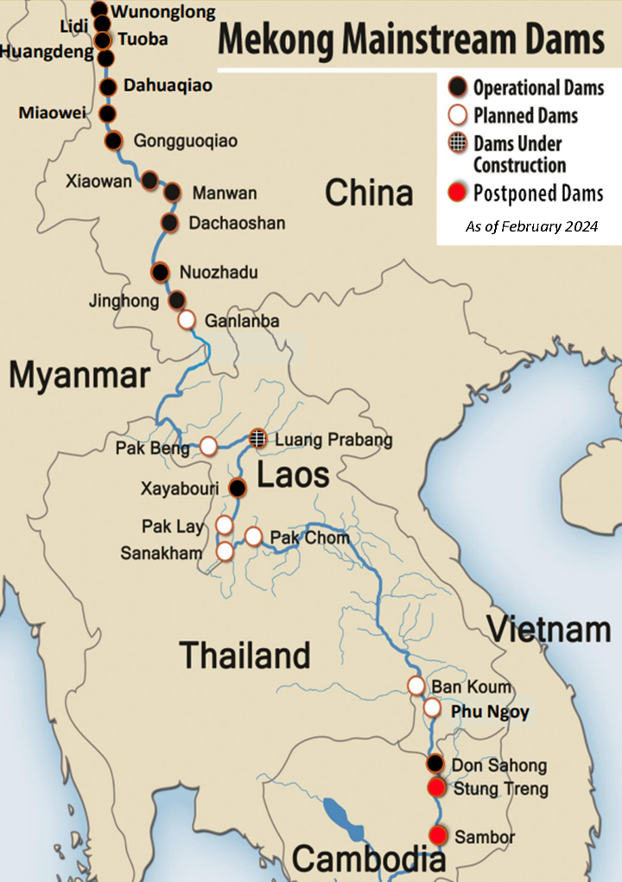
Lastly, the reason for environmental degradation is the mismanagement of the Mekong River. As the geographic top portion of the river is in China, the Chinese government has constructed many dams along the Mekong River, as shown in the picture to the left, moderating the water flow to their benefit. These dams cause high rates of the river's sediment and water to stay in China. This blocks the nutrient-carrying silt and water that flow down into the Mekong Delta, which impacts farmable land and agriculture. In addition, the regulation of water flow by upstream dams also disrupts the natural hydrological processes of the Mekong River. This affects the fish migration pathways, reduces fish populations, and puts the livelihoods of fisheries and fishing-dependent communities within the Mekong River Delta at risk. Reduced freshwater runoff due to upstream water holding also enhances saline intrusion into the delta. Saltwater intrusion destroys rice fields, reduces agricultural output, and forces farmers to abandon the affected lands.
Figure 2. Mekong Mainstream Dams, Stimson Center, 2020

Overall, the effects of ill-advised agricultural production due to national policies and upstream dam developments have decreased the biodiversity of the Mekong River ecosystem. Water species, particularly migratory fish, have been severely affected, and the ecosystems have been compromised, lowering the output from the fisheries. Natural resource degradation, such as groundwater, has resulted in economic losses to communities that rely on them. Shrinking fisheries and diminishing farm productivity have created lower incomes, which have caused farmers and fishermen to migrate and lose their farmlands.

Past Actions
The urgency to protect the Mekong River Delta has united international agencies, development banks, the Vietnamese government, local organizations, and farmers. The delta now receives more funding for environmental initiatives than any other Southeast Asian region.

The two policies passed in the 1980s and 2000s to promote Vietnam’s economic growth with rice production and exportation resulted in Vietnam becoming one of the major rice exporters in the world. However, it also caused soil erosion, floods, land subsidence, etc. The Vietnamese government understood that these policies harmed the environment and limited economic opportunities. Therefore, in 2017, Vietnamese legislators passed a law known as Resolution 120, which emphasizes the need to adopt sustainable use of natural resources and encourage the management of water resources and climate change resilience.

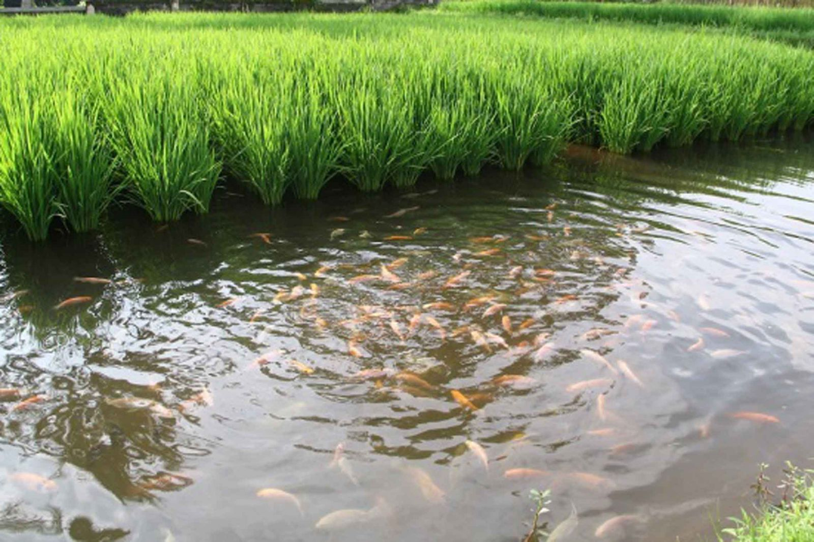
Concerning the loss in crop yield and fisheries, local researchers and farmers have brought back rice fishing, an ancient tradition passed down over generations in Southeast Asia. This practice integrates rice cultivation with aquaculture by constructing channels in the rice fields to introduce aquatic life. The researchers and farmers found that with aquatic life, rice yields were 12% higher. The introduction of aquaculture also resulted in a reduction in the prevalence of invasive vegetation, weeds, and pests, which decreased the need for chemical pesticides. The rice/fish fields also had improved nitrogen-efficient soil, which breaks down organic matter at a higher rate. The increased nitrogen content prevents the need for farmers to use fertilizers and pesticides, which prevents pollution damage in ecosystems. The fish and other marine life help remove pests, diseases, and weeds. The competition for nutrients is significantly less. Therefore, more nutrients are available for the growth of rice. Lastly, marine waste, also rich in nutrients, is used as a natural fertilizer for rice crops, which supports their growth and increases crop yield.
Figure 3. Mekong Ecotour, 2017

Proposed Solutions
Despite many efforts to restore the Mekong River Delta, the delta is still under serious threat. A new study estimated that the Mekong Delta is much lower than it was previously. Almost 75% of the entire delta is below sea level. Urgent action is necessary to address this issue and restore the Mekong Delta to its former condition.

A multi-value farming model that could be implemented and replicated without expensive infrastructure is necessary. A farmer near the coast of the delta named Tieu Hoang Pho has built a freshwater pond that is sealed and isolated from the saline ground and surroundings. During the monsoon season, when rains and floods replenish the land, Pho collects freshwater and uses it to grow freshwater fish in the dry season. Around the pond, he grows fruit trees such as coconut, jackfruit, banana, mango, and durian. This thoughtfully managed freshwater habitat creates an ideal environment for growing freshwater fish, allowing Pho to continue profiting even when the surrounding land becomes dry and saline. This strategy could be implemented by farmers to maximize profits and economic output without spending a lot of money on expensive equipment or infrastructure. Additionally, Pho encourages the revival of agricultural practices that monopolize natural flooding, such as fish farming and lotus farming. Floods have many benefits, such as replenishing the land, bringing nutrients and sediment, and recharging groundwater. Experts suggest that small changes to water management, like opening sluice gates in rivers and canals, can imitate natural flood patterns. By creating periodic floods instead of keeping the gates closed for saltwater protection, we can create habitats for aquatic life and allow fish to access floodplains to feed and breed.

Additionally, it was reported that the total area of mangroves in the Mekong Delta decreased from 185,800 hectares in 1973 to 102,160 hectares in 2020. This represents a loss of 2,150 hectares per year due to aquaculture expansion and 430 hectares per year due to coastal erosion. (US Forest Service) Restoring mangroves in the delta is essential due to the benefits mangroves provide to the environment and ecosystem. Due to land use conversion, pollution, coastal erosion, and the effects of climate change, the mangrove population has plummeted in the Mekong Delta. However, efforts have been made to restore the species. A new Mangrove Living Lab, created through a partnership between Thuyloi University in Hanoi and the Delft University of Technology, will focus on restoring mangrove forests in the Mekong Delta. The Vietnamese government is conducting these restoration activities to address the region's risk of storm surges and flooding. Mangroves act as natural barriers to storms, erosion, and flooding. They store large amounts of carbon and act as carbon sinks. They can also provide food and income for local farmers. One of their biggest characteristics is that they support a variety of plant and animal species, which helps regulate the overall biodiversity in the delta. Restoring mangroves in the Mekong Delta will significantly enhance the region's ecosystem, leading to improved biodiversity.

In conclusion, while Vietnam has achieved remarkable success in global rice exports, the delta is currently facing catastrophic conditions that devastate its biodiversity and ecosystems. Practices like triple cropping, intensive farming, and the mismanagement of the Mekong River are driving significant environmental degradation, resulting in an alarming rate of the delta sinking and a sharp decline in marine life and groundwater levels. Immediate action is imperative. We must implement strategies such as natural flooding, aquaculture, and mangrove restoration as essential first steps to tackle this pressing challenge effectively. By embracing these sustainable solutions, we can preserve the Mekong Delta and protect the livelihoods of the people who are dependent on it. We can protect and sustain this region, making it thrive for generations to come.

Works Cited
Adaobi Ezeokoli. “New Research Identifies Policies That Can Help Vietnam Simultaneously Address Hunger and Climate Change - Center for Health Law and Policy Innovation.” Center for Health Law and Policy Innovation, 29 Sept. 2024, chlpi.org/news-and-events/news-and-commentary/food-law-and-policy/new-research-identifies-policies-that-can-help-vietnam-simultaneously-address-hunger-and-climate-change/.
“Average Household Size - Area Database - Table - Global Data Lab.” Globaldatalab.org, globaldatalab.org/areadata/table/hhsize/VNM/.
Britannica. “Vietnam - Agriculture, Forestry, and Fishing | Britannica.” Encyclopædia Britannica, 2019, www.britannica.com/place/Vietnam/Agriculture-forestry-and-fishing.
“CGSpace :: Home.” Cgiar.org, 2024, cgspace.cgiar.org/server/api/core/bitstreams/30944fac-b67a-495c-b22b-333beac6dce5/content.
Deborah. “Greater Mekong: The “Double Burden” of Middle-Income.” L’Initiative, 8 June 2024, linitiative.expertisefrance.fr/en/greater-mekong-the-challenge-of-dual-burden-for-middle-income-countries/. Accessed 23 Mar. 2025.
Embassy of the Socialist Republic of Vietnam. “Geography | Embassy of the Socialist Republic of Vietnam in the United States.” Vietnamembassy-Usa.org, 23 Mar. 2025, vietnamembassy-usa.org/vietnam/geography.
Huang, Sarah . “Growing Rice at a Cost in Vietnam’s Mekong River Delta | Society of Ethnobiology.” Ethnobiology.org, 16 May 2018, ethnobiology.org/forage/blog/growing-rice-cost-vietnams-mekong-river-delta.
“Land | Open Development Vietnam.” Open Development Vietnam, 21 July 2014, vietnam.opendevelopmentmekong.net/topics/land/.
Lovgren , Stefan. “In a Dammed and Diked Mekong, a Push to Restore the Flow.” Yale E360, 8 May 2024, e360.yale.edu/features/mekong-delta-drought-solutions.
“Population Clock: World.” Www.census.gov, 2025, www.census.gov/popclock/world/vm.
Rijksdienst voor Ondernemend Nederland. “How Dutch Knowlegde Helps the Mekong Delta in Vietnam | Partners for Water.” YouTube, 24 Jan. 2022, www.youtube.com/watch?v=UH5fEMF763E. Accessed 23 Mar. 2025.
Schueman, Lindsey. “The Ancient Tradition of Rice Fishing Has Multiple Modern Benefits.” One Earth, 12 Mar. 2024, www.oneearth.org/the-ancient-tradition-of-rice-fishing-has-multiple-modern-benefits/.
Shahbandeh, M. “Largest Exporter of Rice Worldwide 2019 | Statista.” Statista, Statista, 2019, www.statista.com/statistics/255947/top-rice-exporting-countries-worldwide-2011/.
U.S. Department of State. “Vietnam - United States Department of State.” United States Department of State, 20 Mar. 2023, www.state.gov/reports/2022-country-reports-on-human-rights-practices/vietnam/.
“Vietnam: Employment by Industry 2018.” Statista, June 2024, www.statista.com/statistics/615802/employment-by-industry-vietnam/.
“World Bank Open Data.” World Bank Open Data, 2025, data.worldbank.org/indicator/AG.LND.AGRI.ZS?end=2022&locations=VN&start=1961. Accessed 23 Mar. 2025.

