Malick Sogur
Kennedy High School
Cedar Rapids, IA USA
The Gambia, Infrastructure
August 31, 2025

Bolstering Gambian Infrastructure to Combat Food Insecurity

In the Gambia, over 70% of the population works in the realm of agriculture, despite the about 1.7 billion people that work in this sector, only about 50% of food needs are met within the country showing an obvious gap. Additionally, even though the majority of the population works in agriculture, 29% of the population suffers from food insecurity. These factors lead to a reliance on imported food to feed the Gambia’s population “This leaves it vulnerable to price volatility, with high levels of food inflation creating constant challenges"(“Gambia | World Food Programme”). The Gambia also suffers from low infrastructure quality; 31% of rural households have electricity access, and only 17% of roads are paved. If the Gambia is able to implement a program focused on bolstering the infrastructure specifically in rural areas food security will decrease for a multitude of reasons.

Context/Culture
The Gambia is nicknamed the "Smiling Coast of West Africa" due to both its geographical position and the happy demeanor of its inhabitants. It is located on the western coast of Africa, almost completely engulfed by Senegal, and borders the North Atlantic Ocean. The country has a population of 2,500,000+, but despite its small population size, various ethnic groups such as the Mandinka, Fulani, Wolof, and Jola, can be found in Gambia. The large majority of the country's population is Muslim at 96.4% followed by Christians at 3.5%.
​
The Gambia declared independence from Britain in 1965. Although once combined with Senegal to make Senegambia, the confederation dissolved, and eventually Yahya Jammeh took over the country for over 20 years. Eventually, several groups rallied against Jammeh's rule, and Adama Barrow got elected in 2016. Despite numerous attempts to disrupt the inauguration, Barrow was placed in power, and Jammeh left the country. Although agreeing to serve a three-year transitional term, Barrow decided to extend his presidency and remains in power, currently meaning that since Gambia's formation, the country has only had three presidents.
​
In Gambia, it is common for multiple generations to live together in one household or compound, with the head of the household often being an older male. As a patrilineal society, the men are often the main financial providers, and family leadership runs through them although 44% of household heads have had no formal education. Whereas running the household itself is left up to the women. One factor that contributes to the large household sizes is that in Islam, a man may have up to 4 wives, and in Gambian households, each of these wives normally work together to maintain the house and caretaker. Recently, more women have started to join the workforce, altering the role they play.

Challenge
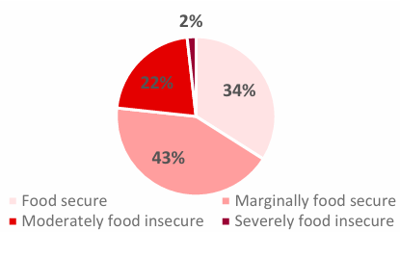
Figure 1
Graphs showcasing food insecurity statistics of households in the Gambia.
*Provided by “The Gambia National Food Security and Survey Report”
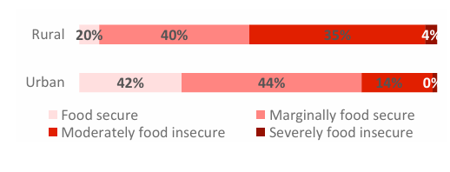
As stated earlier, despite the 70% of the country that works in agriculture only 50% of food needs within the country are met. According to the World Food Programme and Gambia Bureau of Statistics, 24% of households are food insecure. Within the Gambia the urban rural divide is also important to note as one out of eight homes in urban areas are food insecure compared to one in three in rural areas. Additionally many homes are very vulnerable to price changes that can be caused by local or world markets as more than half of households spend half of their budget on food (“Gambia National Food Security Survey Report” 4).

​Some key contributors to food insecurity in the Gambia include climate change, heavy reliance on imports, and weak infrastructure. Only 65% of households have electricity, with a much lower rate of 31% in rural areas. The country has 2,977 km of roads, far less developed than places of the same size such as Connecticut with 34,488km. Less than half the population has access to basic sanitation. Strengthening infrastructure is necessary not only for quality of life but also for food security, as investments in electricity, water access, roads, and other services can make food more affordable and reduce insecurity.
​
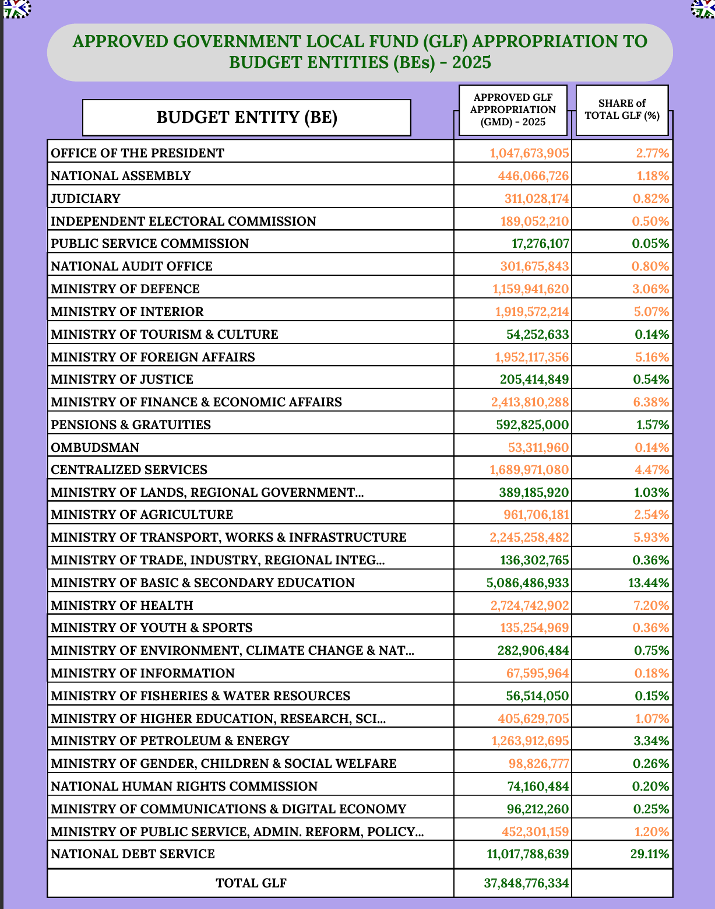
Financing infrastructure can help resolve food insecurity issues in many ways. According to the “Center for Budget and Macroeconomic Transparency” within the Gambia, total revenue and grants for approved funding in 2025 was 44.8 billion Dalasi or ~613 million US dollars. The country is currently operating on a budget deficit and although the country currently spends on agricultural development, more is needed in order to accomplish mass infrastructural upheaval. Additional funds can be gained from the presidential office and if needed possible loans from organizations such as ECOWAS and the African Development Bank. By increasing access to electricity, processes used to cultivate food could be optimized in various areas; by increasing access to roads, food could be better transported; and by increasing irrigation, water distribution could further optimize food resulting in even more. There are a plethora of other ways in which increased infrastructure can directly lead to increased food security.

Figure 2
*Showcases government spending courtesy of Center for Budget and Macroeconomic Transparency

​Solution
As a case study in this phenomenon, we could analyze the staple crop processing zones in Africa, particularly in Nigeria. Staple crop processing zones are built to enable people in agriculture to operate effectively and reduce cost by bringing adequate infrastructure to areas of high agricultural potential (Atsuko). Other places have also done similar initiatives, such as the Agro-Industrial Parks in a myriad of Asian countries. By implementing these zones, large agricultural hubs have been created, and higher yield agriculture has been implemented. "These zones have proven highly successful in Africa, transforming rural areas from regions of economic struggle into vibrant hubs of opportunity, creating jobs, and opening up new markets for local communities" (Desiderio). Gambian food security is majorly limited by agricultural processing capabilities. The country exports much of its produce and imports processed versions; bringing processing inland could cut costs for transportation and reduce exchanges of the same product, while creating additional jobs. Adopting a similar strategy in Gambia may increase opportunities and food availability through higher-yielding farming and better support of food needs.
​
One way in which infrastructure in the Gambia is worsening food insecurity is due to their poor transportation networks. As previously mentioned, much of the country's roads are not paved, and there are not many rural roads to begin with. This can lead to struggles to bring homegrown crops as well as imported food to various regions of the country. Many roads can be difficult to traverse, particularly during the rainy season, and most roads are poorly maintained and lit (“Gambia, the Traffic Safety While Traveling. - CountryReports”). Due to unreliable road networks, high transportation costs can occur, leading to a range of 20-40% of post harvest loss annually.
​
In order to solve this pressing issue. Investment in the roads and transportation of Gambia as a whole is critical. Although Gambia has had many initiatives to improve its roads, often these projects are put on indefinite holds. Implementing initiatives to pave the roads of Gambia may be costly, and some funds from supranational organizations may be necessary. However, investing in better transportation systems could make use of an additional 18,000 tons of peanuts, 16,000 tons of millet, 11,000 tons of rice, and more within just domestic products; clearly access to food would increase immensely.
​
An example of a similar system working involves rural road projects in India. The World Bank invested over 2 billion dollars to help fund the program benefiting almost 19,000 households, and about 171,000 households have benefited from the total 46 billion dollar program. This has not only increased access to health and education for many inhabitants (“Connecting Villages through Rural Roads in India”). But it also helped farmers be able to better access markets, limiting food waste and bolstering agricultural lives. A farmer stated, "He could only carry four or five bunches each time. Now a pick-up van transports his entire produce of 300-400 bundles, doubling his weekly income" (“Connecting Villages through Rural Roads in India”). Not only are the farmers making additional money, but consumers have more access to the food, increasing the supply and lowering prices, yet more produce can be sold. By investing in the roads and transportation infrastructure of the Gambia, hopefully similar results can be achieved.

In order to improve food security in the Gambia, it may also be necessary to invest in better food storage facilities. "About one third of food produced for human consumption is lost or wasted globally, amounting to about 1.3 billion tonnes per year. Storage facilities including grain and rice silos, warehouses and cold storages play a critical role in ensuring food security and ending hunger" (Turley and Uzsoki). In the Gambia, the lack of proper food storage for large amounts of crops is apparent. Contamination often occurs due to inadequate storage facilities and incorrect handling of the produce, and about a quarter of the food produced is contaminated by bacteria such as Aflatoxin (“Stopping Food Losses and Food Waste in the Gambia”). Due to a lack of cold storage, farmers are forced to sell much produce immediately after harvest to avoid any losses, leading to less food at certain times of year. In fact, post harvest handling can at times lead to losses of 30%.
​
To combat this food loss, it is critical to invest in proper storage facilities in rural areas for commonly grown crops including rice, corn, millet, and peanuts, depending on the region. By investing into these facilities, many areas would have access to food during larger amounts of the year and make the country less dependent on imported prices outside of harvesting seasons. One place where this worked is the CONAB program in Brazil, in which the government invested in grain silos, warehouses, and cold storage facilities. Through this program, Brazil has continued to increase the amount of corn and grain produced. By implementing similar programs in Gambia, farmers could potentially have places where they can store their crops to sell throughout the year.
​​
Conclusion
By transforming how food is produced, processed, distributed, and consumed, the Gambia can create sustainable, resilient, and inclusive food systems that provide nutritious and affordable food for all while supporting livelihoods, reducing environmental impacts, and adapting to climate change (“The Six Transitions Gambia Must Navigate for Sustainable Development”). This sentence from the UN is critical in understanding the mass impact that improving the infrastructure of Gambia may have on the food security of the country's citizens. If the Gambian government prioritizes rural infrastructure projects such as improving roads to increase the interconnectedness of the country, investing in storage facilities, and introducing agricultural processing infrastructure within the country, Gambia will be able to increase its food production. By doing so, food cost can lower and supply of food will increase while also allowing the Gambia to be less dependent on imports to feed its citizens. This will also create more self sufficiency in rural areas and make the country less vulnerable to world market price changes. In order to implement these mass overhauls will be needed. It is not beneficial to understate the massive gaps in electricity supply, water distribution, and other factors that may have on this process. Additionally, this is a multi-faceted problem, as dealing with infrastructure alone will not combat all the challenges of climate change, wealth gaps, and many other issues that impact Gambia's food security and other countries across the globe. Despite this, I am hopeful that by taking the time to build up the infrastructure of Gambia, the food security of Gambians will increase, allowing better opportunities for future generations of this country.

Works Cited
Access Gambia. “Gambia Family Structure, Roles & Relations.” Www.accessgambia.com, www.accessgambia.com/information/family-relations.html.
Atsuko, Toda. Staple Crops Processing Zones a Flagship Program of the Feed Africa Strategy. www.afdb.org/fileadmin/uploads/afdb/Documents/Generic-Documents/Staple_Crops_Processing_Zones.pdf.
Center for Budget and Macroeconomic Transparency. Summary of the Approved 2025 National Budget Central Government of the Gambia. Apr. 2025.
Clark, Andrew. “The Gambia | Culture, History, & People | Britannica.” Encyclopædia Britannica, 2019, www.britannica.com/place/The-Gambia.
“Connecticut Infrastructure Report Card | ASCE.” ASCE’s 2025 Infrastructure Report Card |, 27 Oct. 2016, infrastructurereportcard.org/state-item/connecticut/. Accessed 31 Mar. 2025.
“Connecting Villages through Rural Roads in India.” World Bank, 16 Mar. 2022, www.worldbank.org/en/country/india/brief/connecting-villages-through-rural-roads-in-india. Accessed 31 Mar. 2025.
Desiderio, Danilo. “Staple-Crop Processing Zones: A New Hope for the Agro-Processing Sector in Africa to Take Off?” Thehabarinetwork.com, 2024, www.thehabarinetwork.com/staple-crop-processing-zones-a-new-hope-for-the-agro-processing-sector-in-africa-to-take-off. Accessed 31 Mar. 2025.
“Gambia - Market Challenges | Privacy Shield.” Privacyshield.gov, 2018, www.privacyshield.gov/ps/article?id=Gambia-Market-Challenges.
“Gambia | World Food Programme.” Www.wfp.org, www.wfp.org/countries/gambia.
“Gambia Production.” Usda.gov, 2024, ipad.fas.usda.gov/countrysummary/default.aspx?id=GA. Accessed 31 Mar. 2025.
“Gambia, the Traffic Safety While Traveling. - CountryReports.” Countryreports.org, 2025, www.countryreports.org/country/thegambia/traffic.htm. Accessed 1 Apr. 2025.
“Infrastructure Indicators - Gambia | Market Forecast.” Statista, 2024, www.statista.com/outlook/co/infrastructure-indicators/gambia.
Kuku-Shittu, Oluyemisi, et al. “Comprehensive Food Security and Vulnerability Analysis: Nigeria.” SSRN Electronic Journal, 2013, https://doi.org/10.2139/ssrn.2310014. Accessed 2 Aug. 2020.
“Light Innovate Workplace.” Light Innovate Workplace, 2023, lightinnovateworkplace.com/blog?post=agribusiness-in-the-gambia-challenges-opportunities-and-impacts. Accessed 31 Mar. 2025.
Reuters. “Brazil’s Conab Raises Grain Output Forecast on Bigger Corn Crop.” Successful Farming, 13 Feb. 2025, www.agriculture.com/brazil-s-conab-raises-grain-output-forecast-on-bigger-corn-crop-11679137. Accessed 31 Mar. 2025.
“Stopping Food Losses and Food Waste in the Gambia | FAO in the Gambia | Organisation Des Nations Unies Pour l’Alimentation et L’agriculture.” Fao.org, 8 Oct. 2020, www.fao.org/gambia/news/detail-events/fr/c/1312476/. Accessed 31 Mar. 2025.
The CIA. “Gambia, the - the World Factbook.” Www.cia.gov, www.cia.gov/the-world-factbook/countries/gambia-the/.
The Gambia National Food Security Survey Report. Ministry of Agriculture, Livestock and Food Security; Gambia Bureau of Statistics; World Food Programme, Dec. 2024. World Food Programme
“The Six Transitions Gambia Must Navigate for Sustainable Development.” The Gambia, 16 June 2024, gambia.un.org/en/271842-six-transitions-gambia-must-navigate-sustainable-development.
Turley, Laura, and David Uzsoki. “Why Financing Rural Infrastructure Is Crucial to Achieving Food Security.” International Institute for Sustainable Development, 9 Jan. 2019, www.iisd.org/articles/rural-infrastructure-food-security.
UNDP. “Documentation and Downloads.” Hdr.undp.org, 2021, hdr.undp.org/data-center/documentation-and-downloads.

