Regulatory Mechanism of StPP2A-C in the Fungal Pathogen Setosphaeria turcica and Its Implications for Disease Control in Maize

Wang Xiyan
Shijiazhuang Foreign Language Education Group
- mail: 18903110325@163.com
August 28, 2025
Supervisor: Kang Xiaolong

Abstract: ：Northern corn leaf blight caused by Setosphaeria turcica is a major fungal disease causing significant yield losses globally. While eukaryotic type 2A protein phosphatase (PP2A) regulates growth and virulence in various pathogenic fungi, its role in Setosphaeria turcica remains unclear. We functionally characterized StPP2A-C, encoding the catalytic subunit of PP2A in Setosphaeria turcica. Deletion of StPP2A-C impaired colony growth, conidial germination, and appressorium formation, yet increased lesion size on maize plants. These findings highlight StPP2A-C's critical role in fungal development and pathogenicity, potentially informing novel biocontrol strategies against this pathogen.
Keywords: Northern corn leaf blight; StPP2A-C; Conidia; Pathogenicity
1.Introduction

Northern corn leaf blight (NCLB) primarily occurs in cold and humid maize-growing regions and is a major fungal disease threatening global maize production. It is caused by the filamentous fungal pathogen Setosphaeria turcica. In severe outbreak years, susceptible varieties can experience up to 50% yield loss. Historically, disease control has relied on planting resistant varieties. The main resistance genes in maize against Setosphaeria turcica are Ht1, Ht2, Ht3, and HtN. However, due to frequent pathogen variation, physiological differentiation within fungal populations, and differences in toxin compositions among different strains, accurately and effectively monitoring these pathogens remains challenging. This leads to rapid loss of resistance in maize varieties, posing greater difficulties for disease control. Therefore, studying the regulatory mechanisms of fungal pathogenicity has become a research focus for developing new disease control strategies.
Type 2A protein phosphatases (PP2As) are major serine/threonine phosphatases in eukaryotic cells. They are regulated by protein reversible phosphorylation and affect various physiological processes such as cell cycle regulation, cell morphology and development, intracellular signal transduction, and others. PP2A proteins exist as heterotrimeric holoenzyme complexes, consisting of a structural subunit A, a regulatory subunit B, and a catalytic subunit C. Subunits A and C combine to form the core enzyme, which then associates with subunit B to assemble into the active trimeric holoenzyme. The catalytic subunit C is involved in multiple signal transduction processes, and its post-translational phosphorylation or methylation modifications regulate PP2A activity and holoenzyme composition. In fungi, PP2A interacts with various signaling pathways and participates in processes such as cell morphogenesis, autophagy, and secondary metabolism. Previous studies have shown that PP2A inhibitors can inhibit mycelial growth, promote spore formation, and cause changes in melanin content, all of which play important roles in the development and pathogenesis of S. turcica.
Phenotype refers to the characteristics exhibited by an organism in terms of morphology, structure, physiology, biochemistry, and behavior. It is the result of the interaction between genotype and environment. Phenotypic analysis is a method for systematically observing, describing, measuring, and analyzing the observable and measurable characteristics of organisms. It is used to study the relationship between phenotypic traits and genotype and environmental interactions. It helps reveal the functions of genes, genetic laws, and mechanisms of biological evolution. By studying individuals with different phenotypes, the relationship between genes and phenotypes can be determined, and the role of genes in development and environmental responses can be understood. Therefore, our main research goal was to investigate the role of StPP2A-C in regulating the development of infection structures and pathogenicity in S. turcica through phenotypic analysis. We used the StPP2A-C gene knockout mutant H5 to identify the role of StPP2A-C in regulating conidial development and pathogenicity through phenotypic analysis. The research results lay a theoretical foundation for developing new preventive and control agents for biocontrol of S. turcica and provide potential targets.

2.Materials and Methods

(1) Strains and Plasmids
The wild-type strain of the maize stalk rot fungus (Setosphaeria turcica 01-23) and the StPP2A-C knockout mutant H5 were preserved and provided by the Key Laboratory of Plant Physiology and Molecular Pathology of Hebei Province.
(2) Media
D medium (Potato dextrose broth): Glucose 20 g, potato 200 g, boiled and filtered to remove solid matter, ddH2O added to a final volume of 1 L.
PDA medium (Potato dextrose agar): PDA medium with the addition of 13 g agar powder, ddH2O added to a final volume of 1 L.
(3) Equipment
Instrument | Specifications | Manufacturer
Autoclave | 50 L, 0.15 MPa, 121°C | Shanghai Boxun
Clean Bench | Class 100, 1200×600×900 mm | Suzhou Antai
Electronic Balance | Range: 0.1 mg–200 g, Precision: ±0.1 mg | Mettler Toledo
Optical Microscope | Magnification: 40×–1000×, LED light sourc | Olympus

3.Results and Analysis

(1) Effect of StPP2A-C on Colony Morphology of the Maize Stalk Rot Fungus
To further clarify whether StPP2A-C affects the colony morphology of the maize stalk rot fungus, we inoculated the wild-type strain (WT) and the StPP2A-C knockout strain (H5) preserved in the laboratory on PDA medium and observed the colony growth. The experimental results are as follows (Figure 1):
Colony morphology and color: The wild-type strain (WT) had uniform colony color, overall dark gray or black; the mutant strain (H5) had a dark center (black) that gradually lightened outward, presenting a color gradient, with a light gray-white edge. This suggests that the deletion of the StPP2A-C gene (if H5 is a related gene knockout mutant) may have affected the colony expansion ability.
Colony expansion: The WT colony covered the entire petri dish with a large expansion range; the H5 colony had a relatively small expansion range and did not cover the entire petri dish. This suggests that the deletion of the StPP2A-C gene may have affected the expansion ability of the colony.
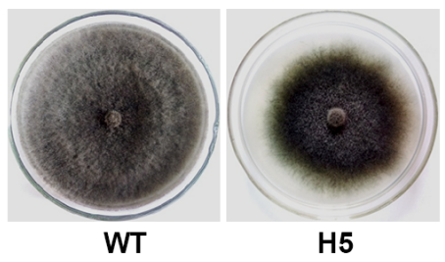
Figure 1: Colony morphology of WT and StPP2A-C knockout mutant (H5) mutant (H5).

(2) Growth Curve Determination
Figure 2 shows the growth of the wild-type WT and the mutant H5 at different culture times, with the abscissa representing culture time (d) and the ordinate representing colony diameter. As can be seen from the figure, the growth curves of WT and H5 are different, reflecting the impact of StPP2A-C gene deletion on the growth rate of the maize stalk rot fungus. In the early stage of culture, the growth of both may be similar; however, as the culture time increases, the difference gradually becomes apparent. The WT growth rate is faster than H5 at a certain stage, indicating that the deletion of the StPP2A-C gene inhibits the growth of the maize stalk rot fungus.

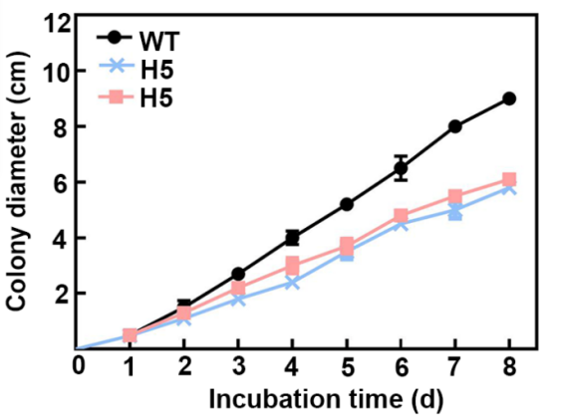
Figure 2: Growth rate analysis of WT and H5.

(3) Morphological Observation of Conidiophores
Previous research in our laboratory found that the mycelial growth rate of the mutant strain H5 is lower than that of WT, but the sporulation rate is higher than that of WT. In this paper, we observed the process of mycelia differentiating into conidiophores to produce conidia, and found that the number of conidiophores differentiated from the mycelia of the mutant strain H5 is significantly more than that of WT (Figure 3).

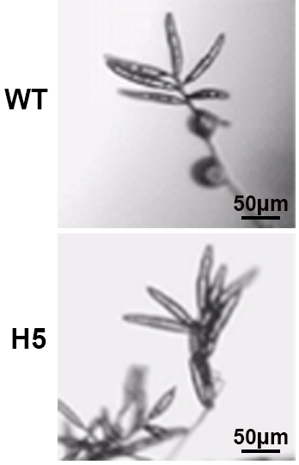
Figure 3: Conidiophore morphology of WT and H5.

(4) Morphological Observation of Hyphae
Figure 4 shows the morphology of hyphae of the wild-type (WT) and StPP2A-C knockout mutant (H5) of the maize stalk rot fungus. Under a 20μm scale: WT hyphae: relatively regular morphology, uniform thickness, clear septa, relatively consistent intercellular distances, showing relatively uniform and stable structural characteristics; H5 hyphae: compared with WT, the morphology of the hyphae has changed to some extent, with uneven thickness and slightly irregular cell morphology, indicating that the deletion of the StPP2A-C gene may have interfered with the normal development and morphology maintenance mechanism of the hyphal cells.
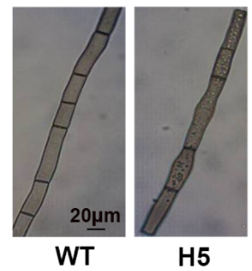
Figure 4: Hyphal morphology of WT and H5.

(5) Spore Development at Different Time Points
Figure 5 shows the spore development of the wild-type WT and the mutant H5 at different time points (12h, 24h, 48h, 72h), with a scale of 40μm. At different time points, there are differences in morphology, number, etc. between the spores of WT and H5. As time passes, the spore development process of WT and H5 is different. The spore development of the mutant H5 may show significant differences from that of the wild-type WT at certain stages, such as spore germination time, germination rate, and spore morphological changes. These differences further prove that the StPP2A-C gene has a regulatory effect on the spore development of the maize stalk rot fungus.
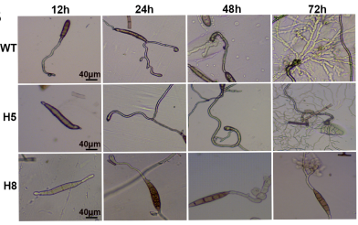
Figure 5: Spore development of WT and H5 at different time points.

(6) Pathogenicity Detection
Figure 6 shows the effect of StPP2A-C on the pathogenicity of the maize stalk rot fungus. The mycelia of WT and H5 mutants were inoculated on maize leaves susceptible to disease, and disease symptoms were observed after one week of inoculation. The knockout mutant produced larger disease lesions than WT, indicating that StPP2A-C has a negative regulatory effect on the pathogenicity of the fungus.
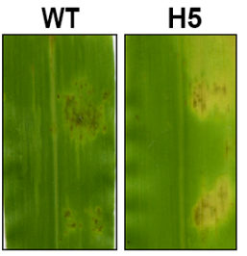
Figure 6: Pathogenicity of WT and H5.

4.Discussion

(1) Effect of StPP2A-C on Growth-Related Phenotypes of the Maize Stalk Rot Fungus
In the life activities of fungi, genes play a crucial role in regulating their morphology and growth. This study focuses on the function of the StPP2A-C gene in the maize stalk rot fungus. Through a multi-faceted comparative analysis of the wild-type WT and the StPP2A-C knockout mutant H5, we obtained a series of valuable results. In terms of colony morphology (Figure 1), the WT colony had uniform color and a large expansion range, while the H5 colony had a color gradient and a small expansion range. This indicates that the deletion of the StPP2A-C gene significantly changed the appearance and expansion ability of the colony. Colony morphology is a macroscopic manifestation of fungal growth status. Color differences may be related to changes in the expression of genes involved in pigment synthesis, while differences in expansion range suggest that gene deletion affects the growth speed or direction of hyphae. In other fungal studies, there are also reports of gene deletion leading to changes in colony morphology, indicating that StPP2A-C may be involved in regulating the basic growth process of the maize stalk rot fungus.
The growth curve determination (Figure 2) clearly shows the difference in growth rates between WT and H5. In the early stage of culture, the growth of both is similar, but then the WT growth rate is faster than H5, fully demonstrating that the deletion of the StPP2A-C gene inhibits the growth of the maize stalk rot fungus. Changes in growth rate reflect the role of genes in regulating cell division, metabolic activity, and other aspects. StPP2A-C may regulate the growth rhythm of the fungus by affecting key metabolic pathways or signaling pathways.
In terms of conidiophore morphology (Figure 3), there are significant differences between WT and H5. Conidiophores are structures that produce conidia, and changes in their morphology may affect sporulation efficiency and the spread and infection ability of spores. After the deletion of the StPP2A-C gene, the morphology of the H5 conidiophores changed, which may have interfered with the microenvironment of spore formation and thereby affected the subsequent sporulation process.
In terms of hyphal morphology (Figure 4), H5 hyphae are uneven in thickness and irregular in cell morphology, forming a sharp contrast with WT. Hyphae are an important structure for fungal nutrient growth, and the stability of their morphology is crucial for nutrient absorption and material transport. The deletion of the StPP2A-C gene disrupted the normal development and morphology maintenance mechanism of hyphal cells, possibly affecting the construction of the cytoskeleton or related signaling pathways, ultimately causing a chain reaction on the overall growth of the fungus.
(2) Regulation of StPP2A-C on Spore Development and Pathogenicity of the Maize Stalk Rot Fungus
Spore development is a key link in fungal reproduction and spread. The observation of spore development at different time points (Figure 5) found that the spores of WT and H5 show different developmental processes in terms of morphology, number, etc. with the passage of time. The mutant H5 has significant differences from the wild-type WT at certain stages, such as spore germination time, germination rate, and morphological changes. This indicates that the StPP2A-C gene has precise regulatory effects on the spore development of the maize stalk rot fungus. Spore development is synergistically regulated by many genes and signaling pathways. StPP2A-C may be involved in this process, regulating the expression of related genes or signal transduction to affect all stages of spore development from formation to maturation.
The pathogenicity test (Figure 6) results reveal the important role of StPP2A-C in the pathogenic process of the fungus. At the same time, it also suggests that StPP2A-C may indirectly affect the pathogenicity of the maize stalk rot fungus by regulating the development of conidia, providing a new perspective for in-depth understanding of the pathogenic mechanism of the fungus.
In summary, the StPP2A-C gene plays a multifaceted regulatory role in the growth, development, and pathogenicity of the maize stalk rot fungus. The research results of this study provide important clues for further exploring the molecular mechanisms of pathogenicity of the maize stalk rot fungus and provide potential targets and theoretical basis for developing new control strategies against this fungus. In the future, further research can be carried out around the StPP2A-C gene, such as analyzing its upstream and downstream signaling pathways and the interaction with other genes, to fully reveal the life activity rules of the maize stalk rot fungus.

6.Conclusion

(1) Morphology-related: Deletion of the StPP2A-C gene changes the morphology of the colony, hyphae, and conidiophores of the maize stalk rot fungus, affecting expansion, pigment synthesis, and cell development and maintenance.
(2) Growth and development: Deletion of this gene inhibits the growth of the fungus, changes the spore development process, and affects stages such as spore morphology, number, germination, etc.
(3) Pathogenicity: StPP2A-C negatively regulates sporulation in the fungus, and increased sporulation affects pathogenicity.
By studying the gene function of the catalytic subunit (StPP2A-C) of the maize stalk rot fungus, we analyzed and revealed its molecular mechanism of regulating the development of pathogenic conidia and pathogenicity. The research results lay a theoretical foundation for developing new preventive and control agents for biocontrol of S. turcica and provide a potential target.

References
[1] J. Sibiya, P. Tongoona, J. Derera, Combining ability and GGE biplot analyses for resistance to northern leaf blight in tropical and subtropical elite maize inbred lines, Euphytica 191 (2) (2013) 245-257.
[2] J. Dong, Y. Fan, X. Gui, X. An, J. Ma, Z. Dong, Geographic distribution and genetic analysis of physiological races of Setosphaeria turcica in Northern China, American journal of agricultural and biological sciences 3 (1) (2008) 389-398.
[3] S. Zhang, Z. Hao, L. Wang, S. Shen, Z. Cao, Y. Xin, M. Hou, S. Gu, J. Han, J. Dong, StRas2 regulates morphogenesis, conidiation and appressorium development in Setosphaeria turcica, Microbiol. Res. 167 (8) (2012) 478-486.
[4] S. Gu, P. Li, M. Wu, Z. Hao, X. Gong, X. Zhang, L. Tian, P. Zhang, Y. Wang, Z. Cao, Y. Fan, J. Han, J. Dong, StSTE12 is required for the pathogenicity of Setosphaeria turcica by regulating appressorium development and penetration, Microbiol. Res. 169 (11) (2014) 817-823.
[5] S. Shen, Z. Hao, S. Gu, J. Wang, Z. Cao, Z. Li, Q. Wang, P. Li, J. Hao, J. Dong, The catalytic subunit of cAMP-dependent protein kinase a StPKA-c contributes to conidiation and early invasion in the phytopathogenic fungus Setosphaeria turcica, FEMS Microbiol. Lett. 343 (2) (2013) 135-144.
[6] Y. Liu, X. Gong, M. Li, H. Si, Q. Zhou, X. Liu, Y. Fan, X. Zhang, J. Han, S. Gu, J. Dong, Effect of osmotic stress on the growth, development and pathogenicity of Setosphaeria turcica, Front. Microbiol. 12 (2021) 706349.
[7] S. Ma, K. Cao, N. Liu, C. Meng, Z. Cao, D. Dai, H. Jia, J. Zang, Z. Li, Z. Hao, S. Gu, J. Dong, The StLAC2 gene is required for cell wall integrity, DHN-melanin synthesis and the pathogenicity of Setosphaeria turcica, Fungal Biol. 121 (6-7) (2017) 589-601.
[8] Z. Zhang, H. Jia, N. Liu, H. Li, Q. Meng, N. Wu, Z. Cao, J. Dong, The zinc finger protein StMR1 affects the pathogenicity and melanin synthesis of Setosphaeria turcica and directly regulates the expression of DHN melanin synthesis pathway genes, Mol. Microbiol. 117 (2) (2022) 261-273.
[9] N. Wlodarchak, Y. Xing, PP2A as a master regulator of the cell cycle, Crit. Rev. Biochem. Mol. 51 (3) (2016) 162-184.
[10] J. Li, A. Enomoto, L. Weng, L. Sun, M. Takahashi, Dephosphorylation of Girdin by PP2A inhibits breast cancer metastasis, Biochem. Bioph. Res. Co. 513 (1) (2019) 28-34.
[11] D.M. Virshup, S. Shenolikar, From promiscuity to precision: Protein phosphatases get a makeover, Mol. Cell 33 (5) (2009) 537-545.
[12] E. Arriazu, R. Pippa, M.D. Odero, Protein phosphatase 2A as a therapeutic target in acute myeloid leukemia, Frontiers in oncology 6 (2016) 78.
[13] E. Kosmidou, P. Lunness, J.H. Doonan, A type 2A protein phosphatase gene from Aspergillus nidulans is involved in hyphal morphogenesis, Curr. Genet. 39 (1) (2001) 25-34.
[14] Y. Choi, W. Shim, Functional characterization of Fusarium verticillioides CPP1, a gene encoding a putative protein

