The Application Status and Prospect Analysis of Information Technology in Dry Alkaline Wheat Planting
—A Case Study of Huanghua District, Cangzhou City, Hebei Province

Liu zimu
Shijiazhuang Foreign Language Education Group
E-mail: 18903197077@189.cn
August 28, 2025
Instructor：Gao wenfang,Senior Teacher of Middle School

Abstract:：As an important grain production base in North China, the large area of saline-alkali land in the Jizhong Plain poses severe challenges to traditional agricultural production methods. This study comprehensively analyzes the current application status of information technology in various processes of dry saline-alkali wheat cultivation through field investigations, data analysis and other methods. The study shows that information-based means such as Internet of Things(IOT) monitoring systems, UAV remote sensing technology, intelligent irrigation equipment, and big data analysis platforms can significantly improve the water and fertilizer utilization efficiency of dry saline-alkali wheat cultivation, improve soil environment, and enhance crop yield and quality. This paper elaborates on the implementation effects, economic benefits, and promotion value of each technology, and puts forward specific suggestions for future development paths. The research results provide important theoretical basis and practical references for promoting the modernization transformation of saline-alkali land agriculture in the Jizhong Plain.
Keywords: Dryland and Saline-Alkali Tolerant Wheat; Information-based Agriculture; Smart Monitoring; Agricultural Big Data

The Current Situation of Dry Alkaline Wheat Planting and Information Technology

(A) Global Food Security and Cultivated Land Resources Challenges
At present, the world is facing increasingly severe food security challenges. According to the latest report of the Food and Agriculture Organization of the United Nations (FAO), global food demand is expected to increase by 60% by 2050, while cultivated land resources continue to decrease due to factors such as urbanization and desertification. In this context, the development and utilization of saline-alkali land resources, which account for about 10% of the world's cultivated land area, appear particularly important. Saline-alkali land, as a special land resource, is widely distributed in more than 100 countries and regions in the world. Among them, the area of saline-alkali land in China reaches 1.48 billion mu, which shows huge development potential. However, the production efficiency of traditional farming methods on saline-alkali land is low, and the average yield per mu of major food crops such as wheat is only 30%-50% of that of normal cultivated land, which seriously restricts the agricultural use value of saline-alkali land.

(B) The Particularity and Importance of Dry Alkaline Wheat Planting
Dry alkaline wheat refers to wheat varieties planted in arid saline-alkali areas, and its growth environment is faced with the dual stress of drought and salinity. This special environment leads to three main challenges for crop growth: first, excessive soil salinity directly affects seed germination and seedling growth; second, drought and water shortage and high evaporation lead to the aggravation of secondary soil salinization; third, traditional irrigation methods are extremely easy to cause water and fertilizer loss and soil compaction. However, dry alkaline wheat planting has important strategic significance: on the one hand, it can make full use of marginal land resources, and on the other hand, the cultivated stress-resistant varieties are of great significance for coping with climate change. Therefore, how to improve the yield and quality of dry alkaline wheat has become an important direction for agricultural scientific and technological research.

(C) The Development Trend of Modern Agricultural Informatization
In recent years, a new generation of information technologies represented by the Internet of Things, big data, and artificial intelligence are profoundly changing the traditional agricultural production mode. According to the forecast of international consulting agencies, the global smart agriculture market scale will reach 30 billion US dollars in 2025, with an annual compound growth rate of 12%. The application of information technology in the agricultural field is mainly reflected in three aspects: first, the real-time monitoring of the farmland environment through the sensor network; second, the precise agricultural decision-making based on data analysis; third, the automated operation of intelligent equipment. These technologies provide new ideas for solving the pain points in dry alkaline wheat planting, such as realizing precise irrigation through soil moisture sensors and using drone multispectral imaging to diagnose crop growth.

(D) Research Status and Gaps at Home and Abroad
Internationally, countries such as Israel and the Netherlands are in a leading position in the information management of saline-alkali land. The intelligent drip irrigation system developed by Israel can increase the water resource utilization efficiency to more than 95%; the digital soil management system in the Netherlands can monitor and adjust the soil salinity in real time. In contrast, there are still obvious gaps in the information-based planting of dry alkaline wheat in China: first, the core sensors rely on imports, and the cost remains high; second, there is a lack of special algorithm models for the characteristics of saline-alkali land; third, the technology promotion system is imperfect,and the application rate of small farmers is low. These gaps have seriously restricted the development and utilization efficiency of saline-alkali land resources in China.

II. Study on the Current Situation of Dry Alkaline Wheat Planting in Huanghua Area, Cangzhou City, Hebei Province

(A) Regional Natural Conditions and Planting Overview
Huanghua City, Cangzhou, is located on the west bank of the Bohai Bay in the southeast of Hebei Province, and is a typical coastal saline-alkali area. The formation of its saline-alkali land is closely related to the geographical environment and climatic conditions. The area has a low and flat terrain, high groundwater level and large mineralization degree. In addition, it belongs to the warm temperate semi-humid continental monsoon climate, with an average annual precipitation of only 500-600 mm, while the evaporation capacity is as high as about 2,000 mm. The strong evaporation makes the salt rise with the water and accumulate in the soil surface, resulting in large-area soil salinization. The saline-alkali land in Huanghua is mainly medium and severe, with the soil salt content generally between 0.4% and 1.0%. In some coastal towns such as Nanpaihe Town and Lüqiao Town, the salt concentration even exceeds 1%, the salt type is mainly chloride-sulfate, and the soil pH value is mostly in the range of 7.5-8.5, showing weak alkaline to strong alkaline characteristics.
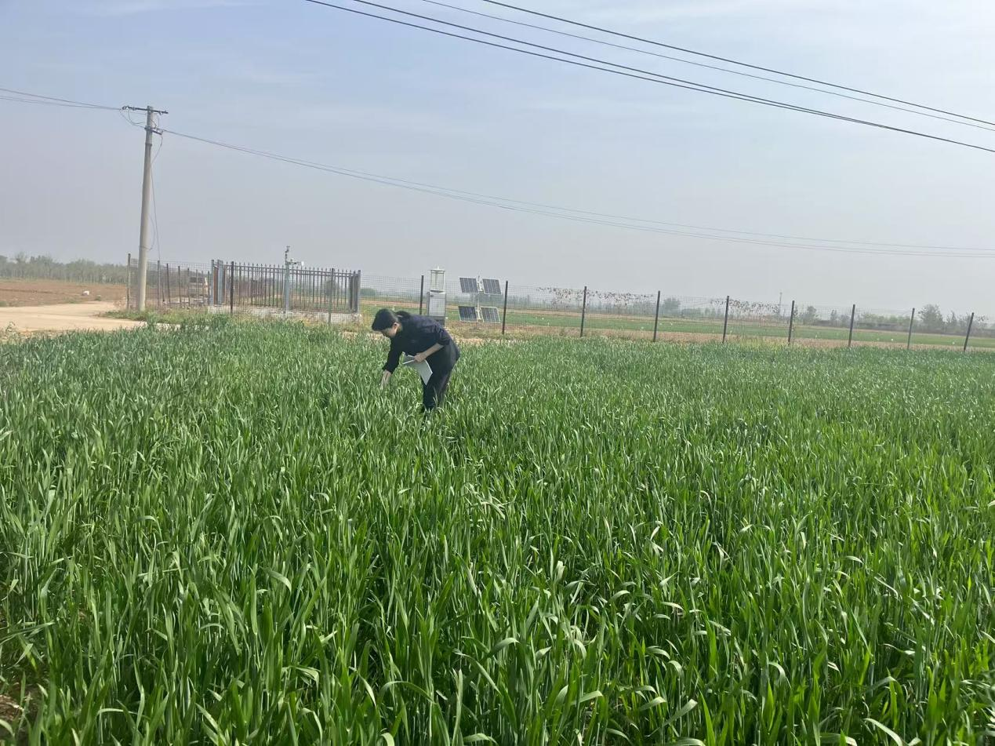
Fig. 1 Investigation on the Planting Status of Dry-Alkali Wheat at Qianying Experimental Station of Cangzhou Academy of Agriculture and Forestry Sciences

As a characteristic crop in the region, dry alkaline wheat has a planting history of more than 100 years. At present, the planting area is stable at about 4.5 million mu, accounting for about 28% of the total wheat planting area in the region. The main varieties include salt-tolerant varieties such as Jimai 32 and Cangmai 6002, with an average yield of 350-400 kg/mu, which is 20%-25% lower than that of ordinary wheat fields. The planting mode is mainly winter wheat-summer corn rotation, and some areas adopt wheat-soybean rotation mode.

(B) Main Challenges Faced
The traditional dry alkaline wheat planting method faces many difficulties: the efficiency of irrigation water is low, with an average utilization rate of less than 40%; the dynamics of soil salinization are difficult to master; the early warning of plant diseases and insect pests is lagging; and the fertilization and drug use lack precision. These problems have seriously restricted the improvement of agricultural production efficiency in saline-alkali land. With the rapid development of information technology, a new generation of information technologies such as the Internet of Things, big data, and artificial intelligence have provided new solutions to solve these problems.

(C) Economic Benefit Analysis of Traditional Planting Mode
Through the investigation and visit to more than 120 planting households, it is shown that the average production cost of dry alkaline wheat under the traditional planting mode is 680 yuan/mu (excluding land rent), of which: irrigation cost accounts for 35% (diesel electricity, labor, etc.), fertilizer input accounts for 25%, pesticide input accounts for 15%, and other expenditures account for 25%.
The average yield per mu is 380 kg, calculated at 2.6 yuan/kg, the mu output value is 988 yuan, and the net profit is 308 yuan. The input-output ratio is 1:1.45, which is significantly lower than the 1:1.8 of ordinary wheat fields. This benefit level is difficult to stimulate the planting enthusiasm of farmers, resulting in the abandonment of some marginal land.
To sum up, under the multiple backgrounds of the increasingly severe global food security situation, the rapid development of information technology, and the strong support of national policies, the research on the application of information technology in dry alkaline wheat planting is not only the inevitable trend of agricultural scientific and technological development but also the strategic need to ensure national food security, which shows important theoretical value and practical significance. This study aims to systematically analyze the current status of technology application, evaluate the actual effect, discuss the challenges faced, and put forward targeted solutions, so as to provide a reference for promoting the intelligent development of dry alkaline wheat planting.

III. Information Technology and Application Practice in Dry Alkaline Wheat Planting in Huanghua Area, Cangzhou City, Hebei Province

(A) Construction and Application of Intelligent Monitoring System

1. Application Support of UAV and Remote Sensing Technology
The multispectral UAV flies once a week with a resolution of 5 cm, which can identify the growth differences at the single plant level. The developed salt damage characteristic spectral library contains 8 typical symptoms, with an identification accuracy of 92%. After the application of the 2,000 mu demonstration area in Renqiu City, the reseeding area of salt spots was reduced by 65%.
Thermal infrared imaging is used to diagnose water stress, and the drought situation is evaluated through the difference between canopy temperature and air temperature (CWSI index). It flies once in the morning and once in the afternoon to establish a daily change model. The application results show that this method can find the drought situation 3-5 days earlier than the traditional visual method.
Satellite remote sensing is mainly used for regional scale monitoring, integrating Sentinel-2 and Landsat-8 data, with a spatial resolution of 10 meters and a revisit period of 3 days. The developed dynamic monitoring system for saline-alkali land can identify salt changes above 0.5%, providing support for township-level decision-making.
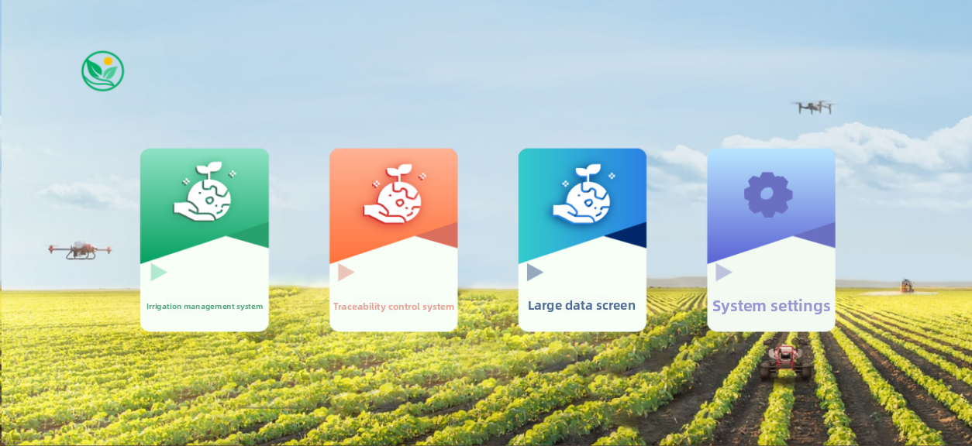
Fig. 2 Smart Agriculture Unified Management Platform
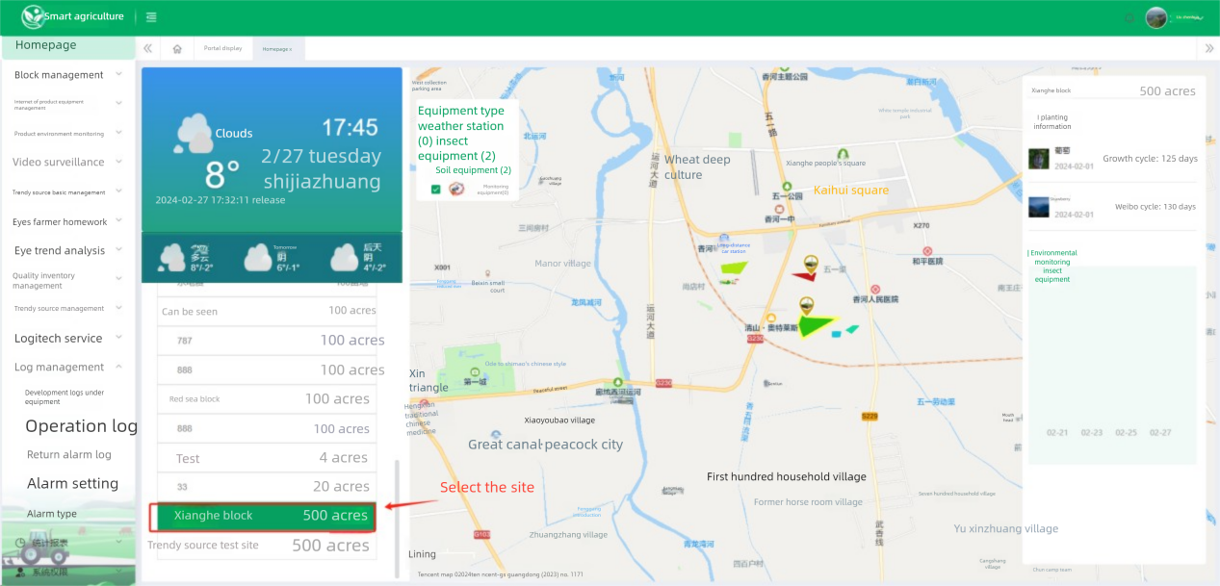
Fig. 3 Reasonable Distribution of Supporting Sensors in Plots in Smart Agriculture Platform

2. Operation of Intelligent Monitoring System
The soil environment monitoring network is composed of three layers of sensors: the surface layer (0-20 cm) monitors temperature and humidity and electrical conductivity; the middle layer (20-50 cm) monitors salt distribution; and the deep layer (50-100 cm) monitors water migration. LoRa wireless transmission technology is adopted, and a single base station can cover an area of 3 square kilometers. The application of the demonstration base in Cangzhou, Hebei shows that the system can advance the salt warning time by 10-15 days, with an accuracy of more than 85%.
In addition to conventional parameters, the meteorological micro-station specially adds evaporation and salt fog monitoring functions. The data is updated every 10 minutes, and the machine learning algorithm is used to predict the small climate change within 3 days. Compared with the data of the government meteorological station, the field scale accuracy of the micro-station forecast is increased by 30%.

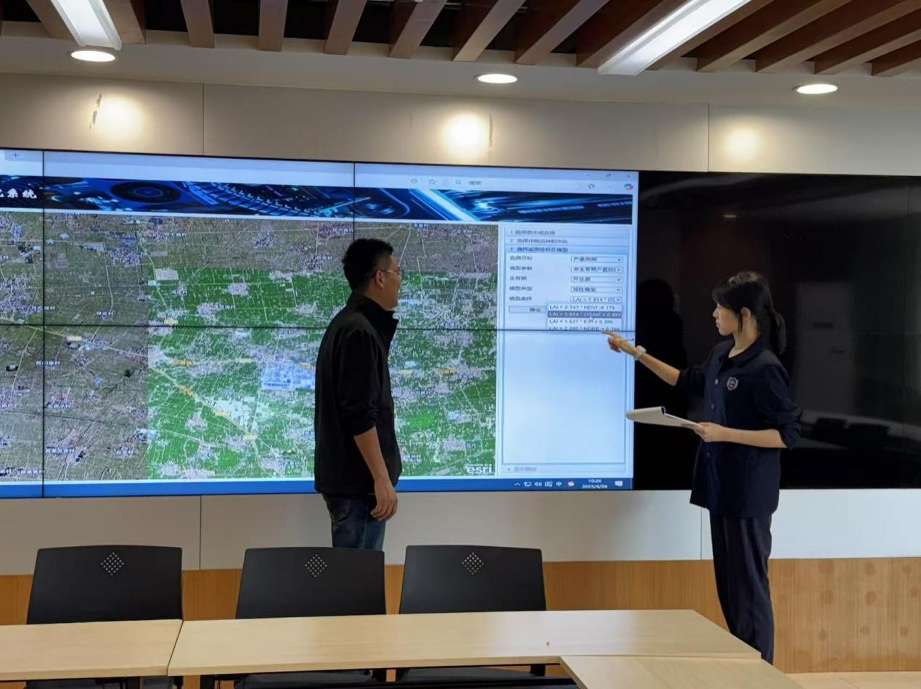
Fig. 4 Practical Application of Intelligent Detection System Based on Plant Model Algorithm

Crop growth monitoring adopts multispectral imaging technology to evaluate growth through 5 spectral indicators such as NDVI (Normalized Difference Vegetation Index) and LCI (Chlorophyll Index). The fixed monitoring equipment collects data once every 2 hours, and the mobile equipment operates as needed. Practice has shown that this technology can detect hidden nutrient deficiency symptoms 7-10 days in advance.

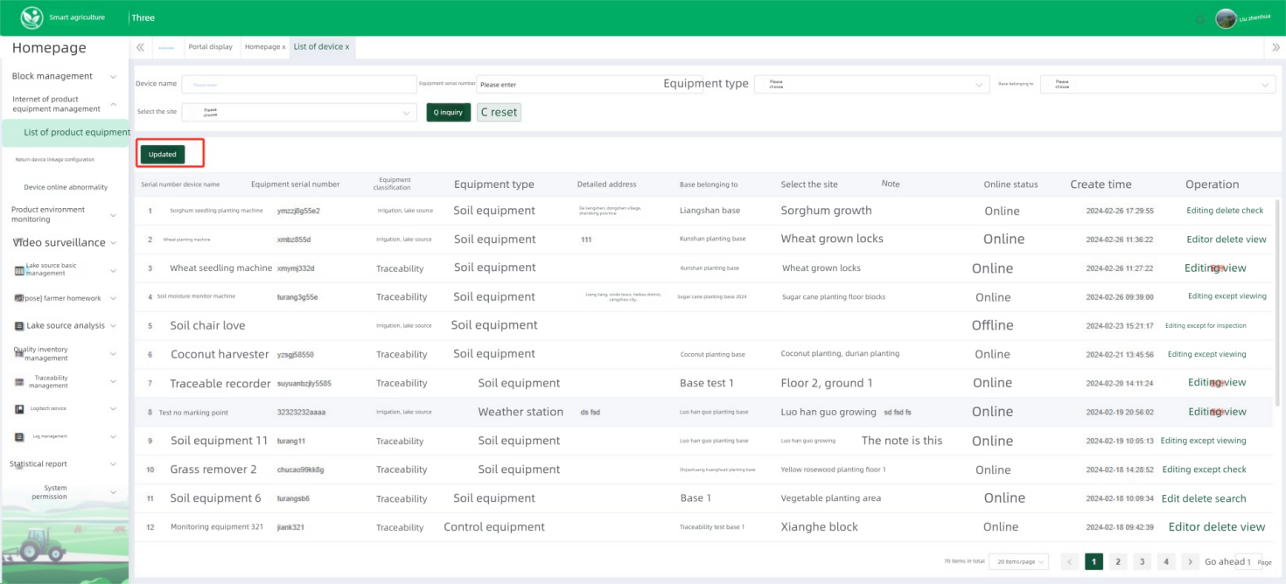
Fig. 5 Details of Information-based Auxiliary Equipment Deployed According to Requirements

(B) Construction and Application of Intelligent Decision System

1. Support of Data Analysis and Decision Platform
The agricultural big data platform integrates 5 major data sources:
(1) Real-time monitoring data (tens of thousands of pieces per minute)
(2) Historical planting records (more than 10 years)
(3) Meteorological environment data
(4) Market quotation information
(5) Expert knowledge base
The machine learning model is trained through 3 years of field test data, which can predict the salt change trend in the next 15 days with an accuracy of more than 80%. The mobile phone APP provides a visual operation interface, with an average daily active user of more than 5,000 people.
The intelligent early warning system has set up a 4-level response mechanism:
Blue warning: salt exceeds the threshold by 10%
Yellow warning: exceeds by 20%
Orange warning: exceeds by 30%
Red warning: exceeds by 50%
The system automatically pushes coping measures. For example, the blue warning suggests increasing the irrigation amount by 5%, and the red warning suggests emergency salt washing and additional application of organic fertilizer. The feedback from farmers using it shows that the early warning system has helped them reduce about 25% of disaster losses.

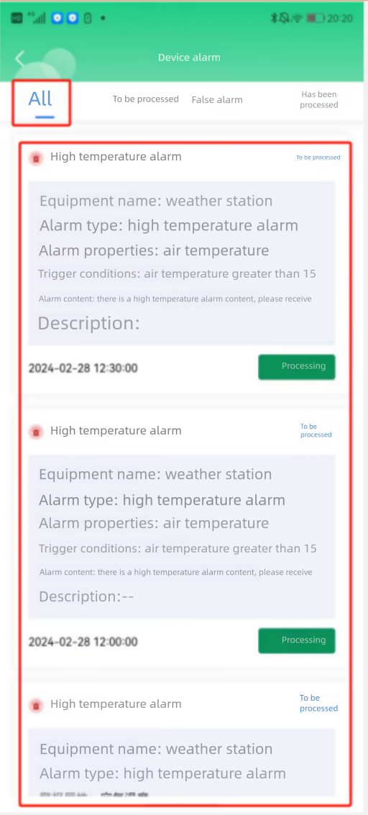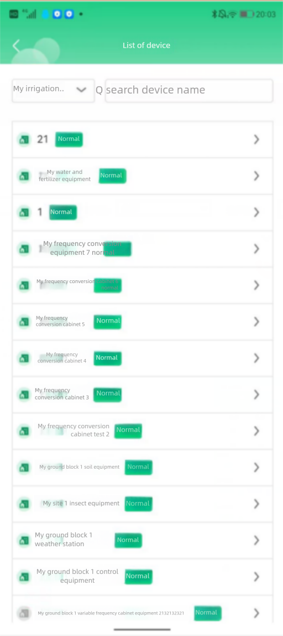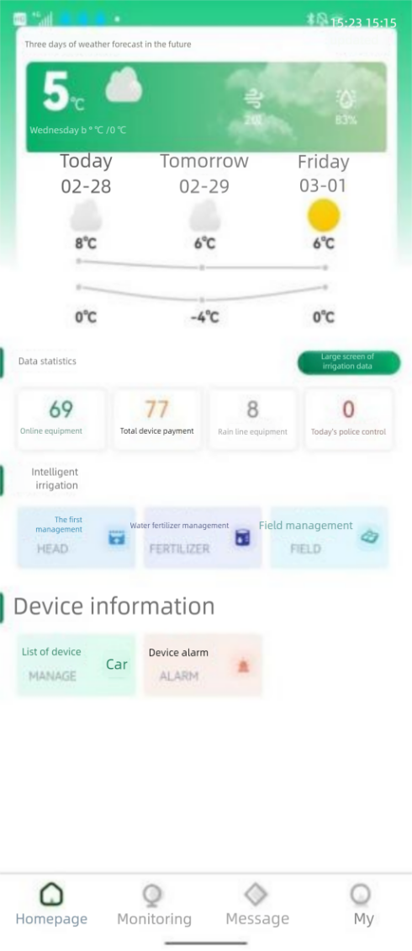
Fig. 6 Data Dashboard of Multi-element Intelligent Control Platform on Mobile Terminal

2. Operation of Intelligent Decision Irrigation System
The intelligent irrigation system integrates the three aspects of data: soil moisture, crop water demand, and meteorological forecast, and establishes a dynamic irrigation model. The system automatically adjusts the irrigation strategy according to the salt tolerance characteristics of wheat at different growth stages (for example, the salt tolerance threshold during the jointing stage is 15% higher than that at other stages). The application results in the Nanpi County project area show that while saving 38% of water, the yield is increased by 22%.
The water and fertilizer integration system adopts a pressure-compensated drip irrigation belt, equipped with an EC/pH online adjustment device. The system can automatically proportion the nitrogen, phosphorus, potassium, and trace elements in the irrigation water according to the monitoring data. A special anti-blocking drip head is developed, which is suitable for high-salt water quality. Application cases show that the fertilizer utilization rate has increased from 30% to 55%.
The brackish water irrigation technology determines the safe use scheme of brackish water with different mineralization degrees (2-5g/L) by establishing a water quality-soil-crop response model. The system automatically allocates the mixing ratio of fresh water and brackish water to expand the irrigation water source on the premise of ensuring crop safety. The test in Huanghua City shows that this technology can increase the utilization rate of brackish water by 40%.

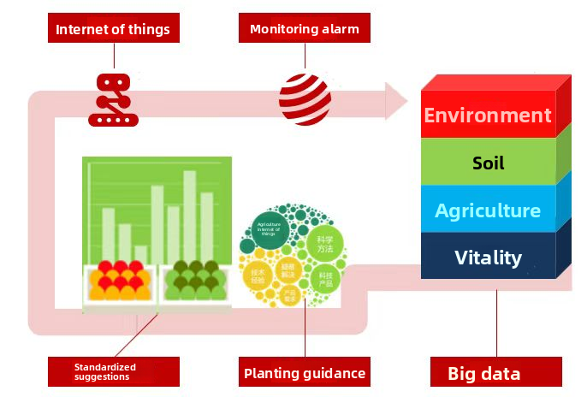
Fig. 7 AI Crop Planting Model
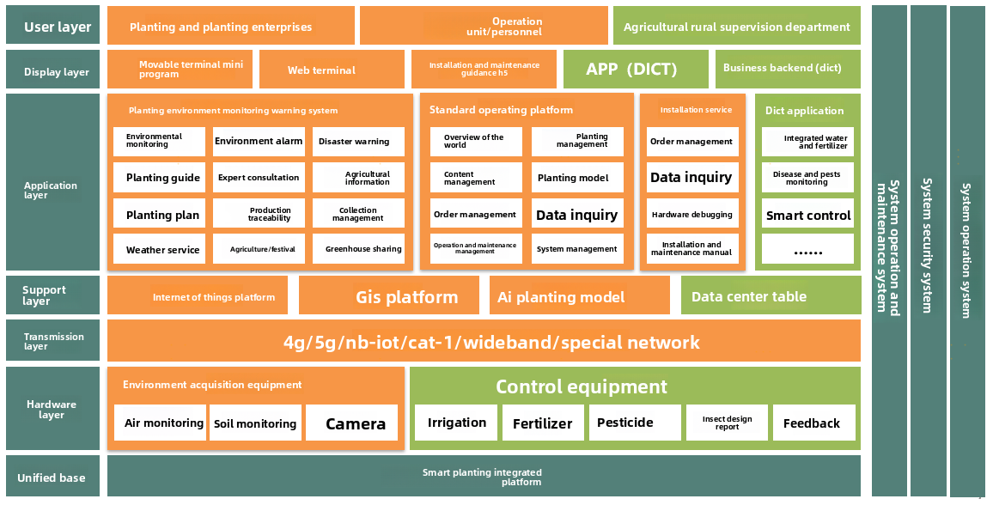
Fig. 8 Architectural Design of Big Data Model Platform

IV. Application Benefit Analysis of Information-based Auxiliary Facilities in Huanghua Area, Cangzhou City, Hebei Province

(A) Economic Benefit Evaluation
Based on the comparison data of 18 demonstration points, the economic indicators of the information-based planting mode and the traditional mode are as follows:

Indicator | Traditional Mode | Information-based Mode | Change Rate
Mu Yield (kg) | 380 | 480 | +26.3%
Irrigation Water (m³) | 220 | 150 | -31.8%
Fertilizer Dosage (kg) | 50 | 38 | -24%
Pesticide Cost (Yuan) | 80 | 60 | -25%
Manual Input (Day) | 6 | 3.5 | -41.7%
Total Cost (Yuan) | 680 | 620 | -8.8%
Net Profit (Yuan) | 308 | 628 | +103.9%

The investment return analysis shows that the average mu investment in information-based equipment is about 850 yuan (calculated according to 5-year depreciation), and the annual increased income is 320 yuan. The static investment recovery period is 2.7 years. Larger family farms (more than 100 mu) can recover the investment within 2 years.

(B) Ecological Benefit Evaluation
Soil environment monitoring data shows that in the plots where information technology has been applied for 3 consecutive years, the surface soil salt content is reduced by 0.12%-0.25%, the organic matter content is increased by 0.35%-0.6%, and the number of microorganisms is increased by 2-3 orders of magnitude. The soil respiration intensity is increased by 15%-20%.
In terms of water resource utilization, the overall water saving rate in the demonstration area reaches more than 30%, which is equivalent to saving 70 cubic meters per mu per year. Calculated according to the current planting area of 4.5 million mu, the annual water saving after comprehensive promotion can reach 315 million cubic meters, which is equivalent to the water storage capacity of 2 large reservoirs.
The carbon emission assessment shows that the information-based planting mode reduces diesel consumption by 4.5 liters per mu, which is equivalent to reducing carbon dioxide emissions by 12 kg; optimizing fertilization reduces nitrogen fertilizer loss, which is equivalent to reducing nitrous oxide (N₂O) emissions by 0.8 kg/mu. Comprehensively calculated, the carbon reduction per mu is about 35 kgCO₂e.

(C) Social Benefit Analysis
The technical training survey shows that after 2 years of promotion, 85% of the demonstration households can independently operate the mobile phone APP, 60% of the farmers understand the basic data meaning, and 30% of the large planting households can carry out simple data analysis. The labor structure has changed: the field work time is reduced by 40%, the technical management time is increased by 200%, and the proportion of farming personnel under 35 years old is increased from 8% to 15%.
At the same time, the extension benefits of the industrial chain are obvious. The order price of high-quality wheat is increased by 0.4 yuan/kg. The agricultural product traceability system drives brand building, and 5 new types of agricultural social service positions are added.
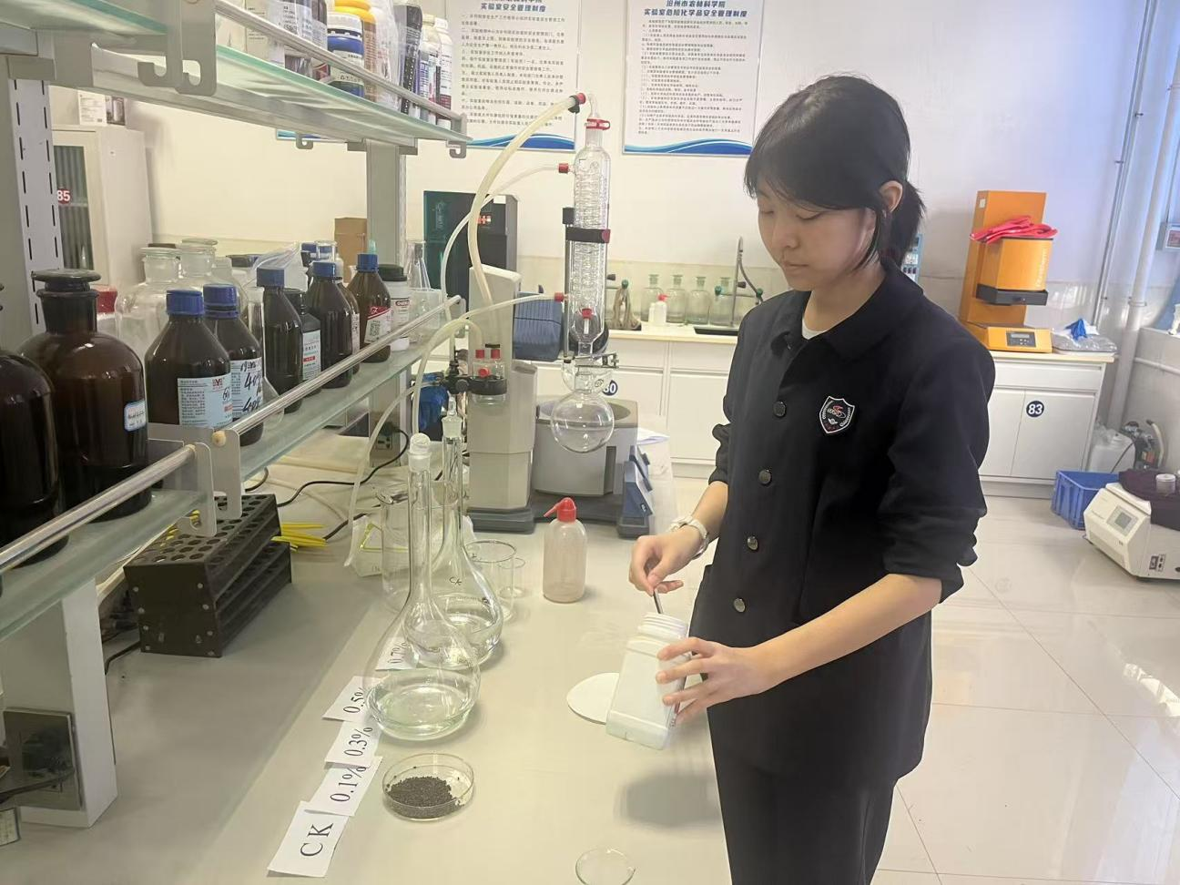
Fig. 9 Determination of Dietary Fiber and Protein Content in High-Quality Dry-Alkali Wheat

V. Problems and Countermeasures in the Promotion and Application of Information Technology

(A) Main Existing Problems
Technical Applicability: The failure rate of some sensors in extreme weather (such as sandstorms) is as high as 25%. The recognition rate of existing algorithms for new composite salinity (such as sodium-magnesium mixed types) is less than 70%, and system compatibility issues cause 30% of equipment to be unable to be used across platforms.
Economic Feasibility: For small-scale farmers (<10 mu), the equipment investment payback period exceeds 4 years. IoT data fees account for 15%-20% of annual operating costs, and the daily fees for professional technical service personnel range from 300 to 500 yuan.
Management Mechanism Barriers: 45% of village committees lack digital management capabilities. Land fragmentation leads to insufficient representativeness of data from 60% of monitoring points, and agricultural insurance does not cover losses of intelligent equipment.

(B) Solutions and Countermeasure Suggestions
Technological Innovation: It is necessary to develop wind and sand-proof sensor protective covers (tests show that the failure rate can be reduced to 5%), establish a mixed saline-alkali characteristic database, enhance algorithm recognition capabilities, and formulate unified communication protocol standards for agricultural IoT.
Business Model Innovation: It is recommended to promote a light-asset model of "equipment leasing + technical services", establish an agricultural data trading platform to monetize data, and develop a carbon trading mechanism for "water-saving indicators".
Policy Support Suggestions: If the subsidy ratio for intelligent agricultural machinery can be increased from 30% to 50%, special loan interest subsidies can be set up to support informatization transformation, county-level agricultural big data centers can be established, and the digital agricultural talent training system can be improved, all of which can enhance the promotion and acceptance of information-based auxiliary facilities at the local level.
Organizational Model Optimization: It is recommended to promote a consortium model of "cooperatives + technical service providers", develop digital services for plot trusteeship, and establish cross-regional expert remote consultation mechanisms.

VI. Development Prospects and Trend Forecast

(A) Industrial Development Forecast
Market Scale Prediction: The market capacity for informatization equipment in saline-alkali lands of the Jizhong Plain is approximately 2.5 billion yuan, with an annual follow-up service market scale of 800 million-1 billion yuan, driving the value of related industries (seed industry, agricultural materials, etc.) to increase by more than 5 billion yuan.
Expansion of Application Scenarios: Extend from single crops to rotation systems, from production links to storage, transportation and processing links, and from agriculture to ecological restoration fields.
Industrial Integration Directions: Integration of agriculture with new energy (photovoltaic + smart agriculture), integration of agriculture with cultural tourism (digital farming experience), and integration of agriculture with education and training (VR planting training).

(B) Policy Environment Outlook
National Strategy Level: The construction of digital villages has entered the 2.0 stage, the comprehensive utilization of saline-alkali land has become a national strategy, and the goals of carbon peaking and carbon neutrality promote green agriculture.
Local Policy Innovation: Hebei Province will build 10 digital agriculture demonstration zones, implement precise subsidies based on "efficiency-based compensation", and establish a system for confirming property rights of agricultural data assets.
Standard System Construction: Formulate technical specifications for smart agriculture in saline-alkali lands, establish a certification system for agricultural IoT equipment, and improve standards for agricultural data security protection.

VII. Conclusions and Recommendations

At present, the promotion and application of information technology in dry alkaline wheat planting are facing multiple practical challenges. Economically, high initial investment and continuous maintenance costs constitute the primary obstacles. The purchase cost of a set of basic IoT equipment often reaches tens of thousands of yuan, plus thousands of yuan in annual maintenance expenses, which discourages ordinary farmers. Technically, there are also problems of "inadaptability": conventional equipment frequently fails in saline-alkali environments, complex operating systems place excessively high demands on farmers' digital literacy, and algorithm models directly transplanted from ordinary farmland often fail to achieve expected effects.
Deeper problems lie in the weak promotion system. Grassroots agricultural technicians generally lack information technology expertise, and equipment failures are often not repaired in a timely manner. The existing demonstration sites are overly concentrated in state-owned farms with good conditions, making it difficult to radiate to ordinary farmers. More notably, farmers who have long been accustomed to traditional farming methods generally take a wait-and-see attitude toward these new technologies. Most of them have doubts about the effectiveness of the technologies and tend to avoid innovation risks.
To break through these dilemmas, systematic improvement measures need to be taken. The top priority is to develop economical equipment that is truly adapted to the saline-alkali land environment. By improving protection levels, simplifying operation interfaces, and developing localized models, the technology can be made truly "grounded". In terms of promotion methods, it is necessary to change the traditional administrative promotion model and establish a multi-party collaboration mechanism involving enterprises, cooperatives, and farmers, reducing the threshold for use through innovative forms such as equipment leasing and on-site training. Policy support also needs to be more targeted. In addition to increasing the subsidy ratio, supporting financial and insurance services are required to effectively address farmers' concerns.
These improvement measures need to be implemented in stages: focusing on building demonstration models and cultivating technical backbones in the short term; expanding coverage and constructing data platforms in the medium term; and aiming to form a sustainable industrial ecosystem in the long term. Only by making technology more "popular", services more "tailored", and benefits more "visible" can the "last mile" of technology promotion be truly broken through .This requires not only continuous innovation on the technology supply side, but also precise docking with user needs, and more supporting policies, which is a systematic project requiring multi-party collaboration and long-term promotion.
Through continuous innovation and systematic advancement, information technology will undoubtedly become the core driving force for the high-quality development of saline-alkali land agriculture in the Jizhong Plain, making important contributions to ensuring national food security and promoting agricultural modernization.

References
[1] Zhang Hua, Li Qiang. Research Progress on Saline-Alkali Land Improvement Technologies in China [J]. Transactions of the Chinese Society of Agricultural Engineering, 2021, 37(10): 1-12.
[2] Wang Ming, Liu Yang. Application Research of Smart Agriculture in Water-Saving Irrigation [J]. Journal of Hydraulic Engineering, 2022, 53(3): 345-356.
[3] Chen Gang, et al. Design of Saline-Alkali Land Monitoring System Based on Internet of Things [J]. Transactions of the Chinese Society for Agricultural Machinery, 2020, 51(S1): 367-374.
[4] Johnson A, et al. Remote Sensing for Salt-Affected Soils [J]. Remote Sensing, 2021, 13(5): 975.
[5] Ministry of Agriculture and Rural Affairs. Digital Agriculture and Rural Development Plan (2025-2030) [Z]. 2023.
[6] Hebei Provincial Bureau of Statistics. Hebei Rural Statistical Yearbook 2023 [M]. Beijing: China Statistics Press, 2023.
[7] Smith B. Precision Agriculture for Saline Environments [J]. Agricultural Water Management, 2022, 259: 107234.
[8] National Technology Innovation Center for Comprehensive Utilization of Saline-Alkali Land. China Saline-Alkali Land Development Report 2022 [R]. 2022.
[9] Li Wei, et al. Analysis and Application of Agricultural Big Data [M]. Beijing: Science Press, 2021.
[10] Zhou Qiang. Progress in UAV Agricultural Remote Sensing Technology [J]. Journal of Remote Sensing, 2023, 27(2): 412-425.
[11] The State Council. Opinions on Accelerating the Promotion of Agricultural Modernization [Z]. 2019.
[12] Ministry of Agriculture and Rural Affairs. Digital Agriculture and Rural Development Plan (2019-2025) [Z]. 2019.

