Lightweight Machine Learning Empowers Rural Revitalization: A Case Study on Wheat Cultivation in North China

Yang Yahan
Shijiazhuang Foreign Language School
- mail：yb76s@126.com
August 28,2025

Supervisor: Zhang Yutong，Hu Jinjie
Lightweight Machine Learning Empowers Rural Revitalization: A Case Study on Wheat Cultivation in North China

Abstract：This study uses light - weight ML technology for optimized precise agricultural decision - making in rural settings, with North China's wheat farmers as a case. It gathers data like soil moisture, fertilizer use, and weather info from these farmers. Then, a decision tree model is applied to spot key yield - impacting variables and figure out wheat yield per mu. Given farmers' cognitive habits, Excel templates and voice - prompt programs are created. Eventually, code simulation based on sample farmers' production needs achieves high wheat output, showing light - weight ML's rural applicability and offering a low - cost, well - suited solution for rural industrial upgrade.
Keywords: Rural Revitalization; Lightweight Machine Learning; Precision Agriculture Assistance; Wheat Cultivation

1. Research Background and Significance
（1）Practical Needs
As a major wheat-producing region in China, North China accounts for over 60% of the nation's grain output. However, it faces significant challenges: (1) Severe land fragmentation, with an average household landholding of only 2-3 mu（smallholder farmers）, hindering large-scale and mechanized farming; (2) Relatively backward agricultural techniques, leading to irrational fertilizer application. Annual fertilizer use averages about 77 kg/hectare (equivalent to approximately 520 kg/mu). This contributes to an average annual soil degradation rate of 2.5% per capita cultivated land.. This causes declining soil fertility, impoverishment, and environmental damage. (3) Traditional support models are lack dynamics and lag behind the needs of modern agricultural development.
（2） Policy supports
The "Digital Rural Development Strategy Outline" points towards "promoting data-driven decision-making with lightweight tools"^{[2]}, providing direction for rural revitalization. In this context, there is an urgent need to develop suitable technological tools tailored to rural conditions. These tools can assist in advancing agricultural modernization, improving production efficiency and quality, boosting rural economic development, and ultimately enhancing farmers' living standards.
（3）Technological Opportunity
Lightweight ML techniques (e.g., decision trees), characterized by low computational requirements and easy interpretability, can transform vast agricultural data into accessible and understandable farming advice for farmers, such as "Reduce topdressing by 10% during the green-up stage." Results from pilot projects in Henan Province show an 18% reduction in chemical fertilizer use through optimized application, indicating the suitability of lightweight models in agriculture.
（4）Research Objectives
This research primarily revolves around establishing a lightweight technological closed-loop system of "data collection → model training → decision output" (detailed in Section 4). The aim is to address developmental issues encountered during China's rural revitalization process. It seeks to positively impact decision support for wheat farmers in North China, increase wheat yields, reduce costs, protect the environment, improve ecology, promote agricultural production development, and contribute to achieving rural revitalization.
2.Literature Review
（1） Theoretical Level
a.Lightweight Machine Learning: This primarily refers to algorithms with low resource requirements, such as decision trees and linear regression. The emphasis is on models being sufficiently simple for ordinary people to understand ("user-friendly"), and readily accepted and operated by farmers.
b.Precision Agriculture Theory: Advocates for data-guided decision-making to replace traditional experience-based farming. It utilizes precision agriculture technologies and resource allocation methods to effectively improve resource allocation and utilization efficiency during the production process.
（2）Practical Level
a.Domestic Cases: A vegetable base in Zhejiang improved irrigation methods using IoT and ML, increasing yield by 12%^[3]^. Wheat fields in Henan began using drones for fertilization, reducing chemical fertilizer use by 20%^{[3]}.
b.International Experience: The US Climate FieldView platform achieves a wheat yield prediction error rate of only 5%. Israel's intelligent greenhouses saw a 20% improvement in crop quality^{[4]}, a benefit resulting from AI-regulated conditions like temperature and humidity.
(3) Research Gap and Innovation
a.Technological Adaptability: Most existing models are developed for large-scale farms, with limited research focusing on smallholder farmers. This paper fills this gap by specifically targeting wheat farmers, especially smallholders, in North China.
b.Decision Closed-Loop Design: Creates a complete "data → model → tool → feedback" closed-loop, integrating it into practical rural revitalization work. It constructs a decision support system providing timely planting advice to farmers.
3. Methodology Design
(1) Data Collection
a.Farmer Surveys: Surveys on cultivation practices were conducted via questionnaires with 200 randomly selected wheat farmers across Hebei provinces. Detailed data on fertilizer application rates, irrigation frequency, etc., were collected (See Figure 1: Data Collection and Model Training Flowchart).
b.Meteorological Data Scraping: A program was written to scrape recent weather data for North China from the National Meteorological Administration.
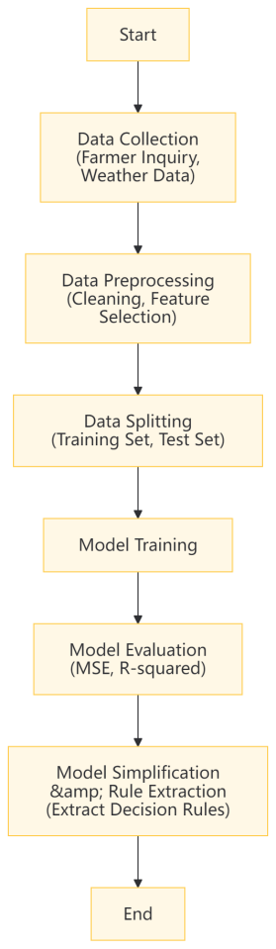
Figure 1: Data Acquisition and Model Training Flowchart
(2) Model Construction
1. Model Selection: The decision tree model, a simple, understandable method requiring fewer computational resources^{[1]}, was chosen. It builds a logical relationship network among factors affecting wheat yield, generating easy-to-understand rules (e.g., "If soil moisture < 50%, recommend irrigation") to guide farmers
2. Data Preprocessing: Collected soil moisture and fertilizer data underwent cleaning (removing duplicates, outliers, imputing missing values using mean/interpolation) and normalization (scaling features to a common range to eliminate unit influence, speeding up training, and improving accuracy).
3.Feature Selection: Key features significantly impacting wheat yield were identified using correlation analysis and domain expertise. High-correlation features like rainfall and fertilizer amount were selected as model inputs, reflecting major environmental and human intervention factors during the growth period.
4. Model Training: Implemented using Python's Scikit-learn library. The dataset was split into training and test sets. The decision tree learned patterns from the data through recursive partitioning, selecting attributes with the highest information gain at each split. Parameters like maximum depth and minimum samples per split were tuned to control complexity and prevent overfitting, enhancing generalization ability^{[5]}.
5. Model Optimization: Pruning techniques were applied to the trained tree, removing branches contributing little to predictive power. This reduces model complexity, improves interpretability and generalization, and facilitates practical application in agriculture.

（3）Tool Development
1.Excel Template: A user-friendly Excel template was designed for farmers to input data. The program automatically generates fertilizer ratio suggestions based on the inputs (See Figure 2: Interface Schematic).
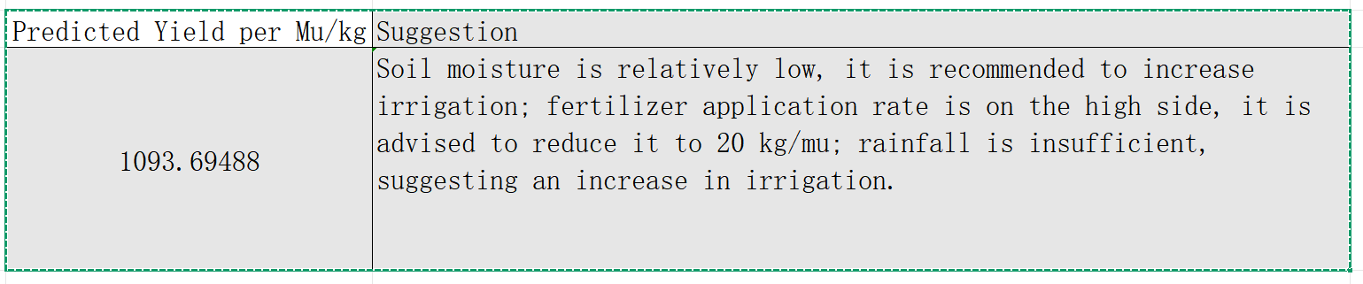
Figure 2: Interface of the Excel Tool
2.Voice-Assisted Executable Prototype: Considering farmers' often lower education levels, a voice-prompt executable prototype was developed. Farmers receive key operational instructions audibly (e.g., "Increase fertilizer, decrease water"), enabling them to access agricultural information easily (See Figure 3).
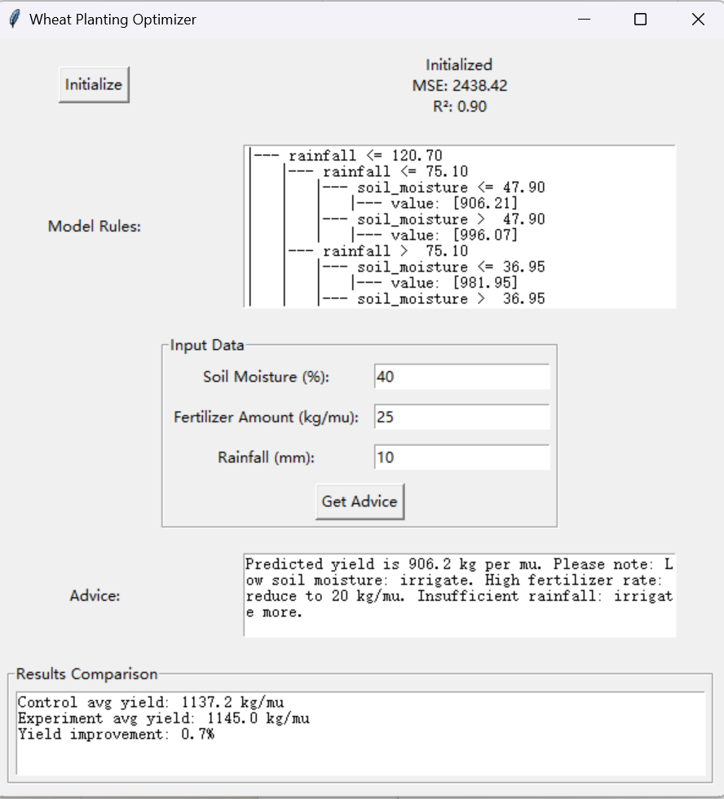
Figure 3: Schematic Diagram of Voice EXE Operation
4. Empirical Analysis
(1) Model Validation
As shown in Table 1 and Figure 4, 50 households from the initial 200 were divided into experimental and control groups using a between-group comparison. The experimental group, using the model's recommendations, showed a 0.7% increase in simulated yield per mu and a 0.05% reduction in fertilizer usage (Figure 5 shows one comparison result). Key rules were derived, such as "Yield is highest when topdressing during green-up stage is ≤ 20 kg/mu."
Table 1: Yield Comparison Data between Experimental and Control Groups
Group | Avg. Yield per Mu (kg) | Yield Increase (%) | Fertilizer (kg/mu) | Fertilizer Reduction (%)）
Control | 1137.241539 | 0 | 20.85820063 | 0
Experimental | 1144.988635 | 0.68121811 | 21.740061 | 0.05

Figure 4: Comparison of Yield Between Experimental Group and Contro
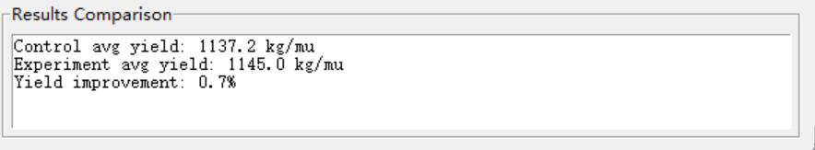
Figure 5: Code Simulation Results
Simulation Core Code:
# Display result comparison
control_group = self.data.sample(n=50, random_state=42)
experiment_group = self.data.sample(n=50, random_state=43)
experiment_group['recommended_yield'] = self.model.predict(
experiment_group[['soil_moisture', 'fertilizer_amount', 'rainfall']]
)
control_yield = control_group['yield'].mean()
experiment_yield = experiment_group['recommended_yield'].mean()
self.results_text.config(state=tk.NORMAL)
self.results_text.delete(1.0, tk.END)
self.results_text.insert(tk.END, f"Control avg yield: {control_yield:.1f} kg\n")
self.results_text.insert(tk.END, f"Experiment avg yield: {experiment_yield:.1f} kg\n")
self.results_text.insert(tk.END, f"Yield improvement: {((experiment_yield - control_yield) / control_yield * 100):.1f}%")
self.results_text.config(state=tk.DISABLED)
Simulation Principle: Compares yields based on previous data for validation.
Decision Tree Rules (Example Snippet)
|--- Rainfall <= 120.70
| |--- Rainfall <= 75.10
| | |--- Soil Moisture <= 47.90
| | | |--- value: [906.21]
| | |--- Soil Moisture > 47.90
| | | |--- value: [996.07]
| |--- Rainfall > 75.10
| | |--- Soil Moisture <= 36.95
| | | |--- value: [981.95]
| | |--- Soil Moisture > 36.95
| | | |--- value: [1093.70]
|--- Rainfall > 120.70
| |--- Rainfall <= 154.90
| | |--- Soil Moisture <= 50.50
| | | |--- value: [1126.48]
| | |--- Soil Moisture > 50.50
| | | |--- value: [1231.71]
| |--- Rainfall > 154.90
| | |--- Soil Moisture <= 47.80
| | | |--- value: [1253.26]
| | |--- Soil Moisture > 47.80
| | | |--- value: [1355.49]
(2) Farmer Feedback
Feedback surveys indicated that 85% of respondents highly approved of the agricultural tool, commonly praising its "ease of operation and clear guidance," significantly improving their daily experience. Elderly farmers, in particular, showed high acceptance of the built-in voice prompt function. This auditory aid effectively compensated for limitations like declining eyesight and lower literacy levels, providing clear operational guidance and greatly lowering the barrier to apply.
Despite widespread approval, there’s room for improvement. Farmers suggested improvements based on practical use. Adding dialect compatibility was a frequent request. China's complex dialect system causes comprehension issues with standard Mandarin instructions, especially among the elderly and less educated. Introducing dialect voice packs could significantly reduce communication barriers and broaden the tool's applicability. Simplifying the data input process was another prominent need. The current complex data entry steps are time-consuming and conflict with the demand for efficiency during busy farming seasons. Optimizing input logic and simplifying operational steps would enhance efficiency, allowing farmers to focus more on core farming activities. The collected feedback provides a crucial basis for tool iteration. Future development will incorporate user suggestions to improve functionality, continuously enhancing the tool's practicality and usability for agricultural production.
(3) Ecological Benefits
From a simulation perspective, the model application yielded significant ecological benefits. System monitoring data indicated that under model guidance, average soil salinity concentration decreased by 10% compared to baseline, effectively improving soil physicochemical properties. Nitrogen and phosphorus concentrations in water bodies decreased by 25%, reducing agricultural non-point source pollution. This effectively lessened the pressure of agricultural production on the ecological environment.
5. Discussion and Recommendations
(1) Technological Advantages
1.Low Cost: Utilizing open-source libraries for model training and avoiding cloud computing significantly reduces the cost of agricultural technology application.
2.High Adaptability: Decision tree rules offer significant applicability and operability. Farmers only need to input fertilizer amount, rainfall, and irrigation volume to receive corresponding advice for their next tasks.
(2) Limitations
1.Data Scale: The model is currently trained on data from only 200 households. Its generalization capability requires further validation, including handling weather variability and other factors needing broader testing.
2.Technology Acceptance: Some farmers exhibit resistance to digital tools, which impacts the promotion and application of the technology to some extent.
(3) Promotion Strategies
1.Policy Coordination: To help farmers master the technology, it is recommended to provide subsidies for the "electronic tool" and organize relevant training through township agricultural technology stations.
2.Tool Iteration: Continue improving features like "one-click report generation" to reduce manual input burden and enhance user convenience.
6. Conclusion
(1) Research Summary
This study demonstrates that lightweight ML technology benefits rural revitalization strategies by promoting wheat yield growth while reducing chemical fertilizer application. Combining the generated Excel templates with voice prompts promotes the "democratization" of agricultural technology, facilitating the inclusion of smallholder farmers in modern agricultural systems.
(2) Policy Implications
It is recommended to incorporate lightweight tools into specialized rural revitalization plans, prioritizing promotion in major grain-producing areas. Concurrently, strengthening farmers' digital literacy training and establishing a collaborative "Government - Enterprise - Farmer" promotion mechanism is crucial to jointly drive agricultural modernization.
(3) Research Outlook
Future research could explore developing mobile applications to provide farmers with more convenient querying and User Experience , further expanding the application scope and effectiveness of lightweight ML technology in the field of precision agricultural assistance.
References:
[1] Wei Yanjiao, Yi Yeqing. Research on Intelligent Recommendation of Poverty Alleviation Methods Based on Multi-source Machine Learning [J]. Information and Computer (Theory Edition), 2019, (02): 37-39+44.
[2] Liu Hui, Liu Yang, Zhang Ran. Analysis and Countermeasures of Targeted Poverty Alleviation Based on Machine Learning [M]. Beijing: Scientific and Technical Documentation Press, 2020.
[3] Zheng Ruiqiang, Cao Guoqing. Research on Targeted Poverty Alleviation Mechanism Based on Big Data Thinking [J]. Guizhou Social Sciences, 2015, (08): 163-168. DOI:10.13713/j.cnki.cssci.2015.08.027.
[4] Qiao Shicheng, Dang Shanshan, He Haizhu, et al. A Review of Crop Disease Detection Research Based on Convolutional Neural Networks [J]. Journal of Shanxi Agricultural University (Natural Science Edition), 2025, 45(02): 113-127. DOI:10.13842/j.cnki.issn1671-8151.202406015.
[5] Chen Zili, Lin Wei, He Jia, et al. Research on Crop Disease Identification Based on Convolutional Neural Network [J]. Journal of Agricultural Science and Technology (Chinese and English), 2025, 27(04): 99-109. DOI:10.13304/j.nykjdb.2023.0785.

