Current Promotion Status and Development Prospects
of Medicinal and Edible Homology

Cao Yuchen
Shijiazhuang Foreign Language School
Shijiazhuang,HeBei,China
E-mail: 284929724@qq.com
Supervisor:Zhang Yutong Sheng Yue

Abstract：The industry of " the medicinal and edible homology (MEH)" in China has a long history of development, rooted in the core concept of traditional Chinese medicine (TCM). It manifests in various forms such as food and health products, deeply integrating into various aspects of people's lives. To understand the current status of the " the medicinal and edible homology" industry and facilitate its rapid and healthy development, this study employs methods including literature review, field visits, and random interviews to investigate and analyze its classification, current status, and future trends.The analysis indicates that the MEH industry is a sunrise industry poised for robust and diversified growth. It will contribute significantly to the Healthy China initiative and the global health industry while promoting greater public understanding and application of traditional Chinese medicine (TCM) culture, thereby enhancing cultural confidence in Chinese traditions.

Keywords:the medicinal and edible homology (MEH), traditional Chinese medicine (TCM),the Healthy China strategy
The concept of Medicinal and Edible Homology has a long history in China, traceable to the legend of Shennong tasting hundreds of herbs. Through dynasties like Xia, Shang, and Zhou, numerous records document the study of the relationship between food and disease. For instance, the Sui Dynasty text "Huangdi Neijing Taisu" states: "When eaten on an empty stomach, it is food; when consumed by the patient, it is medicine," fully embodying the MEH concept. The Tang Dynasty's Meng Shen's "Shi Liao Ben Cao" (Dietary Therapy Materia Medica) is the world's earliest extant monograph on TCM dietary therapy, continuously enriching the MEH concept and product categories. MEH is an integral part of China's traditional TCM culture. With increasing demands for quality of life and a resurgence in TCM awareness, MEH is receiving unprecedented attention. This paper discusses its current promotion, application, and development prospects.
I. Basic Concept and Main Categories of Medicinal and Edible Homology
(I) Concept of Medicinal and Edible Homology
The primary means of TCM treatment are herbal medicine and acupuncture. However, the boundary between some medicinal herbs and food is not entirely clear; they possess both therapeutic effects and can be used as dietary substances. These are known as substances that are both food and traditional Chinese medicinal materials according to tradition, hence termed "Medicinal and Edible Homology" or "Dual-Purpose" substances. Examples include tangerine, non-glutinous rice, adzuki beans, longan pulp, hawthorn, dark plum, walnut, almond, honey, etc. Currently, 106 substances are included in China's MEH catalog. As more people emphasize dietary therapy for nutritional health maintenance, the concept of MEH has gained widespread recognition.
(II) Types of Medicinal and Edible Homology Products
Products can be broadly categorized into five types: traditional primary processed products, ready-to-eat/drink products, snack-format innovative products, functionally segmented products (health supplements), and medicinal cuisine/dishes. These cover both traditional and modern innovative forms.
Traditional Primary Processed Products: Primarily involve raw medicinal materials or simple processed forms, such as sliced or powdered herbs (e.g., American ginseng slices, Goji berries, Huajuhong slices), soup ingredient packs (e.g., stewing materials combining Angelica root, Codonopsis root), and health teas (e.g., chrysanthemum Goji tea, Spina date seed and Poria tea).
The other categories involve integrating MEH ingredients into convenient, portable, snack-format foods (e.g., functional biscuits with Chinese yam, Monkey head mushroom) to attract younger consumers, or into pre-made medicinal cuisine for daily meals, combining taste with health benefits.
II. Current Development Status of Medicinal and Edible Homology
(I) National Guiding Policies
To promote TCM development, the state initiated the classification of MEH substances as early as 1987, when the Ministry of Health first issued the "List of Substances That Are Both Food and Drugs" facilitating related research.
The "Healthy China 2030" Planning Outline (2016) explicitly stated: "By 2030, the dominant role of TCM in preventive treatment, its synergistic role in major disease treatment, and its core role in disease rehabilitation will be fully utilized."
In August 2024, China issued "The Announcement on Four Substances Including Rehmannia Root Classified as Both Drugs and Traditional Chinese Medicinal Materials According to Tradition". This brought the total number of listed substances to 106, and the MEH catalog continues to be adjusted and expanded.
On March 15, 2025, the General Office of the State Council promulgated "The Opinions on Improving the Quality of Traditional Chinese Medicine and Promoting the High-Quality Development of the TCM Industry"(Guo Ban Fa [2025] No. 11). This document requires accelerating the transformation and upgrading of the TCM industry, proposing "TCM+" to extend industrial chains, enriching the high-quality supply of health foods, medicinal food substances, and other products. It also mandates researching and formulating policies to promote the full industrial chain layout of TCM industrial enterprises.
(II) Market Situation
According to the "China Medicinal and Edible Homology Market Status Analysis and Development Prospect Forecast Report 2023-2028" released by Zhongyan Puhua Industrial Research Institute, China's MEH products entered a period of rapid growth in 2022, with the consumer market showing enthusiasm for MEH products.
Data from the "Analysis Report on Medicinal and Edible Homology Health Supplements & Nutritive Tonic Industry" by Magic Mirror Market Intelligence shows that the top ten MEH ingredients added in the Taobao Tmall market are: Ginseng, Goji berry, Donkey-hide gelatin, Honey, Black sesame, Lingzhi (Reishi mushroom), Chrysanthemum, American ginseng, Cassia seed, and Poria.
By the end of 2024, China had nearly 80,000 medicinal cuisine-related enterprises (e.g., Tongrentang, Dong'e Ejiao), over 4,000 health supplement enterprises, and 4,318 successfully registered functional foods.
According to Hejun New Consumption's "2024 China Medicinal and Edible Homology Industry Research Report", the MEH market size grew from RMB 12.99 billion in 2019 to RMB 37.23 billion in 2023. It is projected to exceed RMB 136.25 billion by 2028, indicating significant market potential.
China is actively exploring overseas markets. Beyond traditional sales channels, leveraging cross-border e-commerce and overseas warehouses, exports primarily target Japan, Indonesia, Vietnam, and other Southeast Asian countries. The export value of MEH products in 2025 is estimated to be between USD 6-7 billion. Japan is the core export destination, focusing on Chinese medicinal materials and functional foods (e.g., freeze-dried ginseng tea, and oyster peptide powder). Furthermore, the US and Europe show strong recognition for herbal functional foods, representing potential export markets.
In conclusion, the "Healthy China" strategy and related policies provide a policy guarantee for the development of the MEH industry. With the rapidly increasing recognition of TCM, the MEH product market is heating up and will see greater inheritance and development in the future.

III. Field Research Findings
To further verify the current status and future direction of the MEH industry, data was collected and synthesized through online resources, professional books, random street interviews, and field research conducted at the Anguo market, ensuring the authenticity and reliability of sources.
The field research in Anguo involved visits to key local medicinal cuisine research and development (R&D) enterprises such as the "TCM Inheritance and Innovation Base (Yaodu Yanxuan)" and the "Jinmu TCM Industrial Park," tasting local specialty "medicinal cuisine," and on-site verification of the current status and development direction of MEH.
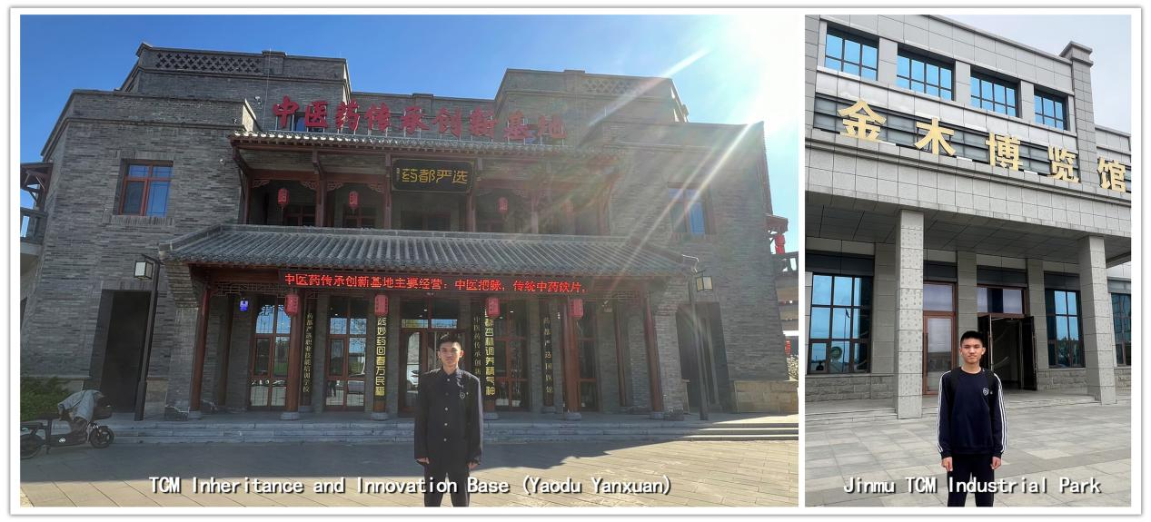
Figure 1: Research Photos
(I) Rationale for Choosing Anguo for Market Research
Anguo City (historically "Qizhou") is one of China's largest distribution hubs for Chinese medicinal materials, known as the "Millennium Medicine Capital." Anguo cultivates over 300 varieties of medicinal herbs, with 40 conventional varieties grown on an area consistently exceeding 150,000 mu (approx. 10,000 hectares). Eight renowned geo-authentic varieties – Chrysanthemum, Chinese yam, Aster root, Adenophora root, Coix seed, Schizonepeta spike, Angelica dahurica root, and Trichosanthes root – are known as "Anguo Treasures, Eight Qizhou Medicinals" and are all listed in the MEH catalog.

In 2014, "Anguo Medicinal Cuisine" was listed as an Intangible Cultural Heritage of Hebei Province. In 2023, the regional collective brand "Anguo Medicinal Cuisine" was launched. Currently, Anguo has 76 MEH production enterprises with an annual output value of RMB 680 million. The Chinese medicinal materials industry has become a pillar industry. Therefore, selecting Anguo City for market research is reasonable, typical, and representative.
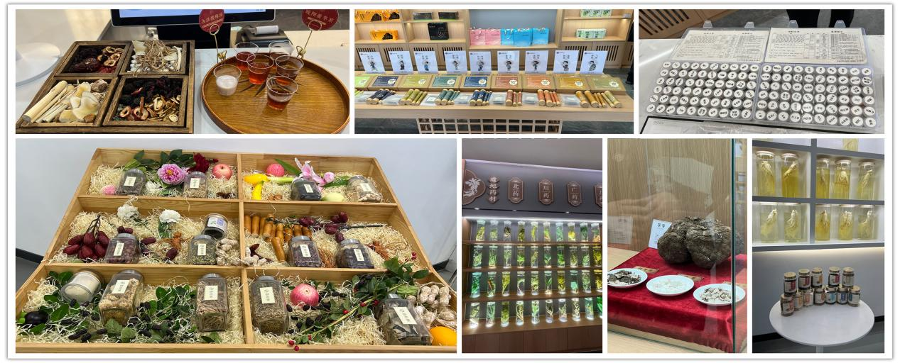
Figure 2: Research Photos
(II) Local Enterprises Prioritize MEH Product R&D
The two key R&D enterprises visited have established dedicated departments and personnel for targeted MEH product development. Taking Jinmu Group as an example, it has currently produced 12 types of nutritional meal series products suitable for different body constitutions.
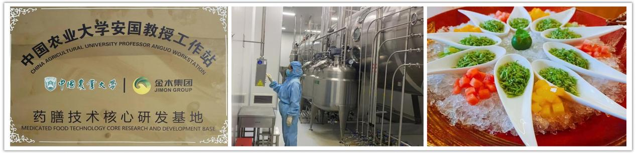
Figure 3: The plaque of Jin'mu Group Medicinal Cuisine R&D base
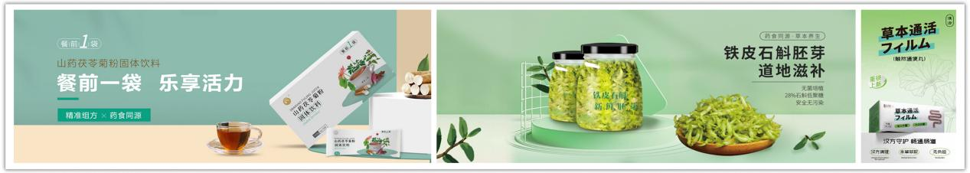
Figure 4: Promotional pictures of some products by Jinmu Group

(III) Consumer Acceptance Survey
We randomly interviewed passersby on three main topics:
1. Are you aware of Medicinal and Edible Homology foods?
2. Do you consume MEH foods regularly?
3. How do you think the MEH food market will develop in the future?
Responses to question 1 were largely consistent: "Have heard of it, but don't know the specifics."
After learning about the MEH concept and its daily applications – such as adding Goji berries or jujubes to soup, herbal teas or pear syrup in supermarkets, Goji capsules or ginseng oral liquids in the health supplement market – responses to question 2 were also nearly unanimous: "Use them often, add jujubes when cooking, drink herbal tea, elderly take ginseng oral liquid, etc."
Regarding question 3, respondents uniformly stated: "The future market is broad, but I don't fully understand the efficacy of some MEH substances. I worry that excessive intake might have adverse effects and harm health."
Analysis of the interview results shows that MEH products are frequently encountered in daily life, and acceptance willingness is high. However, understanding is superficial, and there are concerns about efficacy. Through measures such as increased publicity and quality control, there is significant room for future development.
In summary, analyzing the Anguo market reflects the general national MEH market situation. Current products show trends of diversification and rapid development. The market is burgeoning, with enterprises of various scales keen to enter this sector. The industry's future development is expected to show explosive growth.
IV. Existing Problems
To accelerate the healthy development of the MEH market, multi-party coordination is needed from the "regulatory end" to the "enterprise end" and finally the "consumer end." Only through standardized management, technological innovation, and concept popularization can this sunrise industry achieve high-quality development.
(I) "Regulatory End": Strengthen Oversight and Improve Standards
TCM standardization is the technical foundation for MEH industry development and the basis for advancing industry governance systems. The focus should be on standard formulation, strengthening quality management standards for geo-authentic medicinal materials, TCM identification, and TCM processing, and accelerating the development of digital standards and medicinal material standards.
1. The Geo-authentic Medicinal Material Supervision System Needs Improvement: The cultivation of Chinese medicinal herbs has historically emphasized origin, known as "geo-authentic medicinal materials" (Dao Di Yao Cai). These are recognized for their superior quality and stable efficacy. Among the 500 commonly used Chinese medicinal herbs, 200 are geo-authentic, accounting for 80% of the usage volume. Relevant surveys show that different ecological environments significantly impact medicinal herbs; for example, the difference in active ingredients for varieties like Gansu Scutellaria, Atractylodes, or Peony from different origins can be up to tenfold.
This necessitates incorporating seed breeding, cultivation techniques, and the geographical scope of geo-authentic production areas into regulatory oversight. Establishing and implementing quality standard evaluation systems and creating seed resource banks are essential.
2. Lack of Research and Clinical Data for Some Substances: Research and clinical data are insufficient for some substances. While common substances like Goji berry and Astragalus root have been extensively studied, the pharmacological mechanisms and clinical validation for others, such as mood-regulating substances (e.g., Gastrodia tuber), lack systematic data.
(II) "Enterprise End": Strengthen R&D Investment and Full Industrial Chain Management
1. Severe Homogeneous Competition and difficulty in Brand Building: Due to low entry barriers, new retail brands, beverage, and snack companies have entered the market, leading to severe product homogeneity and intensified competition. Emerging brands struggle to build consumer trust quickly, while traditional established brands face digital transformation pressure. Traditional pharmaceutical companies need to upgrade their channels and marketing models.
2. Weak R&D Capability: Firstly, SMEs are constrained by funds and technology, making deep R&D difficult. Secondly, there is a shortage of interdisciplinary talent (combining pharmacological knowledge and food processing technology). Insufficient research on herb compatibility mechanisms and safety evaluations can easily lead to safety hazards due to misuse or simplified processes, hindering product innovation and industry upgrading.
3. Full Industrial Chain Management: The lack of unified production standards leads to inconsistent product quality. Enterprises should gradually establish standardized systems covering the entire process and industrial chain, from geo-authentic seed breeding and cultivation to processing, ensuring product safety and efficacy.
(III) "Consumer End": Enhance Scientific Health Awareness and Avoid Blind Trend-Following
1.Insufficient Knowledge Popularization:Consumers lack scientific understanding of the efficacy and suitability of MEH products for different body constitutions. Blindly following trends may lead to health risks (e.g., excessive consumption of longan by those with a Yin deficiency constitution causing "heatiness").
2. Mismatch Between Efficacy Expectations and Reality: Younger groups prefer snack-format and ready-to-eat products but have a fragmented understanding of the "Preventive Treatment of Disease" (Zhi Wei Bing) concept. They pursue convenience while overlooking appropriate dosage and long-term safety.
V. Development Direction Analysis
Currently, multiple levels including policy, economy, culture, and social consensus provide fertile ground for MEH development. The direction shows the following trends.
(I) National Policy Direction
Policy support is a major driving force for the vigorous development of MEH. The country is accelerating the improvement of policy systems.
1. Accelerate Regulatory Framework Improvement, Upgrade Quality Standards, Implement Negative List Management:
The 2025 edition of the "Chinese Pharmacopoeia"(effective October 1st) upgrades MEH product quality standards, including pesticide residue testing for Goji berries and optimization of polysaccharide content standards for Chinese yam, phasing out low-quality raw materials and outdated processes to drive high-quality industry transformation.
The National Standardization Administration is accelerating the formulation of standards for geo-authentic medicinal materials. Standards like the "Nationally Certified Geo-authentic Production Technical Regulations" for Northern Atractylodes and Salvia miltiorrhiza will be implemented in the second half of 2025.
Implement "Negative List Management for Market Access," clearly defining prohibited ingredient lists, strengthening raw material safety assessments, and full-chain quality control. This forces enterprises to increase R&D investment and tighten industry regulations regarding issues like ingredient misuse and exaggerated efficacy claims.
2. Industry Support and Innovation Drive:
Pilot a "filing system" replacing a "registration system" for low-risk products (e.g., herbal teas, concentrated pastes), shortening the time-to-market to 3 months, and reducing time costs for SMEs.
The government launched the "Special Support Plan for Healthy Food R&D", providing R&D subsidies and tax reductions for qualified SMEs.
The Ministry of Agriculture and Rural Affairs provides subsidies of RMB 3,000 per mu for GAP-certified medicinal material cultivation bases, promoting digital management of geo-authentic materials.
The "Medicinal and Edible Homology Catalog" will continue to be dynamically expanded, promoting the industrialization of local characteristic medicinal materials.
3. Integration with the Medical System:
With the implementation of the "TCM Dietary Therapy and Medicinal Cuisine Service Specifications (2025 Edition)", dietary therapy and medicinal cuisine are being upgraded from folk remedies to "standard services" in medical institutions. Over 20,000 primary medical institutions nationwide can now file to provide medicinal cuisine services. Class II Grade A hospitals and above must establish dual modules: "Preventive Treatment Department" and "Medicinal Cuisine Nutrition Clinic." A "dietary therapy revolution" driven by policy and clinical validation is reshaping the healthcare service system.
4. Internationalization and Market Expansion:
The "Opinions on Improving the Quality of Traditional Chinese Medicine and Promoting the High-Quality Development of the TCM Industry" (March 2025) explicitly proposed a TCM internationalization strategy, supporting MEH products entering markets like Japan and Southeast Asia through cross-border e-commerce and overseas warehouses.
(II) Consumption Trend Characteristics
1. Changing Consumer Demographics:
MEH products are accelerating their shift from traditional tonics to modern functional foods. The proportion of consumers under 35 has risen significantly. Fast-paced lifestyles leading to increased health issues among young people drive their demand for "convenient + effective" solutions. Products like ginseng water and Goji berry sparkling drinks have gained popularity rapidly via e-commerce. In 2024, the health beverage market size exceeded RMB 400 billion. Additionally, segmented areas like probiotics and gut health show annual growth of around 10%. Meanwhile, as China gradually enters an aging society, middle-aged and elderly people remain the main consumer group for the health supplement industry. The penetration rate of tonic health products among the 54-64 age group in China reached 29%. The rigid demand for dietary therapy and health supplements fuels the rapid growth of the MEH market.
2. Regional Demand Differences and Market Penetration:
Demand and discussion heat are high in Tier 1 and New Tier 1 cities (over 60%), but the proportion of consumers in Tier 2 and 3 cities is also increasing. The development of products at more varied price points is gradually expanding consumption circles to lower-tier cities.
3. Product Form Innovation:
The trend towards ready-to-eat and snack formats is evident (e.g., ginseng dark chocolate, Foxnut cakes), covering multiple scenarios like office, home, and travel.
4. Steady Export Growth:
Japan, South Korea, Indonesia, Vietnam, and other Southeast Asian countries are expected to be the main drivers of future export growth, primarily due to shared cultural recognition of MEH health concepts. With the increasing influence of Chinese traditional culture, markets in Western countries like the US and Europe hold significant potential.
(III) Technological Innovation and Upgrading
Facing the triple challenge of "efficacy + taste + stability," production enterprises need to build integrated "technology + production + marketing" solutions.
1. Optimize formulations and improve processes based on existing MEH products to enhance efficacy and taste.
2. Introduce modern technologies like nanotechnology and microencapsulation to improve bioavailability and stability.
3. Develop new forms like oral liquids, sprays, and patches for ease of use and enhanced convenience.
4. Research special-purpose products, such as customized foods for specific groups like the elderly, children, and athletes, or products with liver-protecting and hangover-relieving effects.
5. Combine with the dietary cultures of target regions (e.g., Southeast Asian medicinal cuisine traditions, Japan's "Functional Foods") to develop product forms that meet local needs.
As a living inheritance of TCM culture, Medicinal, and Edible Homology is transforming from traditional tonics to diverse modern functional forms. Driven by multiple forces including policy support, upgraded health demands, and technological innovation, it exhibits strong development momentum and increasing appeal. It is believed that through further measures such as improving standards, strengthening R&D, and promoting scientific awareness, the concept and products of Medicinal and Edible Homology will become deeply integrated into the daily lives of millions of households, becoming a key pillar of the Healthy China strategy and the global health market.
Works Cited
Cai, Wanru. Medicinal and Edible Homology: Millennium-Old Wisdom of Dietary Therapy. Zhejiang Science and Technology Press, 2019: 118-123.
Hejun New Consumption. 2024 China Medicinal and Edible Homology Industry
Research Report.
[Online] Available: https://2024年中国药食同源行业研究报告「和君新消费」.

Li, Siming, et al. Medicinal and Edible Homology Varieties and Their Efficacy. ChinaLight Industry Press, 2024: 8-15.

