Serena Lin, PA School for Excellence in Ag Sciences

Harriton High School, Bryn Mawr, PA

Senegal, Factor #2: Water Scarcity

**Addressing Water Scarcity in Senegal’s Agriculture through Sustainable Irrigation**

Senegal, a West African country known for its vibrant culture and diverse landscapes. Sharing borders with Mauritania, Mali, Guinea, Guinea-Bissau, and The Gambina, it is home to a population of over 18 million. However, with its semi-arid climate characterized by varied rainfall patterns, Senegal faces significant challenges in ensuring food security for its rapidly growing population. Senegalese agriculture is highly vulnerable to water scarcity (USAID, 2023). This issue is impactful for small farmers, many of whom rely on biological cycles of rain in order to produce (Niang et al, 2017). Water scarcity greatly impacts the country’s way of life, thus, addressing this issue is crucial not only for enhancing agricultural productivity, but also for improving community livelihood, and building resilience towards climate change worldwide (Yang et al, 2023). This proposal explores the various effects and causes of water and food scarcity in Senegal and provides solutions that promote sustainable agriculture strategies. U.S. Census Bureau, U.C.B (2023). Population Pyramid [Data]. International Data Base. https://www.census.gov/data-tools/demo/idb/#/dashboard?COUNTRY_YEAR=2024&COUNTRY_YR_ANIM=2024&CCODE_SINGLE=SN&CCODE=SN


U.S. Census Bureau, U.C.B (2023). Population Pyramid [Data]. International Data

Understanding Senegal's cultural environment is crucial for analyzing the effects of water scarcity. Senegalese families are often close knit and have strong family bonds and community ties with multiple generations living together and sharing resources (Paul et al, 2020). When it comes to development, limited infrastructure, equipment, and clean resources, cause manual labor to be the driving force behind production. With family members all collaborating manually on farming tasks, having more children is the solution to becoming more productive, as a result, Senegal has a growing population consisting mainly of children around the ages of 0-4 (CIA 2021). However, access to services like education and healthcare often fall short of the growing population, especially in rural areas. Healthcare infrastructure is concentrated in urban centers, leaving rural populations with limited access to modern medical facilities and improved technologies (Paul et al., 2020). Increasing these necessary services in both rural and urban areas require more production, which in turn, require more manual labor–––creating a positive feedback loop that results in a rapidly growing population and increased food security. Addressing agricultural development starts from addressing these cultural challenges, only by improving access to essential services can all aspects of food scarcity be combatted.

Small farms dominate Senegal's rural landscape. These family-run operations typically cultivate less than 5 hectares of land, using a mix of traditional and modern farming methods to produce (Junior et al., 2023). When it comes to rainfall, it is important to note that in areas with good soil fertility, the amount of rainfall required is 600mm per year, which is necessary for successful rain-fed agriculture. As the population grows and climate change exacerbates, land rights become a pressing issue (R. Levinthal, personal communication, April 2024). Despite this, there is a growing adoption towards more modernized technologies (Niang et al., 2017). Improved seeds, fertilizers, and pesticides play a role in improving yields. These new technologies have a beneficial impact on Senegal’s infrastructure and cultural stability (Faye & Du, 2021). Furthermore, livestock play a vital role in Senegalese farming systems. Cattle, sheep, goats, and poultry are raised for meat, milk, and eggs, providing valuable nutrition and income (Junior et al., 2023). Although integrating crop and livestock production allows for recycling of nutrients and organic matter, it also increases pressure for land. (Faye & Du, 2021). Livestock production takes up 80% of global agricultural land resources, proving its investment to be inefficient and costly (Ritchie et al. 2024).

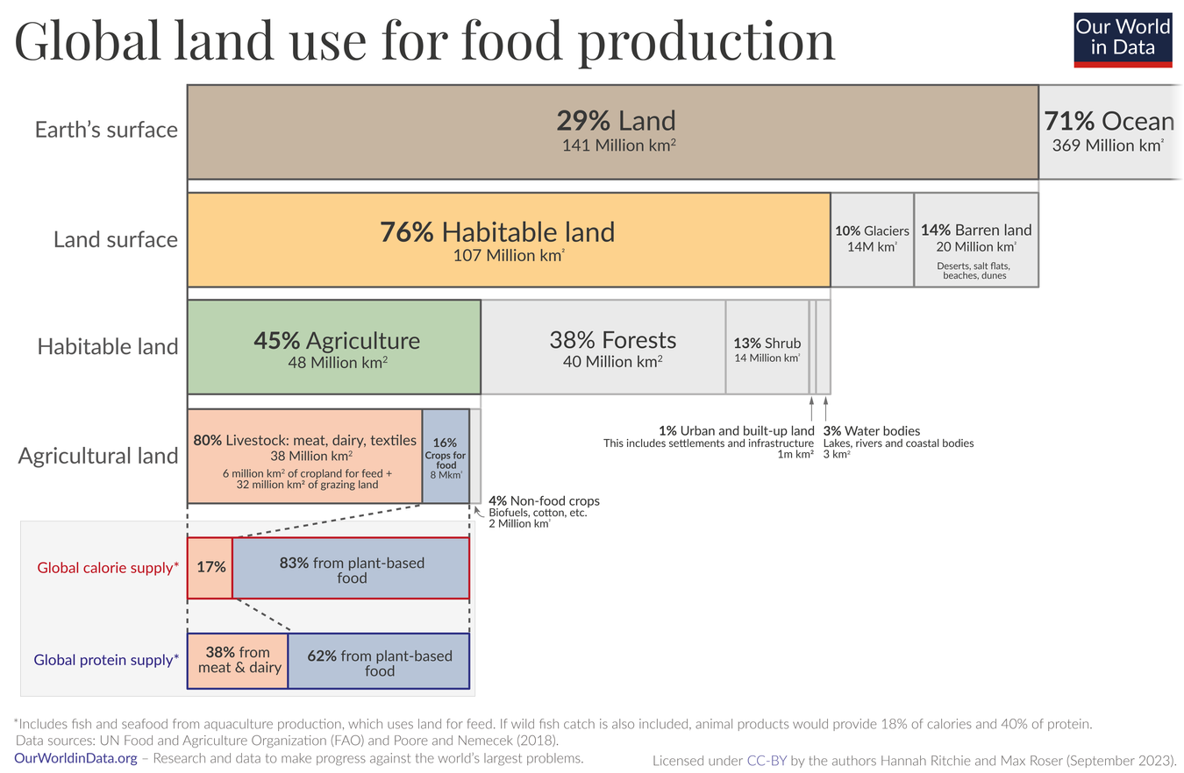Ritchie and Roser, H.R. and M.R. (2023). *Global land use for food production* [Data]. Our World in Data. https://ourworldindata.org/environmental-impacts-of-food

Water stands out as a major limiting factor for Senegalese farmers. Rainfall is highly seasonal and increasingly unpredictable due to climate change (Moller et al., 2024). Characterized by distinct rainy and dry seasons, Senegal grapples with significant water scarcity challenges, often leading to crop failures and livestock losses (UNDP, 2024). Only a small fraction of cultivated land is equipped for irrigation, primarily in the Senegal River Valley and Niayes coastal area (World Bank, 2022a). Most smallholders lack the resources to invest in irrigation equipment and rely on rainfall or manual watering, which limits their ability to expand production (Niang et al., 2017). Furthermore, advanced technologies and excessive land exploitation places additional strain on the limited water resources, making it even more difficult to grow crops and raise livestock stably. These issues include soil degradation, declining soil fertility, and limited access to quality inputs and credit (Niang et al., 2017). Other small-scale farms face the opposite issue, suffering from limited access to essential inputs such as quality seeds, fertilizers, pesticides, and machinery, primarily due to high costs and inadequate distribution network (Junior et al., 2023).

Water scarcity is a critical issue affecting agricultural productivity and food availability in Senegal. The current status of water scarcity in Senegal is dire, with the country already facing significant water stress (World Bank, 2022a). The prolonged dry season, followed by a short rainy season, limits the availability of water for crop cultivation and livestock rearing (USAID, 2023). This situation is further exacerbated by the growing population, which has nearly doubled since 2000 (World Bank, 2022b), and climate change, leading to worse droughts, higher temperatures and decreased rainfall consistency (Moller et al., 2024). Current projections indicate that water withdrawals in Senegal could increase by 30 to 60 percent by 2035 (World Bank, 2022a). These changes are expected to reduce water availability and increase the frequency and severity of crop failures (UNDP, 2024). Moreover, rapid urbanization and excessive land exploitation are additional layers of strain (World Bank, 2022a). As more land is converted for urban development and agricultural expansion, the natural water retention capacity of the landscape is diminished, leading to increased runoff and reduced groundwater recharge. Unsustainable water management practices, such as over-extraction of groundwater for irrigation and inefficient water distribution systems, further contribute to the depletion of water resources (World Bank, 2022b).

Efforts to address water scarcity in Senegal have included various advancements in water infrastructure. The Senegalese government, in collaboration with international organizations and development partners, has implemented several projects to improve water availability and management (World Bank, 2022a), including the Senegal River Basin Multi-Purpose Water Resources Development Project (MWRD), which involves the construction of dams to regulate river flow, control flooding, and provide water for irrigation and electricity generation (World Bank, 2015). Alongside this, the government has also invested in the rehabilitation and expansion of irrigation systems, particularly in the Niayes coastal area and the Senegal River Valley, to increase the area under irrigation, improve water distribution efficiency, and reduce water losses (World Bank, 2022b). Additionally, investments have been made in developing small-scale water storage infrastructure, such as reservoirs and ponds, as well as promoting rainwater harvesting techniques. These interventions help capture and store water during the rainy season, making it available for irrigation and other uses during the dry season (FAO, 2021). However, despite the advancements in technology being introduced, they are often poorly adopted due to local conditions. Often targeting one aspect of the issue, the government fails to provide the Senegalese community with solutions. Drip irrigation, a technology commonly promoted by aid organizations, often fails in the area due to sand and high temperatures clogging or damaging the plastic tubes, resulting in a lot of wasted materials (Levinthal, 2024). Furthermore, machine parts necessary for repairs of modern technologies are not readily available, leading to costly operations and wasteful equipment. Creating new technology that caters towards local conditions would be more efficient and combating water scarcity.

Tackling the intricate challenges of water scarcity and food insecurity in Senegal requires a comprehensive approach that prioritizes not only enhanced irrigation capacity, but also environmental resilience and cultural adoption. Traditional and government supplied irrigation equipment running on fuel is not only inefficient and costly, but also contributes to greenhouse gas emissions. Through partnerships with Senegalese solar technology companies, recent initiatives led by non-governmental organizations have made solar-powered pumps accessible to smallholder farmers. Solar-powered irrigation pumps have the potential to significantly enhance agricultural productivity and resilience. By providing a reliable and affordable source of energy to transport water for irrigation, these systems can help farmers decrease their reliance on natural rainfall and help them mitigate the impacts of drought, extend the growing season, and increase crop yields (Yang et al., 2023). Moreover, solar-powered pumps reduce reliance on fossil fuels, thereby contributing to climate change mitigation efforts and lowering operational costs for farmers (Sarr et al., 2021). By catering new technology such as solar-powered irrigation pumps towards specific local needs, micro-irrigation techniques, like drip and sprinkler systems, are able to significantly improve water efficiency and crop yields (Yang et al., 2023).

However, addressing the issue of food scarcity shouldn’t be narrowed to only one possibility. In addition to solar-powered irrigation systems, improving agriculture in Senegal should also include low-cost, low-tech, and low-disruption technologies that can be scaled up. Robert Levinthal, a Ph.D. candidate from the University of Pennsylvania who served as an agroforestry agent in the Peace Corps in Senegal, shared his experience in helping to run a women's vegetable garden in his village. Instead of using expensive technologies derived chemically, he chose to use organic methods to combat pesticides. He created pesticides for crops using the leaves of an abundant invasive tree species and composting the waste for fertilizer. Levinthal believes that there is an opportunity for low-cost, low-tech solutions to be brought to scale alongside modernizing agriculture (R. Levinthal, personal communication, April 2024).

The successful implementation of these solutions also require addressing the challenges faced by smallholder farmers in maintaining and repairing infrastructure. Levinthal shared that the women's garden in his village is no longer in operation because the women cannot afford to pay for a fence to keep livestock from eating their produce. This is a recurring problem in Senegal, where aid organizations pay enough for infrastructure to launch, but not enough for additional funding and repairs. The small amount of money earned from the vegetable gardens is used to support the families of the women working there, leaving very little or no money for maintenance (R. Levinthal, personal communication, April 2024). To ensure the successful implementation of solar-powered irrigation systems, it is crucial to develop long-term partnerships between government agencies, non-governmental organizations, private sector actors, and local communities. Recent initiatives led by a few organizations have demonstrated the effectiveness of collaborating with local Senegalese solar technology companies and microfinance institutions to make solar-powered pumps accessible to smallholder farmers (USAID, 2023). Scaling up these efforts nationwide cannot solely depend on connections, but will require policy innovation, such as providing targeted subsidies or tax incentives for solar technology adoption, as well as improving coordination among local administrative bodies to streamline installation and maintenance processes (World Bank, 2022a).

Funding for these initiatives can be sought from a variety of sources, including international development agencies, multilateral financial institutions, and private sector investors. The World Bank, for example, has been actively supporting water resources management and agricultural development projects in Senegal, such as the Senegal River Basin Multi-Purpose Water Resources Development Project (MWRD) (World Bank, 2022a). The Green Climate Fund (GCF) and the Global Environment Facility (GEF) are other potential sources of funding for projects that promote sustainable irrigation and climate-smart agriculture practices (GCF, 2024; GEF, 2024). Improving food security for the typical family in Senegal consists of leveraging partnerships between government agencies, NGOs, private sectors, and local communities, as well as securing funding from international development agencies and financial institutions. Furthermore, Senegal can also make significant strides towards enhancing agricultural productivity, resilience, and food security for its rural population through comprehensive approaches that prioritize the expansion of sustainable irrigation practices and the strengthening of institutional support for smallholder farmers.

Understanding these issues, I have taken it upon myself to design an effective and efficient solution to combat water scarcity in Senegal. My design centers around three main goals: environmental sustainability, zero waste, and energy efficiency. It consists of four different components: A water tank, a primary water treatment process, a drip irrigation system, and solar panels. Regular solar panels consist of a single layer of photovoltaic solar cells that work to absorb photons from the sun. These panels are usually laid out across large areas of land such as landfills or parking lots to ensure maximum energy absorption. However, my design recreates solar panels not only to maximize energy efficiency, but also to be better incorporated into Senegalese environments.

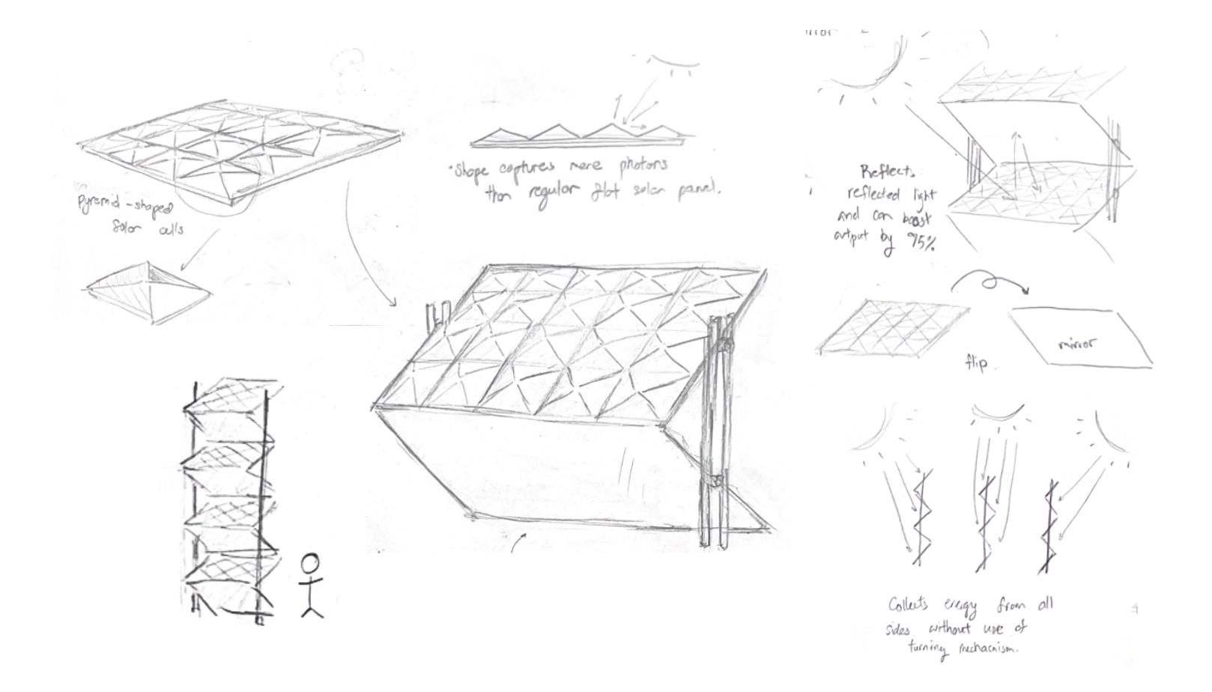

*Space efficiency*

* Solar panels stacked on top of one another each at a 90 degree angle. Building up rather than out allows for a more efficient use of space.

*Energy efficiency*

* Each solar panel is designed to be a 5x4. Solar panels use light to create electricity, each photovoltaic cell in the panel absorbs photons, harnessing electricity from the electrons the photons excite. However, when a photon strikes a PV cell, not only could it be absorbed, it could also pass through the cell or be reflected back. To increase the amount of energy absorbed, the solar cells are shaped to be a pyramid shape and cover the upper-facing layer of the panel. This allows for maximum energy absorption, creating more chances for deflected photons to be absorbed. Furthermore, mirrors are attached to the back of the panel to further maximize energy efficiency.

*System Energy*

* Each panel produces around 380-420 watts, since each stack will have 8 panels, and the average water pump requires around 100 watts. The 2nd law of thermodynamics states that with every energy transfer, some amount of energy will be lost in an unusable form. Since the solar panels will generate a large amount in the beginning, the amount of energy will be enough to sustain the water pump and continue through the treatment process and irrigation. Each stack can produce 3040 watts, enough to generate electricity for multiple farms.

*Sun Orientation*

* Regular solar panels are usually placed on rooftops facing south or north. However, since my panels face two directions simultaneously, they will be placed to face east and west. The most efficient way to organize them is by placing them in a row where one casted shadow won’t affect the other panels.

The water supply would come from natural reserves such as rainfall or underground aquifers. A 2,650-gallon above-ground collection tank would gather and store rainwater. The tank would be equipped with an opening to collect water and be connected to the system with manually operable pipes. When the pipes are opened, solar panels would power a generator. This generator would fuel an impeller, using electricity to create centrifugal force that would propel the water upward, discharging them to the next stage of the process.

After the water enters from the tank, the treatment will require 3 steps. Similar to primary treatments in wastewater facilities, this type of treatment will only be implemented at certain locations if necessary.

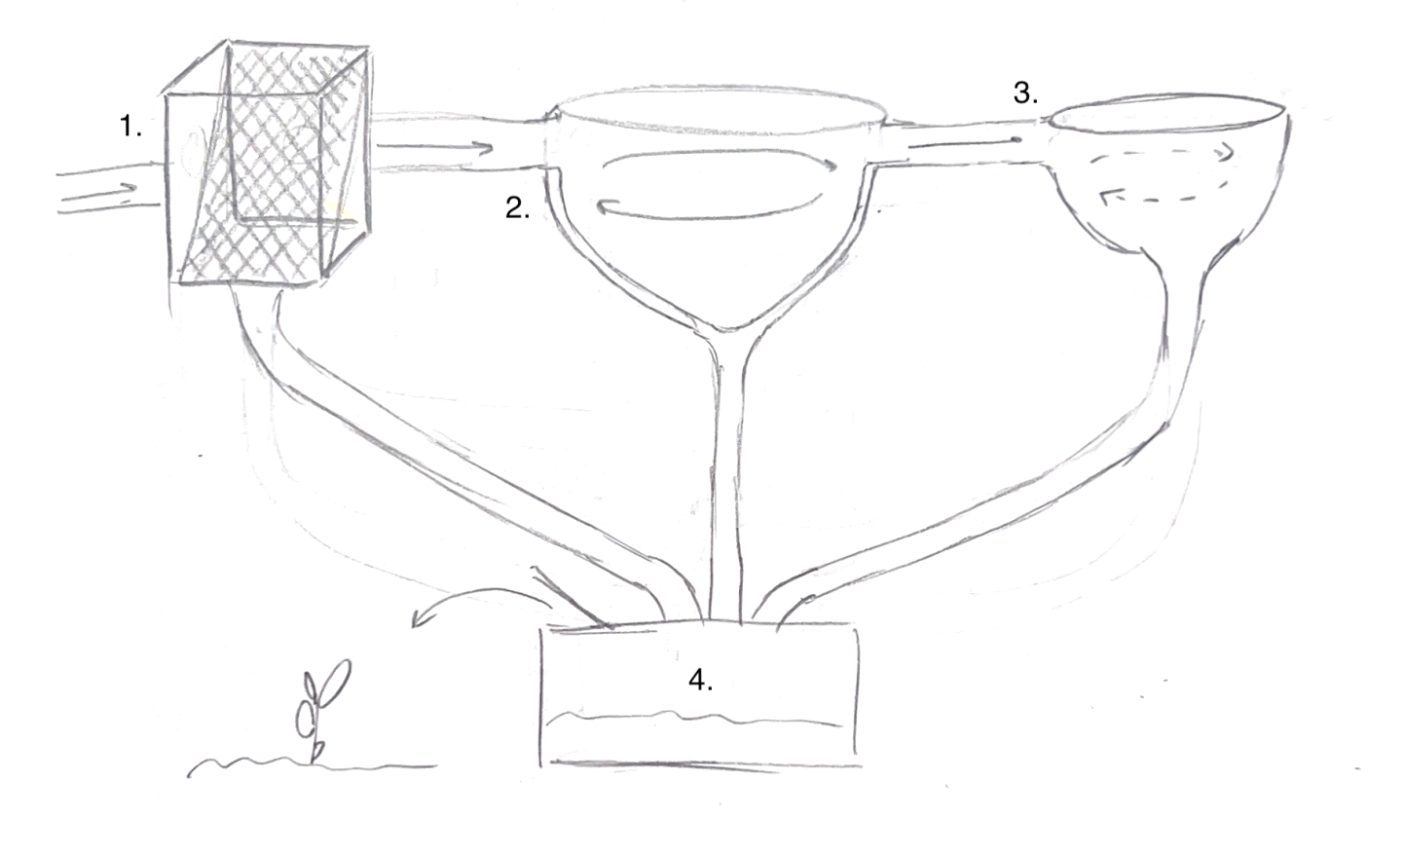

1. Bar screen: filters that screen out large, solid waste such as leaf debris.
2. Grit chamber: air is introduced into the chamber from one side. Using centripetal force, a perpendicular spiral velocity flows through the tank, causing heavier particles to accelerate and diverge from streamlines.
3. Sedimentation tank: a tank that flows water circularly, allowing suspended particles to settle out of the water tank, allowing for some degree of purification.
4. Sludge digester: wastewater sludge that was filtered out through these three processes moves through a sludge digester, which first grinds the sludge into fine particles, then dries it. The final product is a form of fertilizer that can be applied to agricultural land as fertilizer and used as biosolid compost.

The treated water would be supplied to the plants through drip irrigation. Drip irrigation is one of the most sustainable irrigation systems for agriculture, not only does it function in a way that allows plants to maintain the most nutrients, it also minimizes space, soil erosion, and labor and maximizes the amount of irrigated land. The system will save farmers time and labor and increase yields of various produce they grow such as peppers, tomatoes, eggplant, and other vegetables. Furthermore, drip irrigation applies water slowly, mimicking the natural process of infiltration and allowing water to reach the plant roots where it is needed the most.

Ultimately, water scarcity is the biggest challenge for agriculture and food security in Senegal. Issues such as climate change, population growth, and policy often work to exacerbate the problem. Climate change often leads to long dry seasons, unpredictable rainfall, and increasing water stresses which lead to lower crop yields, loss of livestock, and widespread food insecurity, especially for small farmers who depend on rainfall for their crops. When faced with limited access to education and healthcare facilities, families in Senegal can only look towards having more children as the solution, causing mass population growth, worsening the effects of food scarcity. Limited access to irrigation, soil degradation, and not having good quality inputs and credit also contribute to the problem, proper policy enforcing maintenance processes and fundings for agricultural technologies are necessary to ensure streamlined development in Senegal. Some solutions working to increase food security focuses on expanding sustainable irrigation practices. Widespread use of renewable energy-efficient irrigation systems and locally catered watering systems can greatly improve water efficiency, increase crop yields, and help smallholder farmers adapt to climate change. By addressing the underlying barriers to food production, Senegal can make a significant impact towards food security, boosting agricultural productivity all around the world.

# Bibliography

Cabral, F. (2010). What are the key factors of food insecurity among Senegalese farmers. *African Journal of Food Science*, *4*(8), 477–485.

FAO. (2021). *Rainwater Harvesting and Agroecological Irrigation Make Farmers More Resilient in Senegal*. RTP-RNE-WS. https://www.fao.org/platforms/water-scarcity/Knowledge/knowledge-products/detail/rainwater-harvesting-and-agroecological-irrigation-make-farmers-more-resilient-in-senegal/en

Faye, B., & Du, G. (2021). Agricultural Land Transition in the “Groundnut Basin” of Senegal: 2009 to 2018. *Land*, *10*, 996. https://doi.org/10.3390/land10100996

GCF. (2024). *Senegal—Green Climate Fund* [Text]. Green Climate Fund; Green Climate Fund. https://www.greenclimate.fund/countries/senegal

GEF. (2024). *Senegal—Global Environment Facility*. Global Environment Facility. https://www.thegef.org/projects-operations/country-profiles/senegal

Junior, V. N., Carcedo, A. J. P., Min, D., Diatta, A. A., Araya, A., Prasad, P. V. V., Diallo, A., & Ciampitti, I. (2023). Management adaptations for water-limited pearl millet systems in Senegal. *Agricultural Water Management*, *278*, 108173. https://doi.org/10.1016/j.agwat.2023.108173

Levinthal, R. (2024, April). *Personal interview with Robert Levinthal, Ph.D. candidate from the University of Pennsylvania and former agroforestry agent in the Peace Corps in Senegal.* [Personal communication].

Moller, K., Nejadhashemi, A. P., Talha, M., Chikafa, M., Eeswaran, R., Junior, N. V., Carcedo, A. J. P., Ciampitti, I., Bizimana, J.-C., Diallo, A., & Prasad, P. V. V. (2024). Unveiling the resilience of smallholder farmers in Senegal amidst extreme climate conditions. *Food and Energy Security*, *13*(1), e523. https://doi.org/10.1002/fes3.523

Niang, A., Sarr, N. F. M., Hathie, I., Diouf, N. C., Ba, C. O., Ka, I., & Gagné, M. (2017). *Understanding changing land access and use by the rural poor in Senegal*. International Institute for Environment and Development. https://www.iied.org/sites/default/files/pdfs/migrate/17596IIED.pdf

Paul, E., Ndiaye, Y., Sall, F. L., Fecher, F., & Porignon, D. (2020). An assessment of the core capacities of the Senegalese health system to deliver Universal Health Coverage. *Health Policy OPEN*, *1*, 100012. https://doi.org/10.1016/j.hpopen.2020.100012

Ritchie, Hannah, and Max Roser. “How Much of the World’s Land Would We Need in Order to Feed the Global Population with the Average Diet of a given Country?” *Our World in Data*, 31 Jan. 2024, ourworldindata.org/agricultural-land-by-global-diets#:~:text=a%20given%20country%3F%20%2D-,How%20much%20of%20the%20world’s%20land%20would%20we%20need%20in,diet%20of%20a%20given%20country%3F&text=Livestock%20takes%20up%20nearly%2080,as%20shown%20in%20the%20visualization).

Sarr, A., Diop, L., Diatta, I., Wane, Y. D., Bodian, A., Seck, S. M., Lamaddalena, N., & Mateos, L. (2021). Technical and Economic Feasibility of Solar Pump Irrigation in the North-Niayes Region in Senegal. *Engineering*, *13*(7), 399–419.

UNDP. (2024). *Senegal—Climate Change Adaptation*. https://www.adaptation-undp.org/explore/africa/senegal

US, CIA. “Senegal Population Details.” *Central Intelligence Agency*, Central Intelligence Agency, www.cia.gov/the-world-factbook/about/archives/2021/countries/senegal/images/507ee5e4-c389-539e-aa99-b6c5fbac6b02. Accessed 22 May 2024.

USAID. (2023, November 28). *Senega—Climate Change Country Profile*. U.S. Agency for International Development. https://www.usaid.gov/climate/country-profiles/senegal

World Bank. (2015). *Africa—Senegal River Basin Multipurpose Water Resources Development Project* [Text/HTML]. World Bank. https://documents.worldbank.org/en/publication/documents-reports/documentdetail/774031467997915272/Africa-Senegal-River-Basin-Multipurpose-Water-Resources-Development-Project

World Bank. (2022a). *Senegal Water Security: Executive Summary* [Text/HTML]. World Bank. https://documents1.worldbank.org/curated/en/099625203082232347/pdf/P17223301605d00ed0af590aabc6bf858c8.pdf

World Bank. (2022b). *Senegal—Challenges and Recommendations for Water Security in Senegal at National Level and in the Dakar-Mbour-Thiès Triangle* [Text/HTML]. World Bank. https://documents.worldbank.org/en/publication/documents-reports/documentdetail/099625003082251396/P1722330bb79db04d0993305b34176c0341

Yang, Y., Jin, Z., Mueller, N. D., Driscoll, A. W., Hernandez, R. R., Grodsky, S. M., Sloat, L. L., Chester, M. V., Zhu, Y.-G., & Lobell, D. B. (2023). Sustainable irrigation and climate feedbacks. *Nature Food*, *4*(8), 654–663. https://doi.org/10.1038/s43016-023-00821-x