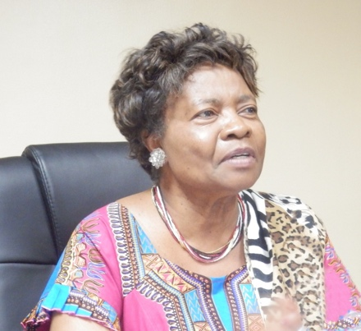Professor Ruth Oniang’o is a Kenyan graduate ofWashington State University, Pullman, and University of Nairobi. She has taught in Kenyan universities and is Adjunct at Tufts University, Massachusetts. She is President of Academy of Food Science and Technology. She spearheaded the completion of Kenya’s food and nutrition policy, facilitated the establishment of nutrition departments in Africa and has given a voice to these issues internationally. She served in the Kenyan Parliament; founded Rural Outreach Africa, to serve women smallholder farmers; and founded African Journal of Food, Agriculture, Nutrition and Development, to highlight African issues. She is Board Chair of Sasakawa Africa Association and Sasakawa Africa Fund for Extension Education, stepping into the shoes of co-founder, the late Nobel Laureate Dr. Norman Borlaug, who was president of SAA and SAFE. She received the 2014 International Food and Agribusiness Management Association (IFAMA) Lifetime Award. She is currently a member of the Board of the Centre for Agriculture and Biosciences International (CABI), which has its headquarters in the UK. She also serves on the Nestle Board.She is the 2017 joint recipient of the Africa Food Prize. In 2018 she received Honoris Causa (Doctor of Science) at the University of Aberdeen, Scotland. She is a strong advocate for Nutrition and eradication of hunger and poverty, and women empowerment and youth mentoring in Africa. She believes Africa is capable of ridding itself of the scourges of poverty and illiteracy, both very indignifying. Children of the educated are not malnourished, and those with a good income do not go hungry. Ruth uses her lifelong experiences to inspire young people. She enjoys Public Speaking to mentor and encourage the next generation into making the world a better place.

Professor Yaye Kene Gassama is acting as Chair of African Union High level Panel on Emerging Technologies and vice chair of the National Science Academy of Senegal. She was previously Minister in charge of Science and technology of Senegal. Acting as chair of African Ministerial Conference of Science and Technology (AMCOST), she actively participated in the elaboration, endorsement and implementation of the African strategy of Consolidated Action Plan (CAP) in science and Technology (African Union). She served as Ceo of the National Agency for Scientific and Applied Research and developed strategic framework for youth employment and girl’s enrollment in STI. Mrs Gassama is professor in Plant biotechnology at University Cheikh Anta Diop Dakar Senegal. As national coordinator for biosafety, she provided support and advice for development of legislative framework on biosafety for Senegal and the West Africa region.

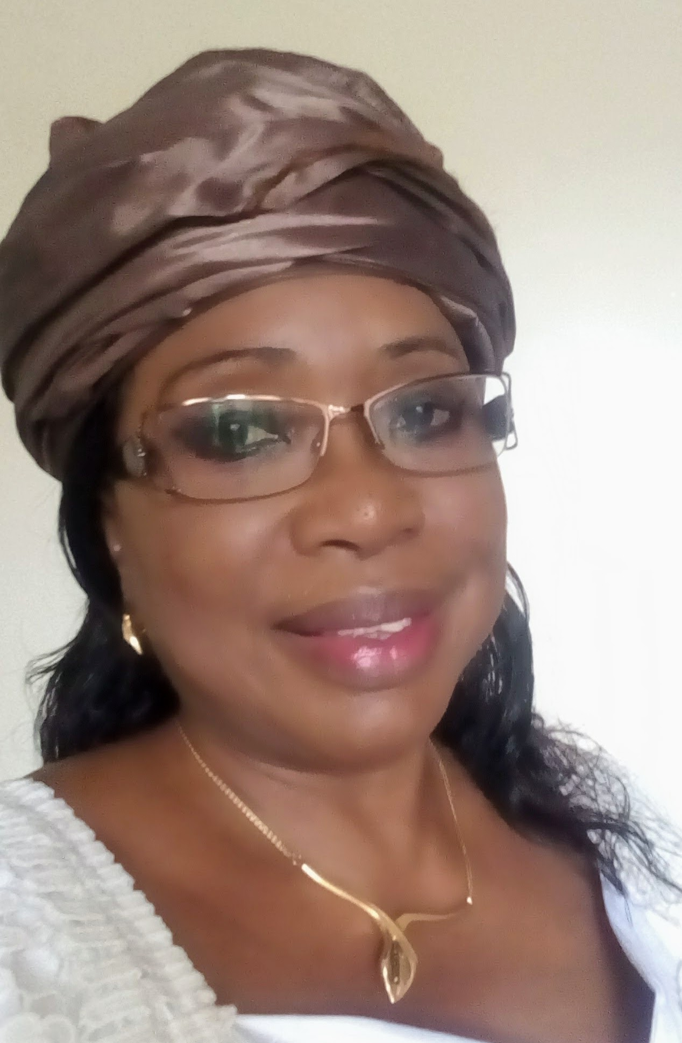

Dr. Dianah R. Ngonyama is President of the Association of African Agricultural Professionals in the Diaspora (AAAPD), which spreads across the US, Canada, Europe and Asia regions. The membership comprise of highly qualified African agricultural experts who are eager to volunteer their time and expertise on efforts that contribute to Africa’s economic transformation. She has been working in the Global Agricultural Biotech industry for +20 years covering US, Europe and Africa, and has contributed to the successful development and commercialization of various biotech traits. Dianah is very passionate about making sure that African farmers have access to advanced technologies, and that the African youth especially young women are empowered to lead agricultural development programs on the continent. In US private sector, Dr Ngonyama worked at Monsanto Company and J.R. Simplot. She led various biotech projects including the R&D phase of the WEMA Biotech Project for Africa that has potential to benefit millions of African smallholder farmers. Dianah holds a PhD in Dairy Science (Nutrition – Corn Quality traits) from University of Wisconsin-Madison, MSc in Animal and Forage Science from University of Reading, UK and an MBA degree with strong focus on Global leadership. Dianah strongly believes in leveraging partnerships between the private sector, universities, and the public sector to facilitate Africa’s transformation.

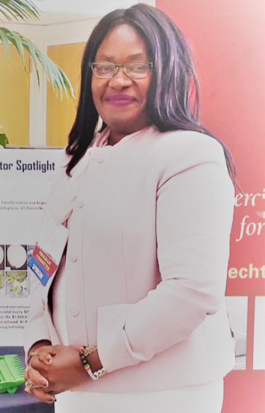

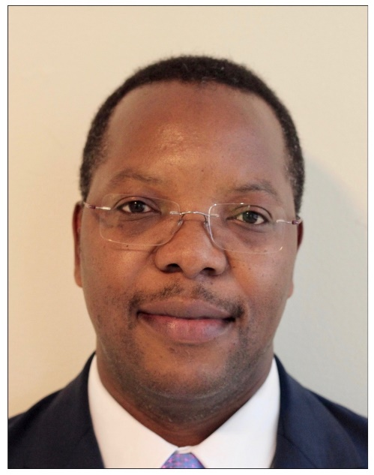

Dr. Ed Mabaya, African Development Bank, Manager - Agribusiness Development Division (AHAI.1), Agriculture & Agro-industry Department