Mechanism of Resistance in Improved Mungbean Lines against Bruchids

The World Food Prize Foundation
2018 Borlaug-Ruan International Internship

Chase Krug
Marion, Iowa

World Vegetable Center – South Asia Office
Hyderabad, India
Table of Contents

Acknowledgments…………………………………………………………………………………2
Personal Page……………………………………………………………………………………...3
Abstract…………………………………………………………………………………………....5
Introduction……………………………………………………………………………………..6-7
Review of Literature…………………………………………………………………………….8-9
Materials and Methods…………………………………………………………………………9-12
Results and Analysis………………………………………………………………………….13-23
Conclusion……………………………………………………………………………………….24
References……………………………………………………………………………………25-27

Index of Charts

Table 1. Screening of improved mungbean lines against Callasobruchus maculatus……….13-14
Table 2. Seed color of improved mungbean lines………………………………………………15
Table 3. Phenol content (GAE g⁻¹ seed) in improved mungbean lines………………………17-18
Table 4. Condensed tannin content (µg CE g⁻¹ seed) in improved mungbean lines…………18-19
Table 5. Soluble protein content (mg g⁻¹ seed) in improved mungbean lines…………………...20
Figure 1. Equipment used in the study…………………………………………………………...10
Figure 2. Experiment setup for screening of mungbean against Callasobruchus maculatus……11
Figure 3. Differentiation of mungbean seeds based on color……………………………………16
Figure 4. Seed hardness of improved mungbean lines…………………………………………..16
Figure 5. Soluble sugars (μg Glu E g -1 seed) of seeds of the improved mungbean lines………21
Figure 6. Starch content (μg Glu E g -1 seed) of seeds of the improved mungbean lines………22
Figure 7. HPLC chromatograms of AVMU 1601, AVMU 1609, V2802 and NM94…………...23

Acknowledgments
A special thank you to my supervisors Dr. Abdul Rasheed War, Entomologist, and Dr. Ramakrishnan Nair, Global Legume Breeder, for their guidance on this research project. I would like to acknowledge the World Vegetable Center South Asia staff: Dr. Warwick Easdown, Regional Director of World Vegetable Center South Asia, for allowing me to become an intern and conduct research; Bharathi Lakshmi, for her help solving any issues that have arisen throughout my internship and Yu An Chiang and Ellen for their help homogenizing mungbean samples.

I am grateful to the ICRISAT Entomology Lab for their help conducting HPLC analysis, and the ICIRSAT BioControl Lab for allowing me to use their rotary evaporator.

I would like to express gratitude to the World Food Prize for allowing me to become a 2018 Borlaug-Ruan intern.

I would like to thank the World Vegetable Center South Asia Staff, for their expression of kindness and assistance throughout my internship.

Personal Page

My name is Chase Krug and I was born in Dubuque, Iowa and grew up in Marion, Iowa. My family is not from an agriculture background and Marion, IA is an urban community. I attended and graduated from Linn-Mar High School and I am pursuing a Bachelor of Science degree in Agronomy at Iowa State University. I plan to go to graduate school to earn a PhD, and my career goal is to become an agriculture research scientist. Eventually I would like to create my own agriculture research institution. My high school agriculture science teacher, Barbara Lemmer encouraged me to become involved with the World Food Prize youth programs. Participation in the World Food Prize youth programs has inspired me to become an agriculture research scientist to assist in solving world food insecurity issues.

During the first few weeks of my Borlaug-Ruan internship, I experienced some culture shock as I got used to being for the first time in my life living on my own and having to solve problems that I ran into by myself. Through the help of the World Vegetable staff, I adjusted to life and work in India. Through my internship experience, I was able to immerse myself into Hyderabadi culture, cuisine and history of the ancient city. The cuisine of Hyderabad is rich in spices, the most popular being chili pepper, as the city is known for one of the largest spice markets in India. I was able to enjoy Hyderabad’s signature dish, Hyderabadi biryani which consists of spiced rice and meat such as goat, chicken or beef that is cooked using the dum method. My favorite part of the culture immersion experience was learning about the rich ancient and modern-day history of the city and its inhabitants. I toured the Qutb Shahi Tombs, Golkonda Fort, Chowmahalla Palace, Salar Jung Mueseum and Ramoji Film City. Through these experiences, I was able to learn about the city’s transition from different dynastic time periods and see how Persian culture influenced Indian traditions and architecture. My favorite place to visit was the Qutb Shahi tombs, the necropolis for royal members of the Qutb Shahi Dynasty. The tombs were reopened just a few months prior to the start of my internship after five years of restoration to bring the tombs back to their original splendor. I was awestruck by the beauty of the tombs that fused Persian and Indian culture. Walking through the mausoleums, admiring the craftmanship and the ancient history that took place there is a treasured memory of mine in India.

The World Vegetable Center organization is one of the world’s most renowned agricultural research organizations dedicated to promoting vegetables for development to relieve vitamin and mineral deficiencies. The World Vegetable Center is headquartered in Tainan, Taiwan with regional offices located around the world. The Asian Vegetable Research and Development Center (AVRDC), was established on May 22, 1971, its core mission is “research and development to realize the potential of vegetables for healthier lives and more resilient livelihoods” particularly in tropical Asia. In 2008, the organization changed its name to the World Vegetable Center to better reflect the globalization of the organization’s work in areas such as sub-Saharan Africa, Central Asia, and South Asia. The World Vegetable Center has amassed the world’s largest public collection of vegetable germplasm, encompassing “more than 61,235 accessions of 440 species from 151 countries”. The seed bank holds accessions of “globally important vegetable such as tomato, onion, peppers and cabbage as well as more than 10,000 accessions of traditional vegetables”. These accessions represent the large amount of genetic diversity located in domesticated plant species which have been created through artificial selection. The collection serves as a repository of genetic traits that plant breeders can use to combat new challenges from agricultural pests and climate change by breeding more resilient and resistant crop plants.
I was stationed at the World Vegetable Center – South Asia Office located in Hyderabad India. At the World Vegetable Center — South Asia Office, the legume breeding team is working on developing mungbean (Vigna radiata) cultivars that are resistant to important pests such as Cercospora Leaf Spot (Cercospora canescens), Anthracnose (Colletotrichum truncatum), Mungbean Mosaic Virus and Bruchids (Callsobruchus ssp.). Mungbean is an important pulse crop grown in areas throughout Asia and are commonly used for bean sprouts. Mungbean matures in about two months which allows it to be grown in between cereal crops such as wheat and rice. Farmers can produce another viable food crop during a period the field typically lies fallow. Mungbeans can utilize nitrogen fixation through a symbiotic relationship with specific bacteria that live in root nodules, this ability reduces the need for nitrogen fertilizer inputs and increases soil fertility. Mungbean has promise for increased production through small-holder farmers that often lack the resources to purchase inputs and to increase farmer’s annual income.
My research experiment involves finding the mechanisms of resistance in mungbean seeds that prevent or deter egg laying and feeding from Bruchid beetles and larvae. Physical seed traits that are being studied include seed color, seed size, seed hardness, seed coat hardness seed coat percentage, seed volume and weight. The goal of the experiment is to establish what traits or combination thereof results in a resistant mungbean. Consumers prefer a mungbean with a shiny green seed coat, but these varieties are highly susceptible to Bruchids. To improve seed quality in these varieties will require a deeper understanding of what traits influence Bruchid resistance. Bruchids are a major storage pest in mungbeans, storage pests are organisms which damage a crop after it has been harvested. Bruchid beetles contaminate the seed in the field or once the seed has been stored. The female bruchid beetle lays one to three eggs per seed, and typically can produce one hundred eggs. Once hatched the larva burrows into the seed and begins consuming the starch located in the seed endosperm. After pupation the beetle emerges creating a large hole in the seed with only the seed coat left, reducing seed weight and quality. Farmers can suffer heavy losses under storage conditions within a couple months. Current control methods of Bruchids under storage conditions include the use of costly toxic chemicals and or oils that can impact seed quality and food safety because they must be directly applied to the seed. Severe sickness has been reported when chemical residue on the seed was consumed. Through this research we hope to provide plant breeders with data of what traits impact Bruchid resistance. Plant breeders then can develop mungbean cultivars with innate resistance to Bruchids reducing the need for the use of toxic and expensive chemicals and maintain good seed quality.

Abstract
The purpose of this study was to identify the morphological and biochemical traits in mungbean seed responsible for resistance against bruchids. Seeds were tested for resistance by homogenizing mungbean seed and extracting compounds from the seed using techniques such as HPLC. Seed hardness was determined using a Pentrometer. This research project will impact mungbean production by reducing the amount of pesticide used to control Bruchids. Legumes are the second most important group of crops after cereals, particularly in developing countries. They are the cheapest source of dietary proteins (25-40%), carbohydrates (50-60%), fat, minerals, vitamins and amino acids such as lysine and tryptophan (Lambrides and Godwin, 2007). Mungbean also known as green gram is an important short duration legume grown widely in South and South East Asia. Bruchids are the important pest of mungbean both in field and the storage. The primary infestation occurs in the field, where female lays eggs on mature pods near the seeds. The eggs hatch and the larvae the seed testa and feed on internal content. Bruchids take a heavy toll on yield and storage losses are significant and sometimes total losses occur within 3–6 months (Somta et al., 2007; Tripathy, 2016). Biochemical compounds in seed and seed coat confer resistance to Bruchids in mungbean, but the basis of the resistance is complex and ambiguous. These factors influence egg hatching and effect larval growth and development. The resistance in Vigna species is either a result of a single component or a combination of chemicals.

Introduction
Vigna radiata commonly named mungbean or green gram is an important pulse crop in Southern and Eastern Asia. Mungbean is typically grown in rotation between two main grain crops such as rice. The seeds are consumed as sprouts or whole seeds and used in various dishes such as soup. Mungbean seeds are a good source of digestible protein that exhibits low flatulence. The lifecycle of mungbean is typically completed in approximately sixty days. As a legume, mungbean can utilize nitrogen fixation in symbiosis with soil rhizobia allowing the plant to grow well in nitrogen poor soil. Mungbean has excellent drought tolerance and can perform well in areas that are primarily rain-fed.
Major pests that affect mungbean include pod borer complex (Maruca vitrata and Helicoverpa armigera), Thrips spp., whitefly (Bemisia tabaci), cowpea aphid (Aphis craccivora), bean fly (Ophiomyia (Melangromyza) phaseoli) and bruchids (Callsobruchus spp.). Bruchids can infest mungbean in both the field and in storage but are primarily storage pests with heavy or total losses occurring within 3-6 months (Tripathy, 2016). Bruchid infestation in mungbean seed can result in weight loss, low germination, and nutritional changes which reduces the nutritional and market value possibly rendering it unfit for human consumption, agricultural and commercial uses (War et al., 2017). Female bruchids use various tactile, chemical, and physical cues to choose suitable egg-laying substrate. These include multiple sensory modalities, egg-marking pheromone, and larval feeding vibrations from the seed (Oshima et al., 1973; Ignacimuthu et al., 2000; Guedes and Yack, 2016). Current storage control methods of bruchids used include seed treatments which utilize chemicals such as carbon disulfide, phosphine, or methyl bromide. Seed quality is affected when the seed is coated in the seed treatment. Chemicals used pose a high food safety risk, severe illness has been reported when seeds with chemical residue were consumed. There are plant-based bruchid control methods which utilize plant derived extracts such as soy oil, maize oil, neem oil, hot pepper powder, custard apple and banana plants (Koona and Dom, 2005; Swella and Mushobozy, 2007). Plant-based control methods are slow to react, highly degradable and affects seed germination. (Yusuf et al., 2011). Currently, possible unintended effects on non-target organisms from the utilization of plant-based control methods cannot be ruled out (Sharma et al., 2012). Dust and wood ash has been shown to provide some protection against bruchids, but the high cost and laborious application process restricts its use and is uneconomical for resource-poor farmers (Tripathy, 2016; War et al., 2017).
Host plant resistance is an important component of pest management program against insect pests. Plant defenses against insect pests can be categorized into antibiosis; a direct effect on insect growth and development, antixenosis; a non-preference of the insect pests and tolerance; the ability for a plant to compensate for the loss of damage caused by a pest. The legume-bruchid interactions are highly specific, as one insect species feeds on a very few seed species (Somta et al., 2007).
Morphological and biochemical traits of mungbean seed contribute to insect resistance against Bruchids. Physiological and biochemical mechanisms affect the insect’s cellular processes, growth and development (Edwards and Singh 2006). Morphological traits include spines, trichomes, seed color, seed texture, seed hardness, and seed size. These traits either deter the female beetle from laying eggs on the seed or prevent the larva from burrowing into the seed. Plant secondary metabolites as phenol content, condensed tannin content, and plant defensive proteins can have toxic effect on insect pests, thus, reducing their growth and development, thereby preventing predation of bruchids on the mungbean seed. The production of secondary metabolites and anti-nutritional compounds can cause anti-metabolic activity in bruchids leading to their death (Singh 2002). Biochemical traits studied for resistance to bruchids include phenol content, condensed tannin content, soluble protein content, total starch content and soluble sugar content. In total, 43 accession lines of Mungbean were screened for these traits and compare against a commercially susceptible line and a commercially resistant line.
The main aim of this study was to identify the morphological and biochemical traits in mungbean seed responsible for resistance against bruchids. These traits would form an important component for breeding bruchid resistant mungbean and other pulses as well.
The main objectives were:
- Screening of improved mungbean lines against Callosobruchus maculatus
- Identify the morphological (seed colour and seed hardness)
- Study biochemical traits (phenol content, condensed tannin content, soluble protein content and total starch content) conferring bruchid resistance in mungbean
- Identify phenolic compounds through HPLC

Review of Literature
Bruchid Infestation in Mungbean and Control Strategies
Bruchids are an important storage pest in leguminous crops such as mungbean (Vigna radiata), adzuki bean (Vigna angularis), cowpea (Vigna unguiculata), and chickpea (Cicer arietinum). The two major bruchid pest species that are the most destructive in mungbean are Callosobruchus maculatus and Callosobruchus chinensis. The range and distribution of both species are cosmopolitan, encompassing areas in Africa, Australia, America, Oceania and Europe (Rees, 2004). Both Callosobruchus maculatus and Callosobruchus chinensis have similar lifecycles and lay eggs both in the field and in storage conditions. A female lays one to three eggs per seed, and typically can produce one hundred eggs. Once hatched the larva burrows into the seed and begins consuming the starch located in the seed endosperm. After pupation the beetle emerges creating a large hole in the seed leaving only the seed coat left. In field conditions, eggs are laid on the seed pod, while in storage conditions eggs are laid directly on the seed. Larger seed size increases surface area that can accommodate more eggs. Yellow colored seeds are preferred compared to green or black. The seed coat also influences egg laying behavior with smooth seed coats being preferred compared to the rough seed coat type.
Bruchids are generally controlled by seed treatment in storage with highly toxic chemicals, such as carbon disulfide, phosphine, or methyl bromide, or by dusting with several other insecticides. These chemicals are environmentally undesirable, and pose a great threat to food safety, besides affecting human health. These chemicals impact the seed quality because they are directly applied to the seed. Severe sickness has been reported when chemical residue on the seed was consumed. Though, plant-based extracts such as soy oil, maize oil, neem oil, hot pepper powder, custard apple extracts, and banana plant juice are being used for controlling bruchids (Koona and Dom, 2005; Swella and Mushobozy, 2007), these oils/juices are slow in action, are easily degradable, and can affect seed germination (Yusuf et al., 2011). Further, their effect on non-target organisms cannot be ruled out (Sharma et al., 2012). Dust and wood ashes do provide some control of bruchids but they are highly expensive and the treatment is laborious for resource-poor farmers (Tripathy, 2016; War et al., 2017).
Resistant Sources in Mungbean Against Bruchids
TC1996 is a wild mungbean (Vigna radiata var. sublobata) collected from Madagascar that exhibited total resistance to both species of bruchids, Callosobruchus maculatus and Callosobruchus chinensis (Fujii and Miyazaki, 1987; Fujii et al. 1989). Controlled crosses were made between TC1996 and high yielding but bruchid susceptible mungbean lines, with the goal of developing a line which merge the traits of high yield and high bruchid resistance. The resulting F₂ generation was shown to be moderately resistant to bruchids and demonstrated that resistance was genetically controlled (Asian Vegetable Research and Development Center [AVRDC], 1990b). Additional lines were created using TC1996 as an important source of bruchid resistant traits. The potential drawback of using wild crop material is the linkage drag, where unwanted wild traits are introduced into the cultivated line along with the resistant gene. World Vegetable Center has been able to identify two mungbean lines, V2709 and V2802 with complete resistance to bruchids, and the two have been the primary lines to transfer resistance genes to other cultivars (Talekar and Lin, 1981, 1982; Asian Vegetable Research Center [AVRDC], 1991).

Resistance Mechanisms in Legumes Against Bruchids
Bruchids and leguminous plants through coevolution have evolved various defensive strategies to protect themselves from the defensive strategies of the other. Legumes have evolved to produce a multitude of toxic compounds which deters or kills bruchids. Host plant resistance in mungbean against bruchids can be integrated with other control measures to provide a better, safe and sustainable management of bruchids. Development of bruchid resistant cultivars has been a major objective of mungbean breeding projects. Host plants use three strategies to resist and or cope with insect pest’s antibiosis, antixenosis (non-preference) and tolerance (Talekar and Lin, 1992; Edwards and Singh, 2006). Resistant traits can be morphological, physiological and biochemical. Biochemical traits can include secondary metabolites and anti-nutritional compounds which affect the metabolic activity in bruchids (Sarikarin et al., 1999; Appleby and Credland, 2003; Lattanzio et al., 2007). Antixenotic traits which deter oviposition by insect pests prevent a high build up and or infestation. These traits can include surface chemicals, plant volatiles, spines and hairs (Watt et al., 1977; Petzold-Maxwell et al., 2011; War et al., 2013). Resistance strategies can involve the host plant’s seeds which directly or indirectly prevent insect oviposition by killing the insect’s eggs to avoid larvae hatching, preventing future damage (Doss et al. 2000; Petzold-Maxwell et al., 2011). Seed traits which can contribute to resistance against bruchids include seed color, texture, hardness, size and chemical constituents (Asian Vegetable Research and Development Center [AVRDC], 1979, 1981; Sarikarin et al., 1999; Appleby and Credland, 2003; Lattanzio et al., 2005; Somta et., 2007). Biochemical compounds that contribute to bruchid resistance include naringenins, vicillins, cysteine rich protein (VrD1 or VrCRP), vignatic acids (A and B) and para-amino phenylalanine (Brich et al., 1986; Sugawara et al., 1996; Chen et al., 2002; Somta et al., 2007). Mungbean seed is composed of lignins, quinines, alkaloids, saponins, non-protein amino acids, polysaccharides and anti-nutritional seed proteins which include lectins, phytohemagglutinins (PHA), and proteinase inhibitors. Bruchid resistant mungbean varieties exhibit higher levels of trypsin inhibitors compared to susceptible varieties. The a-amylase inhibitors are an important biocontrol agent against bruchids, when consumed the inhibitors interfere with the bruchid’s digestive enzymes. Plants use a-amylase inhibitors against a large variety of insect pests such as Homoptera, Diptera, and Lepidoptera (Macedo et al., 2007; Vandenborre et al., 2011; War et al., 2012).
To combat these chemical defenses, bruchids have evolved strategies to combat the effects of these toxic chemicals such as breaking them down into less toxic or non-toxic products.

Material and Methods
Chemicals
The chemicals used in this study were of analytical grade. Bovine serum albumin (BSA), tannic acid, vanillin, disodium hydrogen phosphate, sodium dihydrogen phosphate, sodium carbonate (Na2CO3), acetone and vanillin were obtained from Sisco Research Lab., Mumbai, India. Bradford reagent, Folin-Ciocalteau reagent

Instruments
The Centrifuge (5430-R) and UV Vis-spectrophotometer (Biospectrometer-basic) used for the estimation of biochemical parameters were from Eppendorf, (Hitachi, Japan). Seed hardness was determined using the Texture Analyzer-Penetrometer(Model: TR Turoni, Italy). Solvents were concentrated by Buchi Rotovapor R-205 (Buchi, Switzerland). The HPLC system used was of Waters Series consisting of a Separation module (2695) with Controller (600) and equipped with photodiode array detector (2996).
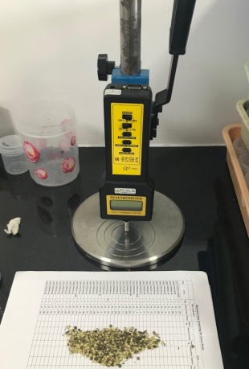
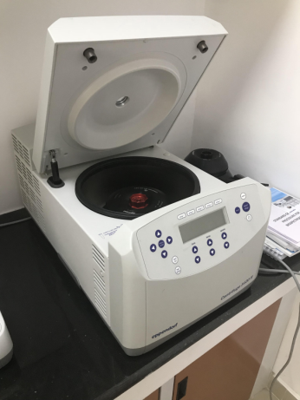

(a) Centrifuge (b) Spectrometer (c) Penetrometer
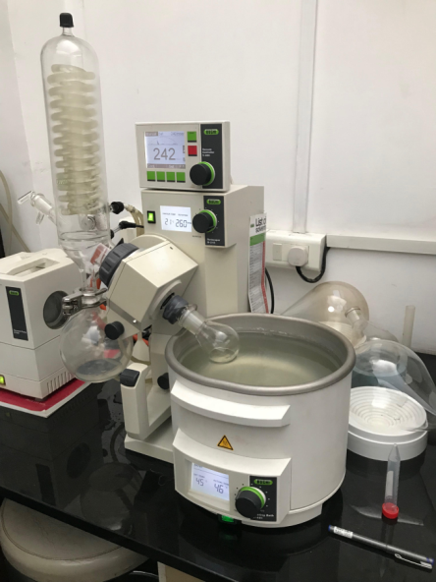
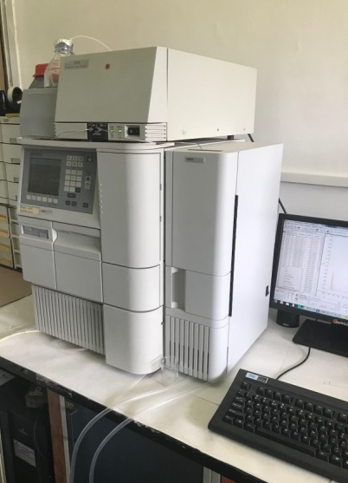

(d) Buchi Rotovapor (e) HPLC system
Figure 1. Equipment’s used in the study

Screening of Improved Mungbean Lines Against C. maculatus
AVMU lines (44) along with resistant (V2802) and susceptible (NM 94) checks were screened against C. maculatus. Fifty seeds of each line were taken in separate vials and five pairs of adults of bruchids (1-2 days old) were transferred into the vials. Three replications were maintained for each line. After seven days of release, the test insects were removed from the vials and the total number of eggs laid on the eggs was counted. Also, the number of seeds with eggs was counted. Eggs laid on the walls of the vials were not considered. From 30 days onwards to 45 days, number of damaged seeds and the number of adults emerged were recorded.
Number of damaged seed
Damage (%) = ---------------------------------- X 100
Total number of seeds

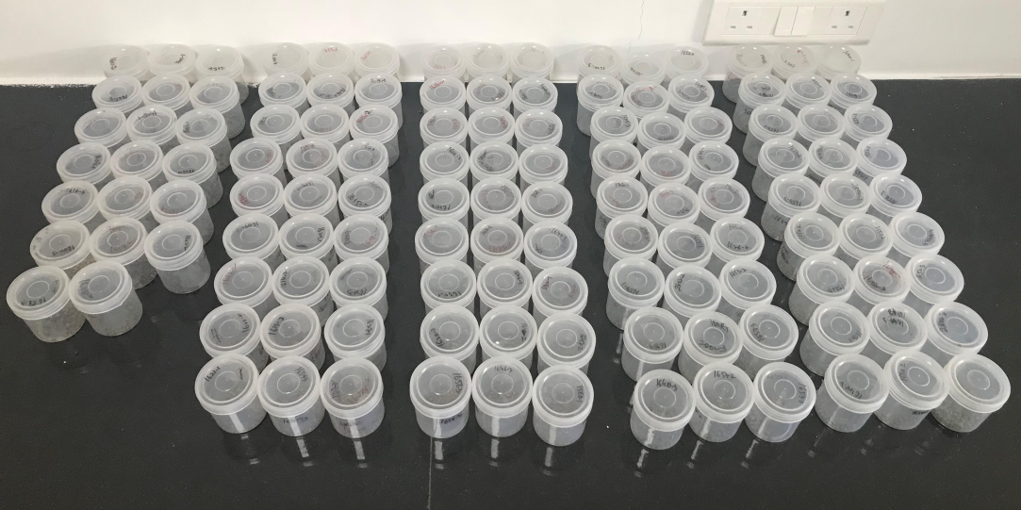
Figure 2. Experiment setup for screening of mungbean against Callosobruchus maculatus

Morphological Traits Against Bruchids
Seed Colour and Lustre
Seed colour and seed lustre were determined visually and the seeds were grouped into shiny green, dull green and brown colours.
Seed Hardness
Seed hardness was determined using the Texture Analyzer –Penetrometer (Model: TR Turoni, Italy). The hardness of grains was measured with comparison test. Pressure was exerted on an individual grain until it cracked and the cracking point was recorded in newtons.

Evaluation of Biochemical Traits of Seed
Estimation of Phenol

For extraction of total phenol, 0.5 g of mung bean seed was homogenized with 3 ml of 99% methanol with a pestle and mortar and centrifuged at 10000 rpm for 20 min. The supernatant was collected and the residue was re-extracted with same extraction described earlier. The supernatants were pooled together in a test tube and evaporated to dryness in hot water bath. The residue was dissolved in 5 ml of distilled water and the extract used as a source of total phenol (Malik and Singh, 1980). Total phenolic contents were estimated spectrophotometrically by Folin- Ciocalteau reagent method with slight modification. Different aliquots of samples (0.5 mL) were pipetted out into test tubes. 0.5 mL of Folin-Ciocalteau reagent was added. The solution was allowed to stand for 3 min and 2 mL of 20% Na2CO3 solution was added to each tube. The contents were mixed thoroughly. The tubes were kept in boiling water for exactly one min, cooled and the absorbance was measured at 760 nm against a reagent blank. Prepare a standard curve with different concentrations of Gallic acid. The results are expressed as μg of gallic acid equivalent (GAE/ μg) per gram of the extracts.

Estimation of Condensed Tannins

Condensed tannins content was estimated by following the method of Lattanzio et al. (2005) with slight modifications. For extraction of tannin, extract 100 mg seed powder with 5ml of acetone: water (70:30 v/v) mixture in a water bath at 30 0C for 30min and vortexed at frequent intervals. Centrifuged the sample at 10,000 rpm for 15 min and collect the supernatant. Repeat the extraction, combine supernatants and evaporate to dryness at 80 ⁰C, make the extract to 2 ml with distilled water. Condensed tannin content was estimated by Folin Ciocalteau method and the results are expressed as tannic acid equivalents from a standard graph prepared from various quantities of tannic acid. To 0.5 ml of extract, 0.5 ml of Folin Ciocalteau reagent (1:1 diluted with distilled water) was added followed by the addition of 1 ml of 20% sodium carbonate. The solution was made upto 10 ml with distilled water and incubated at 25- 30 °C for 40 min. The absorbance of the blue color developed was read at 725 nm in using UV-VIS spectrophotometer.

HPLC Analysis of Phenols
Methanol extracts were vacuum evaporated and filtered through a polyvinyl difluoride filter (PVDF; Millipore, Millex-GV, filter 0.22 diameter) membrane. Separation of the compounds was performed on an Atlantis C18 column (4.6 mm × 250 mm) at a flow rate of 1 mL minute-1 for 40 minutes with 20 µL injected volume of the extract. The column was used at ambient temperature. The mobile phase was water (A) and acetonitrile (B) (v/v) containing 1% orthophosphoric acid. The mobile phase was filtered through a 0.45 µm membrane filter and deaerated using a sonicator (D-Compact, 443). The elution profile used was 0–5 minutes, 65% A, 35% B (isocratic); 5–12 minutes, 35%–40% B in A (linear gradient); 12–20 minutes, 40%–45% B in A (linear gradient); 20–30 minutes, 55% A, 45% B (isocratic); 30–35 minutes, 45%–35% B in A (linear gradient); and 35–40 minutes, 65% A, 35% B. All compounds were identified by comparing their HPLC retention times to those of authentic standards. The peak area of each identified compound was transformed into quantities of the compounds and was expressed in nanograms using internal standard peak areas.
Results and Discussion
Screening of Mungbean Improved Lines Against C. maculatus
Improved mungbean lines AVMU1601, AVMU1602, AVMU1603, AVMU1604, AVMU1605, AVMU1606, AVMU1609, AVMU1610, AVMU1611, AVMU1612, AVMU1613, AVMU1614, AVMU1616, AVMU1617, AVMU1618, AVMU1619, AVMU 1620, AVMU 1621, AVMU1622, AVMU1623, AVMU1624, AVMU 1625, AVMU1626, AVMU1627, AVMU1628, AVMU1629, AVMU1630 showed no damage (%) in the seeds (Table 1). Although the eggs were laid on these lines, there was no hatching of the larvae. This can be attributed to either physical traits usch as seed hardness of the biochemical traits that could either kill the eggs of the first instar larvae emerging from them (Van Huis and De Rooy, 1998; Lattanzia et al., 2005; Soumia 2015). Heavy damage was observed in the susceptible check, NM 94 (98.4%) followed by AVMU 1659, AVMU 1657 and AVMU 1651 (64% each).
Table 1. Screening of improved mungbean lines against Callasobruchus maculatus
Mungbean line | No. of seeds | No. of Bruchid pairs | No. of seeds with eggs | Total no. of eggs | No. of damaged seed | No. of adults emerged | % Damage
AVMU 1601 | 50 | 5 | 46 | 64 | 0 | 0 | 0
AVMU 1602 | 50 | 5 | 49 | 58 | 0 | 0 | 0
AVMU 1603 | 50 | 5 | 49 | 71.3 | 1.7 | 1.7 | 3.3
AVMU 1604 | 50 | 5 | 49 | 62 | 0 | 0 | 0
AVMU 1605 | 50 | 5 | 48 | 75 | 0 | 0 | 0
AVMU 1606 | 50 | 5 | 47 | 57.3 | 0 | 0 | 0
AVMU1607 | 50 | 5 | 45 | 78.9 | 0 | 0 | 0
AVMU 1609 | 50 | 5 | 49 | 86.7 | 0 | 1 | 0
AVMU 1610 | 50 | 5 | 49 | 77.7 | 0 | 0 | 0
AVMU 1611 | 50 | 5 | 50 | 79.7 | 0 | 0 | 0
AVMU 1612 | 50 | 5 | 50 | 101.3 | 0.7 | 0.7 | 1.3
AVMU 1613 | 50 | 5 | 48 | 77.3 | 0.3 | 0.3 | 0.7
AVMU 1614 | 50 | 5 | 50 | 63.7 | 0 | 0 | 0
AVMU 1615 | 50 | 5 | 50 | 76 | 0 | 0 | 0
AVMU 1616 | 46 | 5 | 49 | 102 | 0 | 0 | 0
AVMU 1617 | 40 | 5 | 49 | 93.7 | 0 | 0 | 0
AVMU 1618 | 50 | 5 | 50 | 76.3 | 0 | 0 | 0
AVMU 1619 | 50 | 5 | 48 | 62 | 0 | 0 | 0
AVMU 1620 | 50 | 5 | 50 | 64 | 0 | 0 | 0
AVMU 1621 | 50 | 5 | 49 | 56.3 | 0 | 0 | 0
AVMU 1622 | 50 | 5 | 50 | 92 | 0 | 0 | 0
AVMU 1623 | 50 | 5 | 49 | 63.3 | 0 | 0 | 0
AVMU 1624 | 50 | 5 | 48 | 77 | 1 | 0.7 | 2
AVMU 1625 | 50 | 5 | 49 | 67 | 1.7 | 1.7 | 3.3
AVMU 1626 | 50 | 5 | 49 | 83.7 | 0 | 0 | 0
AVMU 1627 | 50 | 5 | 50 | 106.3 | 1.3 | 1 | 2.7
AVMU 1628 | 50 | 5 | 50 | 108 | 0 | 0 | 0
AVMU 1629 | 50 | 5 | 48 | 94 | 1 | 1 | 2
AVMU 1630 | 50 | 5 | 47 | 91 | 0.7 | 0.3 | 1.3
AVMU 1646 | 50 | 5 | 48 | 56.3 | 20.3 | 20.3 | 40.7
AVMU 1647 | 50 | 5 | 50 | 94.7 | 12.3 | 19 | 24.7
AVMU 1648 | 50 | 5 | 46 | 78.3 | 11.7 | 10.3 | 23.3
AVMU 1649 | 50 | 5 | 50 | 77.7 | 8.7 | 8.7 | 17.3
AVMU 1650 | 50 | 5 | 49 | 83.3 | 20.7 | 20.7 | 41.3
AVMU 1651 | 50 | 5 | 50 | 95 | 32.3 | 31 | 64.7
AVMU 1652 | 50 | 5 | 48 | 78 | 20 | 20 | 40
AVMU 1653 | 50 | 5 | 48 | 65.3 | 17 | 17 | 34
AVMU 1654 | 50 | 5 | 50 | 64.3 | 23 | 23 | 46
AVMU 1655 | 50 | 5 | 50 | 88 | 28.3 | 28.3 | 56.7
AVMU 1656 | 50 | 5 | 49 | 76.7 | 14.7 | 14 | 29.3
AVMU 1657 | 50 | 5 | 50 | 90.3 | 32 | 32 | 64
AVMU 1658 | 50 | 5 | 50 | 62.7 | 5.3 | 5.3 | 10.7
AVMU1659 | 50 | 5 | 50 | 95 | 34 | 32 | 64.0
AVMU 1660 | 50 | 5 | 50 | 92 | 24 | 38.7 | 48
NM94 | 50 | 5 | 50 | 107 | 49.3 | 45.3 | 98.7
V2802 | 50 | 5 | 48 | 63.7 | 0 | 0 | 0
 |  |  | No. of seeds with eggs | Total no. of eggs | No. of damaged seed | No. of adults emerged | % Damage
p |  |  | 0.004 | <0.001 | <0.001 | <0.001 | <0.001
F |  |  | 2 | 9.43 | 159.45 | 172.16 | 159.45
LSD (P 0.05) |  |  | 2.14 | 13.93 | 2.67 | 2.66 | 5.35
CV (%) |  |  | 2.7 | 10.9 | 11.6 | 10.6 | 12.6

Seed Color
In mungbean, seed color contributes to the resistance/susceptibility to bruchids (Asian Vegetable Research and Development Center [AVRDC], 1981; Appleby and Credland, 2003; Lattanzio et al., 2005; Somta et al., 2007). It is considered as an important factor for bruchid oviposition. Our results showed that most of the shiny green colored seeds are susceptible to bruchid damage except AVMU1601, AVMU1605 and AVMU1606. Among dull green seeded improved mungbean lines, AVMU1603, AVMU1604, AVMU1609, AVMU1612, AVMU1613, AVMU1618, AVMU 1620, AVMU 1621, AVMU1622, AVMU1623, AVMU1624, AVMU 1625, AVMU1626, AVMU1627, AVMU1628, AVMU1629 and AVMU1630 were resistant to bruchid damage. Further, some brownish seeded lines such as AVMU1602, AVMU1610, AVMU1611, AVMU1614, AVMU1616, AVMU1617 and AVMU1619 also showed no damage by bruchids. It has been reported that yellow and green shiny colored seeds are preferred to green rough or black seeds for oviposition and bruchid development (War et al., 2017). Seed coat or testa plays an important role in oviposition stimulation (Asian Vegetable Research and Development Center [AVRDC], 1988). The seed color also influences egg laying behavior with smooth seed coats being preferred compared to the rough seed coat type. However, Kapila and Pajni (1989) did not find any correlation between seed size and seed color with bruchid resistance in French bean.

Table 2. Seed color of improved mungbean lines

Mungbean lines | Seed Colour | Mungbean lines | Seed colour
AVMU 1601 | Shiny Green | AVMU 1625 | Dull Green
AVMU 1602 | Brown | AVMU 1626 | Dull Green
AVMU 1603 | Dull Green | AVMU 1627 | Dull Green
AVMU 1604 | Dull Green | AVMU 1628 | Dull Green
AVMU 1605 | Shiny Green | AVMU 1629 | Dull Green
AVMU 1606 | Shiny Green | AVMU 1630 | Dull Green
AVMU 1607 | Shiny Green | AVMU 1646 | Dull Green
AVMU 1609 | Dull Green | AVMU 1647 | Shiny Green
AVMU 1610 | Brown | AVMU 1648 | Shiny Green
AVMU 1611 | Brown | AVMU 1649 | Shiny Green
AVMU 1612 | Dull Green | AVMU 1650 | Shiny Green
AVMU 1613 | Dull Green | AVMU 1651 | Shiny Green
AVMU 1614 | Brown | AVMU 1652 | Shiny Green
AVMU 1615 | Brown | AVMU 1653 | Dull Green
AVMU 1616 | Brown | AVMU 1654 | Dull Green
AVMU 1617 | Brown | AVMU 1655 | Shiny Green
AVMU 1618 | Dull Green | AVMU 1656 | Shiny Green
AVMU 1619 | Brown | AVMU 1657 | Shiny Green
AVMU 1620 | Dull Green | AVMU 1658 | Shiny Green
AVMU 1621 | Dull Green | AVMU 1659 | Dull Green
AVMU 1622 | Dull Green | AVMU 1660 | Dull Green
AVMU 1623 | Dull Green | V2802 | Dull Green
AVMU 1624 | Dull Green | NM94 | Shiny Green

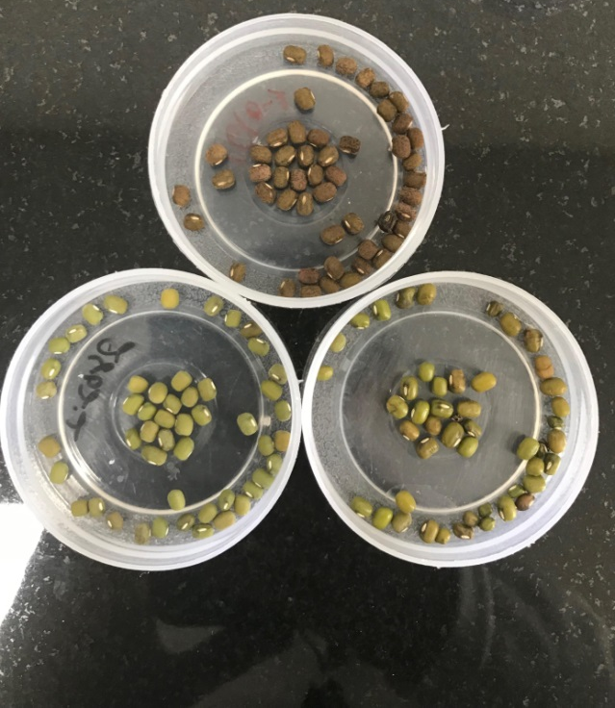
Brown
Shiny Green
Dull Green
Figure 3. Differentiation of mungbean seeds based on color

Seed Hardness

Some of the bruchid resistant lines showed higher hardness than some of the susceptible lines (Fig. 4). The highest seed hardness was observed in AVMU 1625 (54.12 N), V2802 (53.99 N), AVMU 1652 (52.71 N), AVMU 1619 (51.70) and AVMU 1630 (51.43). The lowest seed hardness was observed in AVMU 1655 (17.21 N), AVMU 1617 (16.90 N) and AVMU 1649 (15.95 N). Seed coat hardness is an important trait for bruchid resistance in mungbean (Van Huis and De Rooy, 1998). The hard seed coat prevents the larvae to penetrate into the seed and the roughness render seeds unfit for oviposition by bruchids in mugbean, cowpea, chickpea and other pulses (Nwanze and Horber, 1976; Brewer and Horber, 1983; Messina and Renwick, 1985; Ahmed et al., 1993; Landerito et al., 1993; Shade et al., 1996).

F = 107.45, P = <0.001, LSD (P 0.05) = 3.80, CV (%) = 12.20,
Figure 4. Seed hardness of improved mungbean lines
Phenols

The phenol content of some of the AVMU lines was significantly higher than that of V2802 and NM 94. Phenols are the important plants secondary metabolites involved in resistance against insect pests (War et al., 2012). They are directly toxic to insects and/or act as feeding deterrents (War et al., 2013; Dixit et al., 2017). It has been reported that phenols reduce the growth index of C. chinensis in mungbean (Soumia 2015). Strong negative correlation has been reported between phenol content of the seed and adult emergence of bruchids (Sowmya 2015). Phenols in legume seed reduce the penetration of neonate larvae of bruchids (Bhattacharya and Banerjee, 2001). Further, phenols in seed increase the larval developmental period and reduced percentage of adult emergence, thereby, higher the resistance to storage insect pests (Patel 2002; Misal et al. 2008; Lazar et al., 2014). Further, Ghosal et al. (2004) attributed the resistance or susceptibility of legume seeds to C. chinensis to the phenol content. Resistance or susceptibility of pulse beetle is attributed to bio chemical content of seeds such as phenol (Deshpande et al., 2011).
Table 3. Phenol content (GAE g⁻¹ seed) in improved mungbean lines
Mungbean lines | Phenol content  (μg GAE g⁻¹ Seed) | Mungbean lines | Phenol content  (μg GAE g⁻¹ Seed)
AVMU 1601 | 7.40 | AVMU 1625 | 3.41
AVMU 1602 | 6.03 | AVMU 1626 | 5.26
AVMU 1603 | 6.91 | AVMU 1627 | 6.31
AVMU 1604 | 4.24 | AVMU 1628 | 5.17
AVMU 1605 | 4.76 | AVMU 1629 | 3.79
AVMU 1606 | 3.78 | AVMU 1630 | 3.01
AVMU 1607 | 3.05 | AVMU 1646 | 5.01
AVMU 1609 | 2.37 | AVMU 1647 | 4.92
AVMU 1610 | 3.42 | AVMU 1648 | 4.32
AVMU 1611 | 3.49 | AVMU 1649 | 4.65
AVMU 1612 | 1.75 | AVMU 1650 | 5.22
AVMU 1613 | 2.98 | AVMU 1651 | 5.00
AVMU 1614 | 5.39 | AVMU 1652 | 4.37
AVMU 1615 | 4.45 | AVMU 1653 | 3.43
AVMU 1616 | 4.11 | AVMU 1654 | 2.84
AVMU 1617 | 3.34 | AVMU 1655 | 6.00
AVMU 1618 | 6.27 | AVMU 1656 | 5.49
AVMU 1619 | 7.29 | AVMU 1657 | 5.31
AVMU 1620 | 3.24 | AVMU 1658 | 4.64
AVMU 1621 | 5.68 | AVMU 1659 | 5.68
AVMU 1622 | 5.37 | AVMU 1660 | 6.12
AVMU 1623 | 5.57 | V2802 | 5.22
AVMU 1624 | 3.38 | NM94 | 3.04
F = 79.45, P = <0.01, LSD (P 0.05) = 1.58, CV (%) = 10.3,

Condensed Tannins
AVMU lines (AVMU 1602, AVMU 1607, AVMU 1615 and AVMU 1618) showed higher levels of condensed tannins compared to the checks. Tannins in stored seed are involved in resistance against bruchids (Deshpande 1992; Lale and Makoshi 2000; Lattanzio et al. 2005). They have an astringent (mouth puckering) and bitter taste, which deters the insect pests. Tannins bind to the proteins and digestive enzymes in insect midgut and precipitate them through hydrogen or covalent bonds, thereby, limiting their availability to the insect pests and ultimately reducing the insect growth and development (Peters and Constabel 2002; War et al. 2012). In cowpea, tannins are effectively involved in the resistance against bruchids, which deter insects from oviposition (Lattanzio et al. 2005). Lale and Kolo (1998) showed that in bruchid resistant cowpea, biochemical factors in the testa/seed coat effect the oviposition and survival of pulse beetle eggs. Tannins in seed determine the resistance or susceptibility to the pulse beetle (Deshpande et al., 2011). Significantly positive correlation between tannin content in the seeds with incubation period, larval-pupal period and total developmental period of C. maculatus, and strongly negative with the adult emergence (Misal et al. 2008; Lazar et al., 2014). However, Desroches et al. (1994) did not observe significant effect of tannins on the penetration of bruchid larvae into Vicia faba seed.

Table 4. Condensed tannin content (μg CE g⁻¹ seed) in improved mungbean lines
Mungbean lines | Condensed tannins  (μg CE g⁻¹ seed) | Mungbean lines | Condensed tannins  (μg CE g⁻¹ seed)
AVMU 1601 | 5.63 | AVMU 1625 | 3.45
AVMU 1602 | 6.03 | AVMU 1626 | 3.08
AVMU 1603 | 5.41 | AVMU 1627 | 3.25
AVMU 1604 | 4.56 | AVMU 1628 | 3.44
AVMU 1605 | 4.73 | AVMU 1629 | 3.39
AVMU 1606 | 4.07 | AVMU 1630 | 4.24
AVMU 1607 | 6.28 | AVMU 1646 | 3.52
AVMU 1609 | 4.64 | AVMU 1647 | 4.02
AVMU 1610 | 4.43 | AVMU 1648 | 3.31
AVMU 1611 | 5.09 | AVMU 1649 | 4.55
AVMU 1612 | 4.06 | AVMU 1650 | 3.74
AVMU 1613 | 3.91 | AVMU 1651 | 3.74
AVMU 1614 | 2.34 | AVMU 1652 | 3.30
AVMU 1615 | 6.32 | AVMU 1653 | 3.53
AVMU 1616 | 1.42 | AVMU 1654 | 3.06
AVMU 1617 | 5.09 | AVMU 1655 | 3.91
AVMU 1618 | 6.15 | AVMU 1656 | 4.56
AVMU 1619 | 5.37 | AVMU 1657 | 5.73
AVMU 1620 | 3.10 | AVMU 1658 | 5.82
AVMU 1621 | 3.96 | AVMU 1659 | 3.38
AVMU 1622 | 4.11 | AVMU 1660 | 4.69
AVMU 1623 | 4.04 | V2802 | 4.80
AVMU 1624 | 3.10 | NM94 | 1.32
F = 54.08, p<0.01, LSD (P 0.05) = 1.30, CV (%) = 13.76

Proteins
Differential amounts of proteins were observed across the mungbean lines. The highest protein content was observed in V2802, AVMU 1650, AVMU 1656 and AVMU 1649 (191.4, 190.20, 187.65 and 185.4 mg g⁻¹ seed, respectively). The lowest protein content was observed in NM94 (154.50 mg g⁻¹ seed). Seeds with high protein content have been found less susceptible to insect pests (Singh et al., 1995; Sowmya 2015). Proteins including chitinase, b-1,3-glucanase, and peroxidase in mungbean are involved in bruchid resistance (Khan et al., 2003). Further, bruchid resistance in a NIL VC6089A has been reported to occur due to the BURP (BNM2, USP, RD22, and PG1b) protein family (Lin et al. 2016). They observed that bruchid resistant lines, such as VC6089A, TC1966, and RIL59 showed higher expression of g39185 (resistant-specific protein), g34458 (gag/pol polyprotein), and g5551 (aspartic proteinase) than the susceptible ones (VC1973A and NM92). However, the bad taste or toxicity of these chemicals to non-target organisms has posed a great challenge to scientists to minimize their effects but to stabilize the resistance.
Table 5. Soluble protein content (mg g⁻¹ seed) in improved mungbean lines
Mungbean lines | Soluble protein  (mg g⁻¹ seed) | Mungbean lines | Soluble protein  (mg g⁻¹ seed)
AVMU 1601 | 177.45 | AVMU 1625 | 179.85
AVMU 1602 | 179.10 | AVMU 1626 | 160.95
AVMU 1603 | 178.05 | AVMU 1627 | 180.45
AVMU 1604 | 175.05 | AVMU 1628 | 157.35
AVMU 1605 | 169.95 | AVMU 1629 | 178.50
AVMU 1606 | 172.05 | AVMU 1630 | 171.90
AVMU 1607 | 170.70 | AVMU 1646 | 182.55
AVMU 1609 | 165.45 | AVMU 1647 | 172.95
AVMU 1610 | 174.75 | AVMU 1648 | 168.60
AVMU 1611 | 176.25 | AVMU 1649 | 185.40
AVMU 1612 | 179.40 | AVMU 1650 | 190.20
AVMU 1613 | 169.35 | AVMU 1651 | 163.35
AVMU 1614 | 180.90 | AVMU 1652 | 180.30
AVMU 1615 | 169.95 | AVMU 1653 | 171.90
AVMU 1616 | 177.90 | AVMU 1654 | 182.10
AVMU 1617 | 174.75 | AVMU 1655 | 164.40
AVMU 1618 | 108.80 | AVMU 1656 | 187.65
AVMU 1619 | 183.90 | AVMU 1657 | 177.30
AVMU 1620 | 185.70 | AVMU 1658 | 178.65
AVMU 1621 | 169.20 | AVMU 1659 | 163.50
AVMU 1622 | 175.35 | AVMU 1660 | 159.30
AVMU 1623 | 172.20 | V2802 | 191.40
AVMU 1624 | 174.30 | NM94 | 154.50
F = 99.9, P < 0.05, LSD (P 0.05) = 8.10, CV (%) = 15.20
Soluble Sugars and Starch Contents
The soluble sugar and starch contents of AVMU lines different across the mungbean lines (Figs. 5 and 6). High amounts of soluble sugar content were observed in AVMU 1604, AVMU 1605, AVMU 1622, AVMU 1627 and NM94 (24.97, 26.5, 24.05, 24.08 and 27.8 Glu E g⁻¹ seed, respectively). Reduced sugar content was observed in AVMU 1601, AVMU 1603, AVMU 1611, AVMU 1619, AVMU 1621, AVMU 1652 and AVMU 1656 (5.87, 5.75, 5.89, 5.57, 5.61, 5.95 and 5.82 g Glu E g⁻¹ seed, respectively). High starch content was recorded in AVMU 1654, AVMU 1647, AVMU 1602 and AVMU 1607 (199.4, 198.1, 179.1, 178.9, and μg Glu E g⁻¹ seed, respectively), while as reduced starch content was recorded in AVMU 1610, AVMU 1624 and AVMU 1629 (76.5, 76.5 and 75.2 μg Glu E g⁻¹ seed, respectively). Seeds with higher soluble sugars and starch content are more susceptible to insect pests including bruchids (Lazar et al., 2014). The total soluble sugar content in the seed are negatively correlated to the incubation period, larval-pupal period and total developmental period, while positively correlated to the adult emergence percentage (Lazar et al., 2014).

F = 44.32, P = <0.05, LSD (P 0.05) = 3.74, CV (%) = 10.89,
Figure 5. Soluble sugars (μg Glu E g⁻¹ seed) of seeds of the improved mungbean lines

F = 83,09, P = <0.01, LSD (P 0.05) = 7.98, CV (%) = 14.88,
Figure 6. Starch content (μg Glu E g⁻¹ seed) of seeds of the improved mungbean lines

HPLC Fingerprinting
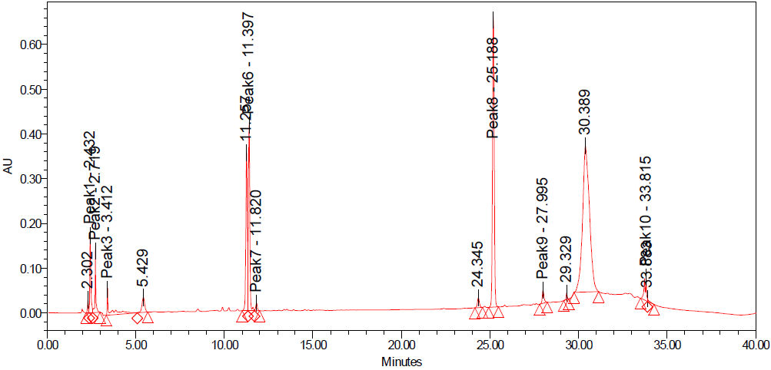
The number of peaks varied across the bruchid resistant and susceptible improved mungbean lines (Fig. 6). The number of peaks was greater in the bruchid resistant lines than the susceptible lines and the susceptible check, NM94 (Fig. 7). AVMU 1601, AVMU 1609 and V2802 had 15, 11 and 11 peaks, respectively, while as the susceptible check NM94 had 10peaks. Each peak determines a single compound. Thus the compounds shown by the additional peaks could be attributed to the bruchid resistance in these lines. However, the susceptibility of some of the compounds cannot be ruled out in the resistant lines as well. The identification of compounds is in progress.
AVMU 1601

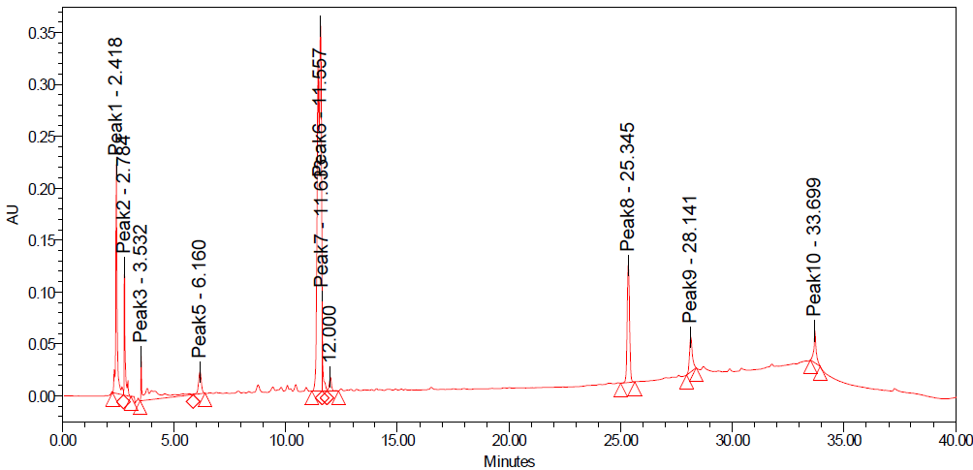
AVMU 1609
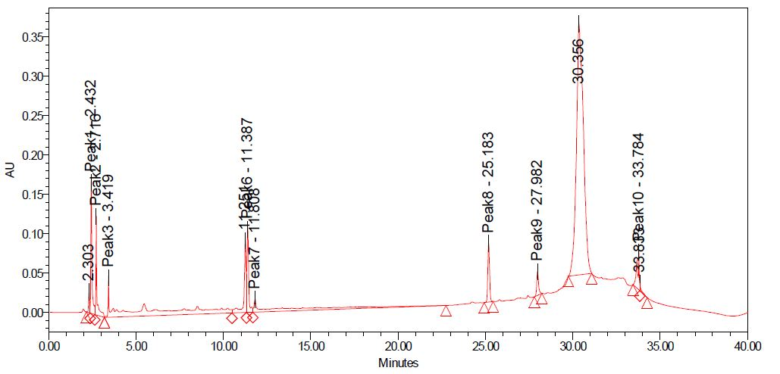
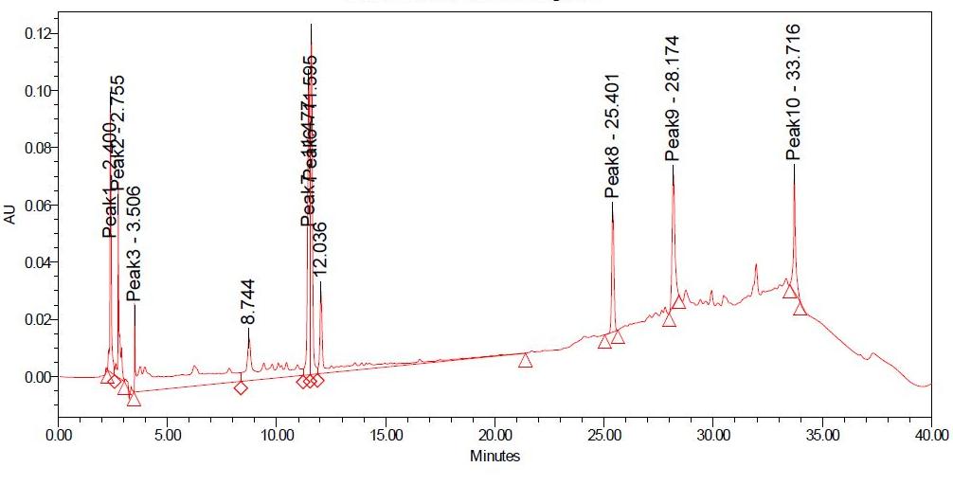
NM 94
V2802

Figure 7. HPLC chromatograms of AVMU 1601, AVMU 1609, V2802 and NM94

Conclusion
AVMU1601, AVMU1605, AVMU1606 with shiny green seed are highly resistant to Callosobruchus maculatus. Some of the bruchid resistant lines showed higher hardness than some of the susceptible lines. Phenol content of some of the AVMU lines with reduced bruchid damage was significantly higher than that of V2802 and NM 94. AVMU 1602, AVMU 1607, AVMU 1615 and AVMU 1618 showed higher levels of condensed tannins compared to the checks. Soluble protein content was significantly different between bruchid resistant and the susceptible lines. The soluble sugar and starch contents of bruchid resistant mungbean lines were significantly lower than the susceptible lines and the susceptible check, NM94. HPLC chromatogram showed differential peaks among the bruchid resistant and bruchid susceptible AVMU lines and V2802 and NM 94. Thus, the higher amounts of phenols, tannins and proteins, and the lower contents of total soluble sugars and starch can be attributed to the resistance and/or susceptibility to C. maculatus in mungbean. However, in-depth studies are needed to elucidate the effects of these compounds on bruchid growth and development to confirm their role in resistance/susceptibility of mungbean to bruchids.

References
Deshpande, S. S. 1992. Food legumes in human nutrition: A personal perspective. Critical Review on Food Science, 32: 333-363.
Desroches, P., Elshazly, E., Mandon, N., Duc, G. and Huignard, J. 1995. Development of Callosobruchus chinensis (L.) and C. maculatus (F.) (Coleoptera: Bruchidae) L. in seeds of Vicia faba differing in tannin, convicine and vicine Contents. The Journal of Stored ProductsResearch, 31: 83-89.
Edwards, O., and Singh, K. B. (2006). Resistance to insect pests: what do legumes have to offer? Euphytica 147, 273–285.
Guedes, R. N. C., and Yack, J. E. (2016). Shaking youngsters and shaken adults: female beetles eavesdrop on larval seed vibrations to make egg laying decisions. PLoS ONE 11:e0150034.
Ignacimuthu, S., Wäckers, F. L., and Dorn, S. (2000). The role of chemical cues in host finding and acceptance by Callosobruchus chinensis. Entomol. Exp. Appl. 96, 213–219.
Khan, M. M. K., Khan, A., Ishimoto, M., Kitamura, K., and Komatsu, S. (2003). Proteome analysis of the relationship between bruchid-resistant and - susceptible mungbean genotypes. Plant Genetic Res. 1, 115–123.
Koona, P., and Dom, S. (2005). Extracts from Tephrosia vogelii for the protection of stored legume seeds against damage by three bruchid species. Annl. Appl. Biol. 147, 43–48.
Lale, N. E. S. and Kolo, A. A. 1998. Susceptibility of eight genetically improved local cultivars of cowpea to Callosobruchus maculatus (F.) (Coleoptera: Bruchidae) in Nigeria, International Journal of Pest Management, 44: pp. 25–27.
Lale, N. E. S. and Makoshi, M. S. 2000. Role of chemical characteristics of the seed coat in the resistance of selected cowpea varieties to Callosobruchus maculatus (F.) (Coleoptera: Bruchidae) in Nigeria. International Journal of Pest Management, 46(2): 97-102.
Lattanzio, V., Terzano, R., Cicco, N., Cardinali, A., Venere, D. D. and Linsalata, V. 2005. Seed coat tannins and bruchid resistance in stored cowpea seeds. Journal of the Science of Food andAgriculture, 85 (5): 839-846.
Lazar L, Panickar B, Patel PS (2014) Impact of biochemicals on the developmental stages of pulse beetle, Callosobruchus maculatus infesting green gram. Journal of Food Legumes 27(2): 121-125.
Lin, W.-J., Ko, C.-Y., Liu, M.-S., Kuo, C.-Y., Wu, D.-C., Chen, C.-Y., et al. (2016). Transcriptomic and proteomic research to explore bruchid-resistant genes in mungbean isogenic lines. J. Agric. Food Chem. 64, 6648–6658.
Misal AM, Patil JV and Chavan UD. 2008. Biochemical basis of resistance to stored grain pest (Callosobruchus chinensis) in different Vigna species. Journal of Food Legumes 21: 262-265.
Oshima, K., Honda, H., and Yamamoto, I. (1973). Isolation of an oviposition marker from azuki bean weevil. Agric. Biol. Chem. 37, 2679–2680.
Peters DJ, Constabel CP. 2002. Molecular analysis of herbivore induced condensed tannin synthesis: cloning and expression of dihydroflavonol reductase from trembling aspen (Populus tremuloides). The Plant Journal: for Cell and Molecular Biology 32:701–712.
Sharma, H. C., War, A. R., and Sahrawat, K. L. (2012). “Botanical pesticides: their environmental effects,” in Biosafety and Environmental Impact of Genetically Modified Organisms and Conventional Technologies for Pest Management, eds H. C. Sharma, M. K. Dhillon, and K. L. Sahrawat (Houston, TX: Studium Press), 159–190.
Singh, V. N., Pandey, N. D and Singh, Y. P. 1995. Relative resistance of gram varieties to Callosobruchus chinensis L. on the basis of biochemical parameters. Ind. J. Entomol., 57(2): 77-82.
Somta, P., Ammaranan, C., Ooi, P. A. C., and Srinives, P. (2007). Inheritance of seed resistance to bruchids in cultivated mungbean (Vigna radiata L. Wilczek). Euphytica 155, 47–55.
Soumia PS (2015) Factors for resistance in mung bean, Vigna radiate against Callosobruchus spp. PhD thesis. Indian Agricultural Research Institute New Delhi. pp. 161.
Sowmya T (2015) Studies on characterization and seed storability against pulse beetle (Callosobruchus chinensis) in green gram genotypes. PhD Thesis. College of Agriculture, Professor Jayashankar Telangana State Agricultural University. pp 211.
Swella, G. B., and Mushobozy, D. M. K. (2007). Evaluation of the efficacy of protectants against cowpea bruchids (Callosobruchus maculatus (F.) on cowpea seeds (Vigna unguiculata (L.) Walp.). Plant Protect. Sci. 43, 68–72.
Tripathy, S. K. (2016). Bruchid resistance in food legumes-an overview. Res. J. Biotechnol. 7, 98–105.
War AR, Murugesan S, Boddepalli VN, Srinivasan R and Nair RM (2017) Mechanism of Resistance in Mungbean [Vigna radiata (L.) R. Wilczek var. radiata] to Bruchids, Callosobruchus spp. (Coleoptera: Bruchidae). Front. Plant Sci. 8:1031.
War, A. R., Paulraj, M. G., Ahmad, T., Buhroo, A. A., Hussain, B., Ignacimuthu, S., et al. (2012). Mechanisms of plant defense against insect herbivores. Plant Signal. Behav. 7, 1306–1320.
Yusuf, A. U., Dike, M. C., Adebitan, S. A., and Ahmed, B. I. (2011). Comparative efficacy of seven plant products on the cowpea bruchid, Callosobruchus maculatus F. development and damage. J. Biopest. 4, 19–26.

